PROJECT

**BCSP**

**–**

**064**

**Luxury Pen E-Commerce**

By

**Abhishek Pandey**

# ENROLLMENT NO. : 2003609680

Under guidance

Of

# GUIDE NAME: Mr. Satya Prakash Arya

Submitted to the School of Computer and Information Sciences, IGNOU

in partial fulfillment of the requirements for the award of the degree

Bachelors of Computer Application ( BCA )



Indira Gandhi National Open University

Maidan Garhi

New Delhi – 110068

**Index**

1. Introduction 5
2. Aim & Objective 6
3. Project Category 7
4. Reason for using PHP and MYSQL 8
5. Tools and Platform 9
6. System Analysis 10
7. Scheduling 11
8. Software Model 12
9. Data Flow Diagram (DFD) 13
10. Entity Relationship Diagram (ERD) 18
11. Database Design 19
12. Input to the System 23
13. Module Description 24
14. Output from the System 26
15. Testing 27
16. Future Scope 30
17. References 31

**Report Index**

1. Introduction 33
2. Aim & Objective 34
3. Project Category 35
4. Reason for using PHP and MYSQL 36
5. Tools and Platform 37
6. System Analysis 38
7. Scheduling 39
8. Software Model 40
9. Data Flow Diagram (DFD) 41
10. Entity Relationship Diagram (ERD) 46
11. Database Design 47
    * Data Integrity and constraints 47
12. Input to the System 67
13. Module Description 68
14. Output from the System 70
15. User Interface 71
    * Source Code 78
16. Admin Interface 187
    * Source Code 191
17. Testing 264
18. System Security Measures 269
19. Debugging 273
20. Future Scope 276
21. References 277

**Introduction**

**Pen Haven(Web Based Application)**

Pen haven is a web-based application, which provides interface to a user. It is an online shopping of branded pens and purchasing using C.O.D (Cash on Delivery) for increasing the trust of online world among users.

Using this web application, user find the best deals for their budget and get exclusively online deals with discount on festive season. Online shopping helps them to save their time also. The price point in online shopping is always less because there will be no intermediary in this system.

This system will help customers and small workers to gain trust on online shopping system. Using online shopping system brands also increase their chain within our country and brands also trying to provide best deals for increase customer base.

**Aim & Objective**

**Aim**

The aim of this website is to provide great value of their investment and helps them to view all the quality products according to their budget, preferences and choice of selection and save their time and money with this service.

This website is design in a simple format so new users can interact with this website is an easy way.

In addition, users can view different smartphones of various brands and find the best deal according to their need. In addition, user can check his/her cart, orders at any time.

**Objective**

* To shop while in the comfort of your home, without having to step out of the door.
* To register and maintain user accounts and profiles.
* To maintain proper security and confidentiality of data.
* Sell Luxury Pens at lower prices to provide best deals.
* Provide Cash on Delivery feature to make customer comfortable

**Project Category**

**Web Based Application**

A web application (or web app) is [application software](https://en.wikipedia.org/wiki/Application_software) that runs on a [web server](https://en.wikipedia.org/wiki/Web_server), unlike computer-based software programs that are run locally on the [operating system](https://en.wikipedia.org/wiki/Operating_system) (OS) of the device.

The user through a web browser with an active internet connection accesses web applications. These applications are programmed using a [client–server](https://en.wikipedia.org/wiki/Client%E2%80%93server_model) modeled structure—the user ("client") is provided services through an off-site server that is hosted by a third party.

Examples of commonly used web applications include [web-mail](https://en.wikipedia.org/wiki/Webmail), [online retail sales](https://en.wikipedia.org/wiki/Online_shopping), [online banking](https://en.wikipedia.org/wiki/Online_banking), and [online auctions](https://en.wikipedia.org/wiki/Online_auction).

**Reason for Using PHP and MYSQL**

**PHP**

PHP is an open source language, all the components are free to use, and distribute. PHP is a server side scripting language. It is used to generate dynamic pages content. People find it useful to develop websites and dynamic web pages. It is platform independent. PHP supports all major web servers such as Apache, Microsoft IIS and Netscape etc. All the major database such as MySQL, PostgreSQL, Oracle, Sybase, Microsoft SQL server is supported by PHP.

The main reason for using PHP language are:

* It collects form data and save data send by mail.
* It sends and receives cookies by accessing cookies variables.
* It provides add, delete and modify element function within our database.
* Through PHP, we can restrict users to access some pages of our website.
* It can encrypt data, so our data will become more secure.

**MYSQL**

MySQL is the most popular open source relational database management system. It is ease of the best RDBMS used to develop web based software applications. It is easy to use and fast RDBMS. There are many good reasons, which help us to develop website using this RDBMS.

* It is open source, so available free.
* It works on many operating system and with many languages including PHP, PERL, C, C++ etc.
* MySQL works very quickly and works well even with large data sets.

**Tools and Platform**

**Hardware specification**

* Processor : Intel i5 8th gen
* RAM : 4 GB
* Hard disk : 500 GB
* Display : 1920 * 1080

**Software specification**

* Operating System : Windows 10
* Front End : HTML, CSS
* Back End : PHP
* Text Editor : Visual Studio Code
* Database : MySQL
* Web Browser : Google Chrome
* Web Server : XAMPP (Apache)

Q. **Are you doing this project for any Industry/ Client?**

A. No

**SYSTEM ANALYSIS**

Analysis of the current and future roles of proposed computer system in an organization, the system analyst (usually a software engineer or programmer) examines the flow of documents, information, and material to design a system that best meets the cost, performance, and scheduling objectives

Systems analysis the process of observing systems for troubleshooting or development purpose. It is applied to information technology, where computer-based systems require defined analysis according to their makeup and design.

In IT, systems analysis can include looking at end-user implementation of a software package or product; looking in-depth at source code to define the methodologies used in building software; or taking feasibility studies and other types of research to support the use and production of a software product, among other things.

Systems analysis professionals are often called upon to look critically at systems, and redesign or recommend changes as necessary. Inside and outside of the business world, systems analysts help to evaluate whether a system is viable or efficient within the context of its overall architecture, and help to uncover the options available to the employing business or other party.

Systems analysts are different from systems administrators, who maintain systems day to day, and their roles generally involve a top-level view of a system to determine its overall effectiveness according to its design.

**SCHEDULING**

**GANTT CHART**

A Gantt chart, commonly used in project management, is one of the most popular and useful ways of showing activities (tasks or events) displayed against time. On the left of the chart is a list of the activities and along the top is a suitable time scale. Each activity is represented by a bar; the position and length of the bar reflects the start date, duration and end date of the activity. This allows you to see at a glance:

* What the various activities are
* When each activity begins and ends
* How long each activity is scheduled to last
* Where activities overlap with other activities, and by how much
* The start and end date of the whole project

To summarize, a Gantt chart shows you what has to be done (the activities) and when (the schedule)

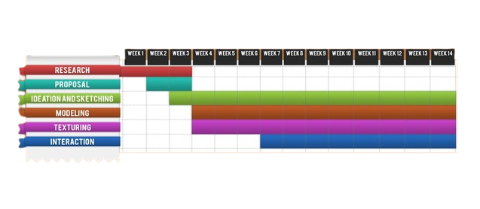

**SOFTWARE MODEL**

**Waterfall Model**

The waterfall Model is a linear sequential flow. In which progress is seen as flowing steadily downwards (like a waterfall) through the phases of software implementation. This means that any phase in the development process begins only if the previous phase is complete. The waterfall approach does not define the process to go back to the previous phase to handle changes in requirement. The waterfall approach is the earliest approach and most widely known that was used for software development.

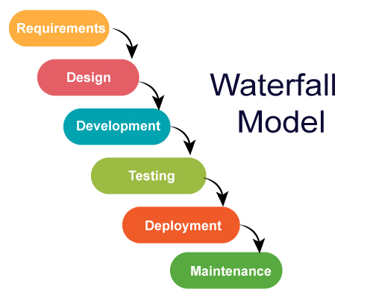

**Data Flow Diagram**

A Data Flow Diagram (DFD) is a graphical representation of the "flow" of data through an Information System. A data flow diagram can also be used for the visualization of Data Processing. It is common practice for a designer to draw a context-level DFD first, which shows the interaction between the system and outside entities.

A DFD represents flow of data through a system. It views a system as a function that transforms the input into desired output. A DFD shows movement of data through the different transformations or processes in the system.

 Dataflow diagrams can be used to provide the end user with a physical idea of where the data they input ultimately has an effect upon the structure of the whole system from order to dispatch to restock how any system is developed can be determined through a dataflow diagram. The appropriate register saved in database and maintained by appropriate authorities.

**Zero Level DFD**

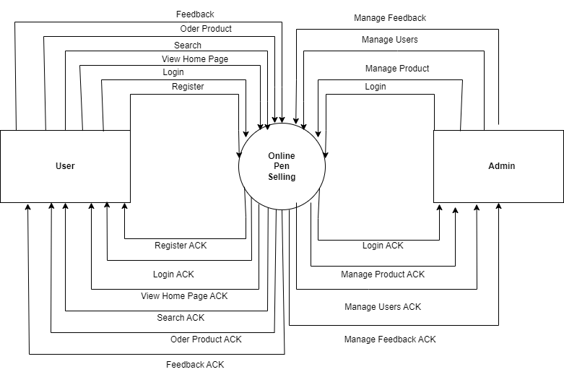

**1st level User DFD**

**1.1**

User

Enter details

Acknowledgement

If failed

Enter Details

Acknowledgement

Enter data

User Data

Enter Credentials

Acknowledgement

Send to

Go to Give

For

Feedback Data

Order Data

For order

**1st Level Admin DFD**

**1.2**

Enter data

Admin

Invalid

User Data

Check

Keep

Add or delete

Read

Feedback data

Order data

Find

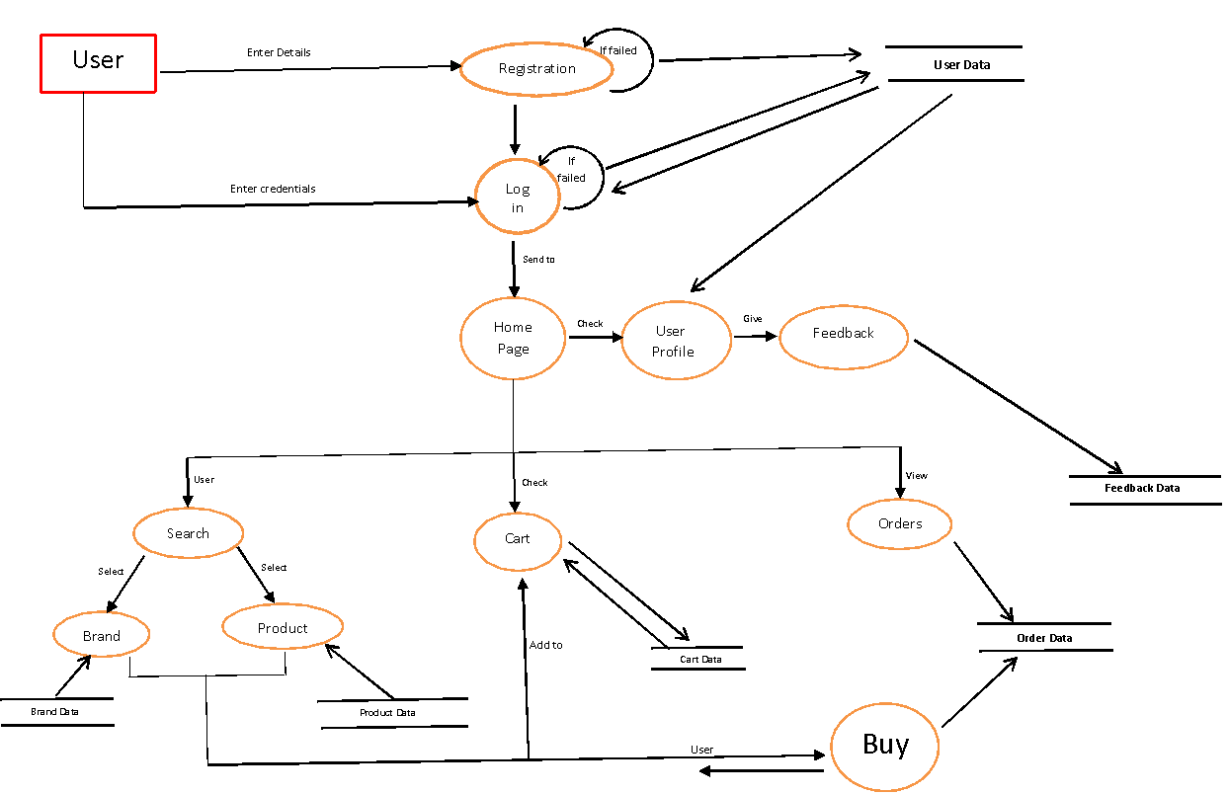

**2nd Level User DFD**

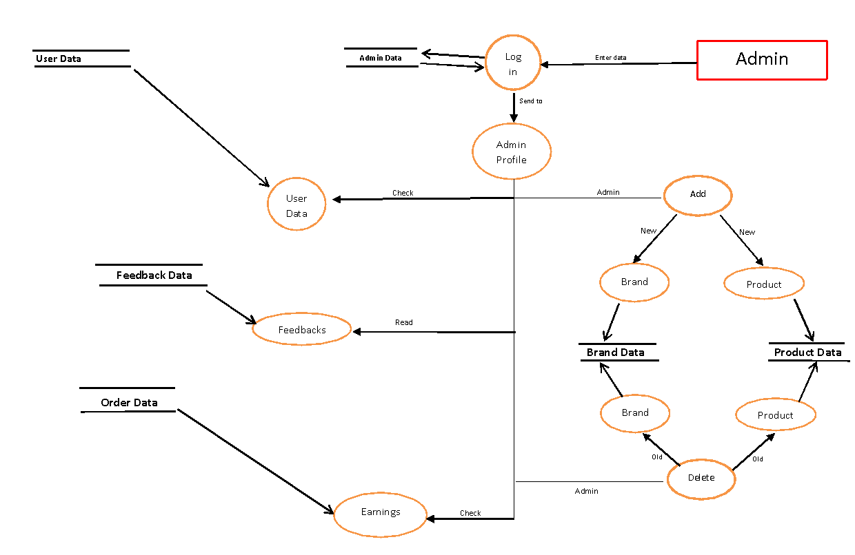

**2nd Level Admin DFD**

**2.1**

**2.2**

**Entity Relationship Diagrams (ER-Diagrams)**

An entity-relationship (ER) diagram is a specialized graphic that illustrates the interrelationships between entities in a database. ER diagrams often use symbols to represent three different types of information. Boxes are commonly used to represent entities. Diamonds are normally used to represent relationships and ovals are used to represent attributes

An entity-relationship model (ERM) in software engineering is an abstract and conceptual representation of data. Entity-relationship modeling is a relational schema database modeling method, used to produce a type of conceptual schema or semantic data model of a system, often a relational database, and its requirements in a top-down fashion.

**Symbols used in this E-R Diagram:**

**Entity**: Entity is a “thing” in the real world with an independent existence. An entity may be an object with a physical existence such as person, car or employee. Entity symbol is as follows

**Attribute**: Attribute is a particular property that describes the entity. Attribute symbol is

**Relationship**: Relationship will be several implicit relationships among various entity types whenever an attribute of one entity refers to another entity type some relationship exits. Relationship symbol is:

**Key attributes**: An entity type usually has an attribute whose values are distinct for each individual entity in the collection. Such an attribute is called key attribute. Key attribute symbol is as follows:

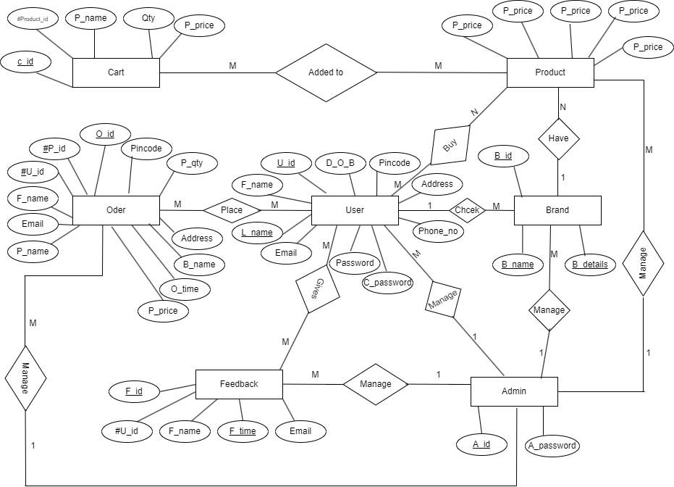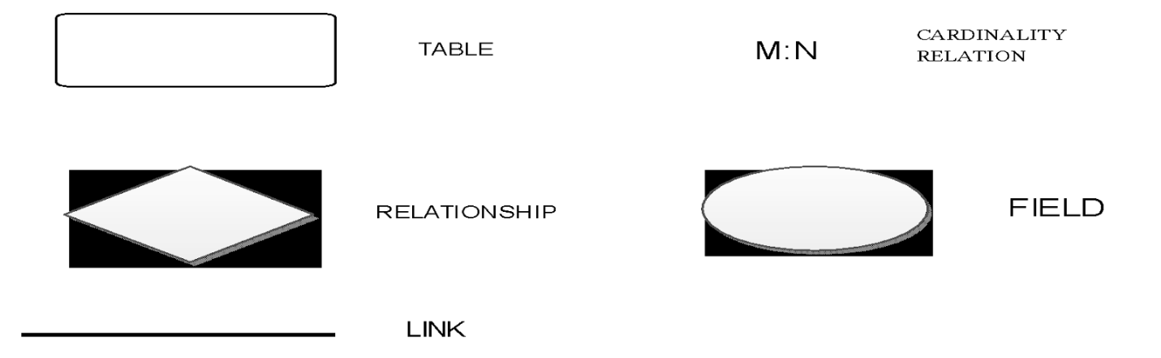

**DATABASE DESIGN**

A database is an organized collection of data. The data are typically organize to model relevant aspects of reality in a way that supports processes requiring this information.

Database management systems (DBMSs) are specially designed applications that interact with the user, other applications, and the database itself to capture and analyze data. A general-purpose database management system (DBMS) is a software system designed to allow the definition, creation, querying, update, and administration of databases.

**Admin**

|  |  |  |  |  |
| --- | --- | --- | --- | --- |
| S.No | Field Name | Data type | Constraint | Description |
| 1 | A_id | Varchar(10) | Primary Key | It store admin id |
| 2 | A_password | Varchar(20) | Not Null | It store password |

**User**

|  |  |  |  |  |
| --- | --- | --- | --- | --- |
| S.No | Field Name | Data type | Constraint | Description |
| 1 | U_id | Varchar(10 | Primary Key | User id generate by system |
| 2 | F_name | Varchar(20) | Not Null | First Name of user |
| 3 | L_name | Varchar(20) | Not Null | Last Name of user |
| 4 | Email | Varchar(30) | Not Null | Email address of user |
| 5 | Password | Varchar(20) | Not Null | For security purpose |
| 6 | C_password | Varchar(20) | Not Null | For rechecking password |
| 7 | Phone_no | Big Int | Not Null | Contact number of user |
| 8 | Address | Varchar(30) | Not Null | Address of the user |
| 9 | Pincode | Int | Not Null | Pin code of user address |
| 10 | D_O_B | Date Time | Not Null | User’s date of birth |

**Login**

|  |  |  |  |  |
| --- | --- | --- | --- | --- |
| S.No | Field Name | Data type | Constraint | Description |
| 1 | U_id | Varchar(10) | Foreign Key | User id |
| 2 | Password | Varchar(20) | Not Null | Password of user |

**Brand**

|  |  |  |  |  |
| --- | --- | --- | --- | --- |
| S.No | Field Name | Data type | Constraint | Description |
| 1 | B_id | Varchar(10) | Primary Key | Id of brand |
| 2 | B_name | Varchar(20) | Not Null | Name of brand |
| 3 | B_details | Varchar(50) | Not Null | Details of brand |

**Product**

|  |  |  |  |  |
| --- | --- | --- | --- | --- |
| S.No | Field Name | Data type | Constraint | Description |
| 1 | P_id | Varchar(10) | Primary Key | Id of products |
| 2 | P_name | Varchar(20) | Not Null | Name of product |
| 3 | P_price | Varchar(20) | Not Null | Price of product |
| 4 | B_id | Varchar(10) | Foreign Key | Id of brand |
| 5 | B_name | Varchar(20) | Not Null | Name of brand |

**Cart**

|  |  |  |  |  |
| --- | --- | --- | --- | --- |
| S.No | Field Name | Data type | Constraint | Description |
| 1 | C_id | Varchar(10) | Primary Key | Id of cart |
| 2 | Product_id | Varchar(10) | Foreign Key | Id of product |
| 3 | P_name | Varchar(10) | Not Null | Name of product |
| 4 | Qty | Int | Not Null | Quantity of product |
| 5 | P_price | Int | Not Null | Price of product |

**Order**

|  |  |  |  |  |
| --- | --- | --- | --- | --- |
| S.No | Field Name | Data type | Constraint | Description |
| 1 | O_id | Varchar(10) | Primary Key | Id of order |
| 2 | P_id | Varchar(10) | Foreign Key | Id of product |
| 3 | U_id | Varchar(10) | Foreign Key | Id of user |
| 4 | F_name | Varchar(20) | Not Null | First name of user |
| 5 | Email | Varchar(30) | Not Null | Email of user |
| 6 | P_name | Varchar(20) | Not Null | Name of product |
| 7 | P_price | Int | Not Null | Price of product |
| 8 | O_time | Date Time | Not Null | Time of order |
| 9 | B_name | Varchar(20) | Not Null | Name of brand |
| 10 | Address | Varchar(30) | Not Null | Address of user |
| 11 | P_qty | Int | Not Null | Quantity of product |
| 12 | Pincode | Int | Not Null | Pin code of user address |

**Feedback**

|  |  |  |  |  |
| --- | --- | --- | --- | --- |
| S.No | Field Name | Data type | Constraint | Description |
| 1 | F_id | Varchar(10) | Primary Key | Id of feedback |
| 2 | U_id | Varchar(10) | Foreign Key | Id of user |
| 3 | F_name | Varchar(20) | Not Null | First name of user |
| 4 | F_time | Time | Not Null | Time of feedback |
| 5 | Email | Varchar(30) | Not Null | Email of user |

**INPUT TO THE SYSTEM**

**User modules**

Registration

* Login
* Search product
* User information
  + View detail
  + Add detail
* My cart
* Add to cart
* Remove cart item
* Feedback
* About us
* Contact us
* Logout

**Admin modules**

* Admin login
* User Data
* Brand Update
  + Add Brand
  + Remove Brand
* Product Update
  + Add Product
  + Remove Product
* Check earnings
* Feedbacks
* Logout

**MODULE DESCRIPTION**

**1. User modules**

1. **Registration**

Allow user to give his/her personal information to the website server to become a member to this system.

1. **Login:**

After Registration user can login to the system with the help of user id generated by the system or email and password.

1. **Search**

In Search box, user can search for various products and brands also and select best smartphone according to his/her need.

1. **User Information**

User can check their information at any time. User view his/her profile and add new information of their profile.

1. **My cart**

User can add products to their cart. In this cart user can view their cart product any time and order them as per their convenience and delete items from cart.

1. **Feedback**

User can give some helpful feedback to us about our website and service. We also ensure that they did not face any problem after their precious feedback.

1. **About us**

In this section user can find information about the makers of the website and some other information about our system.

1. **Contact us**

User can find our details like company number, email and helpline.

1. **Logout**

User log out from our system with this module.

**2. Admin Modules**

* **Admin Login**

Allow admin to login to the system by his/her unique admin Id and password.

* **User Data**

Admin can view all the user base of their system and check all the basic information other than their password.

* **Brands update**

Admin can add and remove Brands from the database.

* **Product update**

Admin can add and remove Products from the database.

* **Check Earnings**

Admin can view all the earnings from this module.

* **Feedbacks**

Admin can read all the feedbacks receive from users.

* **Logout**

Admin can logout from the system with the help of this module.

**Output from the System**

* **User Data**

In this Admin can check all the register user details, except their private data like their password and security question.

* **Feedback Data**

In this Admin can check all the feedbacks regarding to our website and admin try to solve their queries also.

* **Cart Details**

Information related to user cart also store in cart table in our database.

* **Order Details**

Information related to user orders and purchasing is also store in our database.

**Testing**

Testing is the process of running a system with the intention of finding errors. Testing enhances the integrity of a system by detecting deviations in design and errors in the system. Testing aims at detecting error-prone areas. This helps in the prevention of errors in a system. Testing also adds value to the product by conforming to the user requirements.

Software testing can be state as the process of validating and verifying that a computer program/application/product:

• Meets the requirements that guided its design and development

• Works as expected

• Can be implement with the same characteristics

• Satisfies the needs of stakeholders

Software testing, depending on the testing method employed, can be implement at any time in the software development process.

**TESTING METHODS**

System testing is the stage of implementation. This is to check whether the system works accurately and efficiently before live operation commences. Testing is vital to the success of the system. The candidate system is subject to a variety of tests: on line response, volume, stress, recovery, security and usability tests. A series of tests are perform for the proposed system is ready for user acceptance testing. The Testing Steps are:

**Black- Box Testing**

The technique of testing without having any knowledge of the interior workings of the application is called black box testing. The tester is oblivious to the system architecture and does not have access to the source code. Typically, while performing a black-box test, a tester will interact with the system's user interface by providing inputs and examining outputs without knowing how and where the inputs are worked upon.

**White-Box Testing**

White-box testing is the detailed investigation of internal logic and structure of the code. White-box testing is also called glass testing or open-box testing. In order to perform white-box testing on an application, a tester needs to know the internal workings of the code. The tester needs to have a look inside the source code and find out which unit/chunk of the code is behaving inappropriately.

**Unit Testing**

Unit testing focuses efforts on the smallest unit of software design. This is known as module testing. The modules are tested separately. The test is carried out during programming stage itself. In this step, each module is found to be working satisfactory as regards to the expected output from the module

**Integration Testing**

Data can be lost across an interface. One module can have an adverse effect on another, sub functions, when combined, may not be linked in desired manner in major functions. Integration testing is a systematic approach for constructing the program structure, while at the same time conducting test to uncover errors associated within the interface. The objective is to take unit tested modules and builds program structure. All the modules are combined and tested as a whole.

**Output Testing**

After performing the validation testing, the next step is output testing of the proposed system, since no system could be useful if it does not produce the required output in a specific format. The output format on the screen is found to be correct. The format was designed in the system design time according to the user needs. For the hard copy also; the output comes as per the specified requirements by the user. Hence, output testing did not result in any correction for the system.

**User Acceptance Testing**

User acceptance of a system is the key factor for the success of any system. The system under consideration is tested for the user acceptance by constantly keeping in touch with the prospective system users at the time of developing and making changes whenever required.

This is done in regard to the following point:

a) Input Screen Design

b) Output Screen Design

c) Format of reports and other outputs.

**FUTURE SCOPE**

We always try to make it simple and more user friendly. As by increasing some coding, we can improve its functionality. Online payment system is not available for users, which should be improve in near future. Until now, it does not have the facility of back of database. We also try to add some discount on payment via some specific bank credit card and add feature of EMI for convenience of customer.

For security issue we also try to make it more secure than before at every aspects and also try to give some additional for our premium members. For make it more beneficial, we also try to add compare feature for comparing two or more similar product for grab the best deal among them. We also give platform to give feedback on every product of our website as review.

For affiliate marketing, we also add feature for customer to gain some profits by selling our products. There will be endless possibilities for making our website more comfortable among users.

**References**

**Books**

* The Complete Reference PHP
* Head First SQL: Your Brain on SQL by Lynn Beighley
* IGNOU: Introduction to Software Engineering

**Websites**

* [www.google.com](http://www.google.com)
* [www.php.net](http://www.php.net)
* [www.yahoobaba.net](http://www.yahoobaba.net)
* [www.geekyshows.com](http://www.geekyshows.com)

**Project Report on**

Luxury Pen E-Commerce

**Introduction**

**Pen Haven(Web Based Application)**

Pen haven is a web-based application, which provides interface to a user. It is an online shopping of branded pens and purchasing using C.O.D (Cash on Delivery) for increasing the trust of online world among users.

Using this web application, user find the best deals for their budget and get exclusively online deals with discount on festive season. Online shopping helps them to save their time also. The price point in online shopping is always less because there will be no intermediary in this system.

This system will help customers and small workers to gain trust on online shopping system. Using online shopping system brands also increase their chain within our country and brands also trying to provide best deals for increase customer base.

**Aim & Objective**

**Aim**

The aim of this website is to provide great value of their investment and helps them to view all the quality products according to their budget, preferences and choice of selection and save their time and money with this service.

This website is design in a simple format so new users can interact with this website is an easy way.

In addition, users can view different smartphones of various brands and find the best deal according to their need. In addition, user can check his/her cart, orders at any time.

**Objective**

* To shop while in the comfort of your home, without having to step out of the door.
* To register and maintain user accounts and profiles.
* To maintain proper security and confidentiality of data.
* Sell Luxury Pens at lower prices to provide best deals.
* Provide Cash on Delivery feature to make customer comfortable

**Project Category**

**Web Based Application**

A web application (or web app) is [application software](https://en.wikipedia.org/wiki/Application_software) that runs on a [web server](https://en.wikipedia.org/wiki/Web_server), unlike computer-based software programs that are run locally on the [operating system](https://en.wikipedia.org/wiki/Operating_system) (OS) of the device.

The user through a web browser with an active internet connection accesses web applications. These applications are programmed using a [client–server](https://en.wikipedia.org/wiki/Client%E2%80%93server_model) modeled structure—the user ("client") is provided services through an off-site server that is hosted by a third party.

Examples of commonly used web applications include [web-mail](https://en.wikipedia.org/wiki/Webmail), [online retail sales](https://en.wikipedia.org/wiki/Online_shopping), [online banking](https://en.wikipedia.org/wiki/Online_banking), and [online auctions](https://en.wikipedia.org/wiki/Online_auction).

**Reason for Using PHP and MYSQL**

**PHP**

PHP is an open source language, all the components are free to use, and distribute. PHP is a server side scripting language. It is used to generate dynamic pages content. People find it useful to develop websites and dynamic web pages. It is platform independent. PHP supports all major web servers such as Apache, Microsoft IIS and Netscape etc. All the major database such as MySQL, PostgreSQL, Oracle, Sybase, Microsoft SQL server is supported by PHP.

The main reason for using PHP language are:

* It collects form data and save data send by mail.
* It sends and receives cookies by accessing cookies variables.
* It provides add, delete and modify element function within our database.
* Through PHP, we can restrict users to access some pages of our website.
* It can encrypt data, so our data will become more secure.

**MYSQL**

MySQL is the most popular open source relational database management system. It is ease of the best RDBMS used to develop web based software applications. It is easy to use and fast RDBMS. There are many good reasons, which help us to develop website using this RDBMS.

* It is open source, so available free.
* It works on many operating system and with many languages including PHP, PERL, C, C++ etc.
* MySQL works very quickly and works well even with large data sets.

**Tools and Platform**

**Hardware specification**

* Processor : Intel i5 8th gen
* RAM : 4 GB
* Hard disk : 500 GB
* Display : 1920 * 1080

**Software specification**

* Operating System : Windows 10
* Front End : HTML, CSS
* Back End : PHP
* Text Editor : Visual Studio Code
* Database : MySQL
* Web Browser : Google Chrome
* Web Server : XAMPP (Apache)

Q. **Are you doing this project for any Industry/ Client?**

A. No

**SYSTEM ANALYSIS**

Analysis of the current and future roles of proposed computer system in an organization, the system analyst (usually a software engineer or programmer) examines the flow of documents, information, and material to design a system that best meets the cost, performance, and scheduling objectives

Systems analysis the process of observing systems for troubleshooting or development purpose. It is applied to information technology, where computer-based systems require defined analysis according to their makeup and design.

In IT, systems analysis can include looking at end-user implementation of a software package or product; looking in-depth at source code to define the methodologies used in building software; or taking feasibility studies and other types of research to support the use and production of a software product, among other things.

Systems analysis professionals are often called upon to look critically at systems, and redesign or recommend changes as necessary. Inside and outside of the business world, systems analysts help to evaluate whether a system is viable or efficient within the context of its overall architecture, and help to uncover the options available to the employing business or other party.

Systems analysts are different from systems administrators, who maintain systems day to day, and their roles generally involve a top-level view of a system to determine its overall effectiveness according to its design.

**SCHEDULING**

**GANTT CHART**

A Gantt chart, commonly used in project management, is one of the most popular and useful ways of showing activities (tasks or events) displayed against time. On the left of the chart is a list of the activities and along the top is a suitable time scale. Each activity is represented by a bar; the position and length of the bar reflects the start date, duration and end date of the activity. This allows you to see at a glance:

* What the various activities are
* When each activity begins and ends
* How long each activity is scheduled to last
* Where activities overlap with other activities, and by how much
* The start and end date of the whole project

To summarize, a Gantt chart shows you what has to be done (the activities) and when (the schedule)



**SOFTWARE MODEL**

**Waterfall Model**

The waterfall Model is a linear sequential flow. In which progress is seen as flowing steadily downwards (like a waterfall) through the phases of software implementation. This means that any phase in the development process begins only if the previous phase is complete. The waterfall approach does not define the process to go back to the previous phase to handle changes in requirement. The waterfall approach is the earliest approach and most widely known that was used for software development.



**Data Flow Diagram**

A Data Flow Diagram (DFD) is a graphical representation of the "flow" of data through an Information System. A data flow diagram can also be used for the visualization of Data Processing. It is common practice for a designer to draw a context-level DFD first, which shows the interaction between the system and outside entities.

A DFD represents flow of data through a system. It views a system as a function that transforms the input into desired output. A DFD shows movement of data through the different transformations or processes in the system.

 Dataflow diagrams can be used to provide the end user with a physical idea of where the data they input ultimately has an effect upon the structure of the whole system from order to dispatch to restock how any system is developed can be determined through a dataflow diagram. The appropriate register saved in database and maintained by appropriate authorities.

**Zero Level DFD**



**1st level User DFD**

**1.1**

User

Enter details

Acknowledgement

If failed

Enter Details

Acknowledgement

Enter data

User Data

Enter Credentials

Acknowledgement

Send to

Go to Give

For

Feedback Data

Order Data

For order

**1st Level Admin DFD**

**1.2**

Enter data

Admin

Invalid

User Data

Check

Keep

Add or delete

Read

Feedback data

Order data

Find



**2nd Level User DFD**



**2nd Level Admin DFD**

**2.1**

**2.2**

**Entity Relationship Diagrams (ER-Diagrams)**

An entity-relationship (ER) diagram is a specialized graphic that illustrates the interrelationships between entities in a database. ER diagrams often use symbols to represent three different types of information. Boxes are commonly used to represent entities. Diamonds are normally used to represent relationships and ovals are used to represent attributes

An entity-relationship model (ERM) in software engineering is an abstract and conceptual representation of data. Entity-relationship modeling is a relational schema database modeling method, used to produce a type of conceptual schema or semantic data model of a system, often a relational database, and its requirements in a top-down fashion.

**Symbols used in this E-R Diagram:**

**Entity**: Entity is a “thing” in the real world with an independent existence. An entity may be an object with a physical existence such as person, car or employee. Entity symbol is as follows

**Attribute**: Attribute is a particular property that describes the entity. Attribute symbol is

**Relationship**: Relationship will be several implicit relationships among various entity types whenever an attribute of one entity refers to another entity type some relationship exits. Relationship symbol is:

**Key attributes**: An entity type usually has an attribute whose values are distinct for each individual entity in the collection. Such an attribute is called key attribute. Key attribute symbol is as follows:





**DATABASE DESIGN**

A database is an organized collection of data. The data are typically organize to model relevant aspects of reality in a way that supports processes requiring this information.

Database management systems (DBMSs) are specially designed applications that interact with the user, other applications, and the database itself to capture and analyze data. A general-purpose database management system (DBMS) is a software system designed to allow the definition, creation, querying, update, and administration of databases.

**Admin**

|  |  |  |  |  |
| --- | --- | --- | --- | --- |
| S.No | Field Name | Data type | Constraint | Description |
| 1 | A_id | Varchar(10) | Primary Key | It store admin id |
| 2 | A_password | Varchar(20) | Not Null | It store password |

**User**

|  |  |  |  |  |
| --- | --- | --- | --- | --- |
| S.No | Field Name | Data type | Constraint | Description |
| 1 | U_id | Varchar(10 | Primary Key | User id generate by system |
| 2 | F_name | Varchar(20) | Not Null | First Name of user |
| 3 | L_name | Varchar(20) | Not Null | Last Name of user |
| 4 | Email | Varchar(30) | Not Null | Email address of user |
| 5 | Password | Varchar(20) | Not Null | For security purpose |
| 6 | C_password | Varchar(20) | Not Null | For rechecking password |
| 7 | Phone_no | Big Int | Not Null | Contact number of user |
| 8 | Address | Varchar(30) | Not Null | Address of the user |
| 9 | Pincode | Int | Not Null | Pin code of user address |
| 10 | D_O_B | Date Time | Not Null | User’s date of birth |

**Brand**

|  |  |  |  |  |
| --- | --- | --- | --- | --- |
| S.No | Field Name | Data type | Constraint | Description |
| 1 | B_id | Varchar(10) | Primary Key | Id of brand |
| 2 | B_name | Varchar(20) | Not Null | Name of brand |
| 3 | B_details | Varchar(50) | Not Null | Details of brand |

**Product**

|  |  |  |  |  |
| --- | --- | --- | --- | --- |
| S.No | Field Name | Data type | Constraint | Description |
| 1 | P_id | Varchar(10) | Primary Key | Id of products |
| 2 | P_name | Varchar(20) | Not Null | Name of product |
| 3 | P_price | Varchar(20) | Not Null | Price of product |
| 4 | B_id | Varchar(10) | Foreign Key | Id of brand |
| 5 | B_name | Varchar(20) | Not Null | Name of brand |

**Cart**

|  |  |  |  |  |
| --- | --- | --- | --- | --- |
| S.No | Field Name | Data type | Constraint | Description |
| 1 | C_id | Varchar(10) | Primary Key | Id of cart |
| 2 | Product_id | Varchar(10) | Foreign Key | Id of product |
| 3 | P_name | Varchar(10) | Not Null | Name of product |
| 4 | Qty | Int | Not Null | Quantity of product |
| 5 | P_price | Int | Not Null | Price of product |

**Order**

|  |  |  |  |  |
| --- | --- | --- | --- | --- |
| S.No | Field Name | Data type | Constraint | Description |
| 1 | O_id | Varchar(10) | Primary Key | Id of order |
| 2 | P_id | Varchar(10) | Foreign Key | Id of product |
| 3 | U_id | Varchar(10) | Foreign Key | Id of user |
| 4 | F_name | Varchar(20) | Not Null | First name of user |
| 5 | Email | Varchar(30) | Not Null | Email of user |
| 6 | P_name | Varchar(20) | Not Null | Name of product |
| 7 | P_price | Int | Not Null | Price of product |
| 8 | O_time | Date Time | Not Null | Time of order |
| 9 | B_name | Varchar(20) | Not Null | Name of brand |
| 10 | Address | Varchar(30) | Not Null | Address of user |
| 11 | P_qty | Int | Not Null | Quantity of product |
| 12 | Pincode | Int | Not Null | Pin code of user address |

**Feedback**

|  |  |  |  |  |
| --- | --- | --- | --- | --- |
| S.No | Field Name | Data type | Constraint | Description |
| 1 | F_id | Varchar(10) | Primary Key | Id of feedback |
| 2 | U_id | Varchar(10) | Foreign Key | Id of user |
| 3 | F_name | Varchar(20) | Not Null | First name of user |
| 4 | F_time | Time | Not Null | Time of feedback |
| 5 | Email | Varchar(30) | Not Null | Email of user |

**Data Integrity and Constraints**

-- Database: `ecom`  
--  
  
-- --------------------------------------------------------  
  
--  
-- Table structure for table `admin_table`  
--  
  
CREATE TABLE `admin_table` (  
`Name` varchar(25) NOT NULL,  
`Password` varchar(255) NOT NULL  
) ENGINE=InnoDB DEFAULT CHARSET=utf8mb4 COLLATE=utf8mb4_general_ci;  
  
--  
-- Dumping data for table `admin_table`  
--  
  
INSERT INTO `admin_table` (`Name`, `Password`) VALUES  
('admin@123', '$2y$10$JY/y3WpTkvP52KvWzDKcbeRt22EVjR5byNoQUfzaarsrwr8W6juqm');  
  
-- --------------------------------------------------------  
  
--  
-- Table structure for table `brand`  
--  
  
CREATE TABLE `brand` (  
`id` int(11) NOT NULL,  
`brand` varchar(25) NOT NULL,  
`status` tinyint(4) NOT NULL,  
`image` varchar(255) NOT NULL  
) ENGINE=InnoDB DEFAULT CHARSET=utf8mb4 COLLATE=utf8mb4_general_ci;  
  
--  
-- Dumping data for table `brand`  
--  
  
INSERT INTO `brand` (`id`, `brand`, `status`, `image`) VALUES  
(1, 'Montblanc', 1, '79040828_logo-vector-montblanc.jpg'),  
(2, 'NOVIUM', 1, '36251025_950b46eef090-brandlogo1-16742365.jpg'),  
(3, 'DUCATI', 1, '89199324_Ducati-Logo-Vector-scaled.jpg'),  
(4, 'CROSS', 1, '62483496_Cross-logo.jpg');  
  
-- --------------------------------------------------------  
  
--  
-- Table structure for table `cart1`  
--  
  
CREATE TABLE `cart1` (  
`cart_id` int(40) NOT NULL,  
`p_id` int(10) NOT NULL,  
`p_name` varchar(255) NOT NULL,  
`brand_id` int(10) NOT NULL,  
`price` int(10) NOT NULL,  
`image` varchar(255) NOT NULL  
) ENGINE=InnoDB DEFAULT CHARSET=utf8mb4 COLLATE=utf8mb4_general_ci;  
  
--  
-- Dumping data for table `cart1`  
--  
  
INSERT INTO `cart1` (`cart_id`, `p_id`, `p_name`, `brand_id`, `price`, `image`) VALUES  
(3, 19, '128467 Meisterstück LeGrand Around The World In 80 Days Fountain Pen (14K Fine) - Anthracite With Gold Trims', 1, 86000, '72975583_4.webp');  
  
-- --------------------------------------------------------  
  
--  
-- Table structure for table `cart2`  
--  
  
CREATE TABLE `cart2` (  
`cart_id` int(40) NOT NULL,  
`p_id` int(10) NOT NULL,  
`p_name` varchar(255) NOT NULL,  
`brand_id` int(10) NOT NULL,  
`price` int(10) NOT NULL,  
`image` varchar(255) NOT NULL  
) ENGINE=InnoDB DEFAULT CHARSET=utf8mb4 COLLATE=utf8mb4_general_ci;  
  
-- --------------------------------------------------------  
  
--  
-- Table structure for table `cart3`  
--  
  
CREATE TABLE `cart3` (  
`cart_id` int(40) NOT NULL,  
`p_id` int(10) NOT NULL,  
`p_name` varchar(255) NOT NULL,  
`brand_id` int(10) NOT NULL,  
`price` int(10) NOT NULL,  
`image` varchar(255) NOT NULL  
) ENGINE=InnoDB DEFAULT CHARSET=utf8mb4 COLLATE=utf8mb4_general_ci;  
  
-- --------------------------------------------------------  
  
--  
-- Table structure for table `feedback`  
--  
  
CREATE TABLE `feedback` (  
`f_id` int(11) NOT NULL,  
`email` varchar(50) NOT NULL,  
`subject` varchar(255) NOT NULL,  
`query` varchar(2000) NOT NULL,  
`time` datetime NOT NULL DEFAULT current_timestamp()  
) ENGINE=InnoDB DEFAULT CHARSET=utf8mb4 COLLATE=utf8mb4_general_ci;  
  
--  
-- Dumping data for table `feedback`  
--  
  
INSERT INTO `feedback` (`f_id`, `email`, `subject`, `query`, `time`) VALUES  
(1, 'sunny@gmail.com', 'nice pens', 'sab badhiya h', '2023-09-07 15:55:14');  
  
-- --------------------------------------------------------  
  
--  
-- Table structure for table `order_table`  
--  
  
CREATE TABLE `order_table` (  
`order_id` int(40) NOT NULL,  
`brand_id` int(20) NOT NULL,  
`p_name` varchar(30) NOT NULL,  
`image` varchar(50) NOT NULL,  
`price` int(12) NOT NULL,  
`u_id` int(30) NOT NULL,  
`username` varchar(30) NOT NULL,  
`email` varchar(50) NOT NULL,  
`phone_no` bigint(10) NOT NULL,  
`address` varchar(80) NOT NULL,  
`time` datetime NOT NULL DEFAULT current_timestamp()  
) ENGINE=InnoDB DEFAULT CHARSET=utf8mb4 COLLATE=utf8mb4_general_ci;  
  
-- --------------------------------------------------------  
  
--  
-- Table structure for table `order_table1`  
--  
  
CREATE TABLE `order_table1` (  
`order_id` int(40) NOT NULL,  
`brand_id` int(20) NOT NULL,  
`p_name` varchar(30) NOT NULL,  
`image` varchar(50) NOT NULL,  
`price` int(12) NOT NULL,  
`u_id` int(30) NOT NULL,  
`username` varchar(30) NOT NULL,  
`email` varchar(50) NOT NULL,  
`phone_no` bigint(10) NOT NULL,  
`address` varchar(80) NOT NULL,  
`time` datetime NOT NULL DEFAULT current_timestamp()  
) ENGINE=InnoDB DEFAULT CHARSET=utf8mb4 COLLATE=utf8mb4_general_ci;  
  
--  
-- Dumping data for table `order_table1`  
--  
  
INSERT INTO `order_table1` (`order_id`, `brand_id`, `p_name`, `image`, `price`, `u_id`, `username`, `email`, `phone_no`, `address`, `time`) VALUES  
(1, 1, '128475 Meisterstück Classique ', '63540709_3.jpg', 14680, 1, 'Abhishek', 'abhi@gmail.com', 9315887944, 'delhi', '2023-09-07 15:17:07'),  
(2, 1, '128467 Meisterstück LeGrand Ar', '72975583_4.webp', 86000, 1, 'Abhishek', 'abhi@gmail.com', 9315887944, 'delhi', '2023-09-07 15:17:16');  
  
-- --------------------------------------------------------  
  
--  
-- Table structure for table `order_table2`  
--  
  
CREATE TABLE `order_table2` (  
`order_id` int(40) NOT NULL,  
`brand_id` int(20) NOT NULL,  
`p_name` varchar(30) NOT NULL,  
`image` varchar(50) NOT NULL,  
`price` int(12) NOT NULL,  
`u_id` int(30) NOT NULL,  
`username` varchar(30) NOT NULL,  
`email` varchar(50) NOT NULL,  
`phone_no` bigint(10) NOT NULL,  
`address` varchar(80) NOT NULL,  
`time` datetime NOT NULL DEFAULT current_timestamp()  
) ENGINE=InnoDB DEFAULT CHARSET=utf8mb4 COLLATE=utf8mb4_general_ci;  
  
--  
-- Dumping data for table `order_table2`  
--  
  
INSERT INTO `order_table2` (`order_id`, `brand_id`, `p_name`, `image`, `price`, `u_id`, `username`, `email`, `phone_no`, `address`, `time`) VALUES  
(1, 3, 'Black Trofeo Ballpoint Pen', '18600373_2.jpeg', 6248, 2, 'sunny', 'sunny@gmail.com', 56161551, 'as/paschim vihar delhi', '2023-09-07 15:56:15'),  
(2, 1, '128475 Meisterstück Classique ', '63540709_3.jpg', 14680, 2, 'sunny', 'sunny@gmail.com', 56161551, 'as/paschim vihar delhi', '2023-09-07 16:06:06');  
  
-- --------------------------------------------------------  
  
--  
-- Table structure for table `order_table3`  
--  
  
CREATE TABLE `order_table3` (  
`order_id` int(40) NOT NULL,  
`brand_id` int(20) NOT NULL,  
`p_name` varchar(30) NOT NULL,  
`image` varchar(50) NOT NULL,  
`price` int(12) NOT NULL,  
`u_id` int(30) NOT NULL,  
`username` varchar(30) NOT NULL,  
`email` varchar(50) NOT NULL,  
`phone_no` bigint(10) NOT NULL,  
`address` varchar(80) NOT NULL,  
`time` datetime NOT NULL DEFAULT current_timestamp()  
) ENGINE=InnoDB DEFAULT CHARSET=utf8mb4 COLLATE=utf8mb4_general_ci;  
  
--  
-- Dumping data for table `order_table3`  
--  
  
INSERT INTO `order_table3` (`order_id`, `brand_id`, `p_name`, `image`, `price`, `u_id`, `username`, `email`, `phone_no`, `address`, `time`) VALUES  
(1, 4, 'Century II Transluscent Green ', '72886916_4.jpeg', 9368, 3, 'anuj', 'aNUJ@GMAIL.COM', 78945612302, 'sultanpuri', '2023-09-07 16:03:13');  
  
-- --------------------------------------------------------  
  
--  
-- Table structure for table `product`  
--  
  
CREATE TABLE `product` (  
`p_id` int(11) NOT NULL,  
`brand_id` int(11) NOT NULL,  
`p_name` varchar(255) NOT NULL,  
`mrp` float NOT NULL,  
`price` float NOT NULL,  
`qty` int(11) NOT NULL,  
`image` varchar(255) NOT NULL,  
`status` int(11) NOT NULL,  
`short_desc` varchar(2000) NOT NULL,  
`long_desc` varchar(2000) NOT NULL,  
`specification` varchar(3000) NOT NULL,  
`features` varchar(3000) NOT NULL,  
`count` int(20) NOT NULL  
) ENGINE=InnoDB DEFAULT CHARSET=utf8mb4 COLLATE=utf8mb4_general_ci;  
  
--  
-- Dumping data for table `product`  
--  
  
INSERT INTO `product` (`p_id`, `brand_id`, `p_name`, `mrp`, `price`, `qty`, `image`, `status`, `short_desc`, `long_desc`, `specification`, `features`, `count`) VALUES  
(1, 4, 'Century II Medalist Ball Pen', 6200, 4960, 1, '43751976_1.jpeg', 1, 'Writing will be much more fun with this amazing pen. This century II medalist silver ballpoint pen by Cross offers a comfortable and seamless writing experience. Its slim tip flows butter-smooth ink, while its sleek body offers an easy grip. This pen is crafted with care from metal. Besides, its amazing ink flow technique ensures a consistent thickness of writing with smudge-proof ink.', 'Writing will be much more fun with this amazing pen. This century II medalist silver ballpoint pen by Cross offers a comfortable and seamless writing experience. Its slim tip flows butter-smooth ink, while its sleek body offers an easy grip. This pen is crafted with care from metal. Besides, its amazing ink flow technique ensures a consistent thickness of writing with smudge-proof ink.', 'COLOR\r\nSilver\r\nMATERIAL TYPE\r\nMetal\r\nNET QUANTITY\r\n1\r\nWRITING INSTRUMENT TYPE\r\nBallpoint Pen', 'COLOR\r\nSilver\r\nMATERIAL TYPE\r\nMetal\r\nNET QUANTITY\r\n1\r\nWRITING INSTRUMENT TYPE\r\nBallpoint Pen', 0),  
(2, 4, 'Bailey Black/c Fp Med Nib-SST', 5700, 4560, 1, '53677811_2.jpeg', 1, 'Write your bright destiny with this fountain pen from Cross. Its finest nib gives you writing flow as smooth as butter. Made with superior quality metal, it has got a smooth finish for your ease of gripping. Moreover, it comes in a black hue that adds on to its beauty.', 'Write your bright destiny with this fountain pen from Cross. Its finest nib gives you writing flow as smooth as butter. Made with superior quality metal, it has got a smooth finish for your ease of gripping. Moreover, it comes in a black hue that adds on to its beauty.', ' COLOR\r\nBlack\r\nMATERIAL TYPE\r\nMetal\r\nNET QUANTITY\r\n1\r\nWRITING INSTRUMENT TYPE\r\nFountain Pen', 'COLOR\r\nBlack\r\nMATERIAL TYPE\r\nMetal\r\nNET QUANTITY\r\n1\r\nWRITING INSTRUMENT TYPE\r\nFountain Pen', 0),  
(3, 4, 'Bailey Light Green Resin Fountain Pen Pen With Gold Plate Appts - Med Nib', 3200, 2719, 1, '85380679_3.jpeg', 1, 'Endlessly elegant, this fountain pen from Cross will be a perfect gifting option for your dear one. Made with care using high-quality resin, it assures long years of usage. It is sleek, modern and fun to take and write with no matter wherever you are.', 'Endlessly elegant, this fountain pen from Cross will be a perfect gifting option for your dear one. Made with care using high-quality resin, it assures long years of usage. It is sleek, modern and fun to take and write with no matter wherever you are.', 'COLOR\r\nTeal & Gold\r\nMATERIAL TYPE\r\nResin\r\nWRITING INSTRUMENT TYPE\r\nFountain Pen', 'COLOR\r\nTeal & Gold\r\nMATERIAL TYPE\r\nResin\r\nWRITING INSTRUMENT TYPE\r\nFountain Pen', 0),  
(4, 4, 'Century II Transluscent Green Lacquer W Polished Black PVD Ball Pen', 11760, 9368, 1, '72886916_4.jpeg', 1, 'A wonderful way to make your loved one feel special, present this roller ball pen from Cross on their special day. Designed to perfection, this writing instrument will be a perfect companion for working professionals.', 'A wonderful way to make your loved one feel special, present this roller ball pen from Cross on their special day. Designed to perfection, this writing instrument will be a perfect companion for working professionals.\r\n COLOR\r\nGreen\r\nFEATURE1\r\nLifetime Mechanical Guarantee\r\nMATERIAL TYPE\r\nBrass\r\nMULTIPACK CONTENTS\r\nNo\r\nWRITING INSTRUMENT TYPE\r\nRollerball', ' COLOR\r\nGreen\r\nFEATURE1\r\nLifetime Mechanical Guarantee\r\nMATERIAL TYPE\r\nBrass\r\nMULTIPACK CONTENTS\r\nNo\r\nWRITING INSTRUMENT TYPE\r\nRollerball', 'COLOR\r\nGreen\r\nFEATURE1\r\nLifetime Mechanical Guarantee\r\nMATERIAL TYPE\r\nBrass\r\nMULTIPACK CONTENTS\r\nNo\r\nWRITING INSTRUMENT TYPE\r\nRollerball', 1),  
(5, 3, 'Red Trofeo Ballpoint Pen', 8979, 6248, 1, '17333297_1.jpeg', 1, 'More than a pen, a brand statement. The Ducati Corse shield adorn the top of the ballpoint pen with a colored resin triangular pin that shapes the entire pen cap, making this product unique. The clip is itself inspired by motorbike vent and a small italian flag complete the design at half lenght. All very sporty, all very unique.', 'More than a pen, a brand statement. The Ducati Corse shield adorn the top of the ballpoint pen with a colored resin triangular pin that shapes the entire pen cap, making this product unique. The clip is itself inspired by motorbike vent and a small italian flag complete the design at half lenght. All very sporty, all very unique.', ' COLLECTION NAME\r\nTrofeo\r\nCOLOR\r\nRed\r\nMATERIAL TYPE\r\nStainless Steel\r\nNET QUANTITY\r\n1\r\nWRITING INSTRUMENT TYPE\r\nBallpoint Pen', 'COLLECTION NAME\r\nTrofeo\r\nCOLOR\r\nRed\r\nMATERIAL TYPE\r\nStainless Steel\r\nNET QUANTITY\r\n1\r\nWRITING INSTRUMENT TYPE\r\nBallpoint Pen', 0),  
(6, 3, 'Black Trofeo Ballpoint Pen', 8925, 6248, 1, '18600373_2.jpeg', 1, 'More than a pen, a brand statement. The Ducati Corse shield adorn the top of the ballpoint pen with a colored resin triangular pin that shapes the entire pen cap, making this product unique. The clip is itself inspired by motorbike vent and a small italian flag complete the design at half lenght. All very sporty, all very unique.', 'More than a pen, a brand statement. The Ducati Corse shield adorn the top of the ballpoint pen with a colored resin triangular pin that shapes the entire pen cap, making this product unique. The clip is itself inspired by motorbike vent and a small italian flag complete the design at half lenght. All very sporty, all very unique.\r\nCOLLECTION NAME\r\nTrofeo\r\nCOLOR\r\nBlack\r\nMATERIAL TYPE\r\nStainless Steel\r\nNET QUANTITY\r\n1\r\nWRITING INSTRUMENT TYPE\r\nBallpoint Pen', ' COLLECTION NAME\r\nTrofeo\r\nCOLOR\r\nBlack\r\nMATERIAL TYPE\r\nStainless Steel\r\nNET QUANTITY\r\n1\r\nWRITING INSTRUMENT TYPE\r\nBallpoint Pen', 'COLLECTION NAME\r\nTrofeo\r\nCOLOR\r\nBlack\r\nMATERIAL TYPE\r\nStainless Steel\r\nNET QUANTITY\r\n1\r\nWRITING INSTRUMENT TYPE\r\nBallpoint Pen', 3),  
(7, 3, 'Townsend Blue Laquer Roller Ball Pen', 18795, 15500, 1, '55410647_3.jpeg', 1, 'An excellent gift for your dear ones, this blue rollerball pen from Cross ensures a smooth writing experience. Ideal for both students and professionals, this pen is crafted with care using superior quality metal that gives a good finish and prevents fingers from slipping off. Moreover, its fine nib ensures stress-free writing for hours.', 'An excellent gift for your dear ones, this blue rollerball pen from Cross ensures a smooth writing experience. Ideal for both students and professionals, this pen is crafted with care using superior quality metal that gives a good finish and prevents fingers from slipping off. Moreover, its fine nib ensures stress-free writing for hours.', ' COLOR\r\nBlue\r\nMATERIAL TYPE\r\nMetal\r\nWRITING INSTRUMENT TYPE\r\nRoller Ball', 'COLOR\r\nBlue\r\nMATERIAL TYPE\r\nMetal\r\nWRITING INSTRUMENT TYPE\r\nRoller Ball', 0),  
(8, 3, 'Townsend Regirth - Lustrous Chrome', 12660, 10900, 1, '67756406_4.jpeg', 1, 'A perfect blend of performance and stylish look, this silver ballpoint pen from Cross will offer a smooth flow of ink while writing. Ideal for both students and professionals, this pen is crafted with care using superior quality metal that gives a good finish and prevents fingers from slipping off. Moreover, its fine nib ensures stress-free writing for hours.', 'A perfect blend of performance and stylish look, this silver ballpoint pen from Cross will offer a smooth flow of ink while writing. Ideal for both students and professionals, this pen is crafted with care using superior quality metal that gives a good finish and prevents fingers from slipping off. Moreover, its fine nib ensures stress-free writing for hours.', ' COLOR\r\nSilver\r\nMATERIAL TYPE\r\nMetal\r\nWRITING INSTRUMENT TYPE\r\nBallpoint Pen', 'COLOR\r\nSilver\r\nMATERIAL TYPE\r\nMetal\r\nWRITING INSTRUMENT TYPE\r\nBallpoint Pen', 0),  
(12, 2, 'ROBERTO CAVALLI 1', 18500, 14680, 1, '77863397_2.jpeg', 1, 'Write your thoughts with this ballpoint pen from Roberto Cavalli. It is gold-plated which renders the pen an amazing shine. If you are thinking of gifting something to your teacher or parent on their special days, this ballpoint pen is a striking choice.', 'Write your thoughts with this ballpoint pen from Roberto Cavalli. It is gold-plated which renders the pen an amazing shine. If you are thinking of gifting something to your teacher or parent on their special days, this ballpoint pen is a striking choice.', ' COLOR\r\nBlack & Gold\r\nMATERIAL TYPE\r\nStainless Steel\r\nNET QUANTITY\r\n1\r\nWRITING INSTRUMENT TYPE\r\nBallpoint Pen', 'COLOR\r\nBlack & Gold\r\nMATERIAL TYPE\r\nStainless Steel\r\nNET QUANTITY\r\n1\r\nWRITING INSTRUMENT TYPE\r\nBallpoint Pen', 0),  
(13, 2, 'ROBERTO CAVALLI', 18999, 15800, 1, '20956048_1.jpeg', 1, 'Write your thoughts with this ballpoint pen from Roberto Cavalli. It is gold-plated which renders the pen an amazing shine. If you are thinking of gifting something to your teacher or parent on their special days, this ballpoint pen is a striking choice.', 'COLOR\r\nBlack & Gold\r\nMATERIAL TYPE\r\nStainless Steel\r\nNET QUANTITY\r\n1\r\nWRITING INSTRUMENT TYPE\r\nBallpoint Pen\r\nWrite your thoughts with this ballpoint pen from Roberto Cavalli. It is gold-plated which renders the pen an amazing shine. If you are thinking of gifting something to your teacher or parent on their special days, this ballpoint pen is a striking choice.', ' COLOR\r\nBlack & Gold\r\nMATERIAL TYPE\r\nStainless Steel\r\nNET QUANTITY\r\n1\r\nWRITING INSTRUMENT TYPE\r\nBallpoint Pen', 'COLOR\r\nBlack & Gold\r\nMATERIAL TYPE\r\nStainless Steel\r\nNET QUANTITY\r\n1\r\nWRITING INSTRUMENT TYPE\r\nBallpoint Pen', 0),  
(14, 2, 'Hoverpen 1.0 Shining Silver Ballpoint Pen', 14000, 12999, 1, '29349490_1.jpeg', 1, 'Hoverpen 1.0 from Novium is a unique and stylish writing instrument. It is durable and corrosion-resistant. The pen has an ergonomic design that makes it comfortable to write with for long periods of time. It also features a floating design that allows it to stand upright on its own. It is a great gift for anyone who loves unique and functional writing instruments.', 'Hoverpen 1.0 from Novium is a unique and stylish writing instrument. It is durable and corrosion-resistant. The pen has an ergonomic design that makes it comfortable to write with for long periods of time. It also features a floating design that allows it to stand upright on its own. It is a great gift for anyone who loves unique and functional writing instruments.\r\nCOLOR\r\nShining Silver\r\nFEATURE1\r\nThe Hoverpen 1.0 Shining Silver Titanium Ballpoint Pen is made from titanium, which is a strong and durable material that is also corrosion-resistant. The pen is available in a variety of colours, including pitch black, which is a sleek and sophisticated colour that will look great on any desk.\r\nFEATURE2\r\nThe Hoverpen is 5.5 inches long and 0.5 inches in diameter. This makes it a comfortable size to hold and use. This makes it a lightweight pen that is easy to carry around.\r\nFEATURE3\r\nThe Hoverpen uses a magnetic field to levitate and spin on its own. This is made possible by the pen\'s unique design, which includes a small magnet in the pen and a larger magnet in the base.\r\nMATERIAL TYPE\r\nTitanium\r\nWRITING INSTRUMENT TYPE\r\nBallpoint Pen\r\n', ' COLOR\r\nShining Silver\r\nFEATURE1\r\nThe Hoverpen 1.0 Shining Silver Titanium Ballpoint Pen is made from titanium, which is a strong and durable material that is also corrosion-resistant. The pen is available in a variety of colours, including pitch black, which is a sleek and sophisticated colour that will look great on any desk.\r\nFEATURE2\r\nThe Hoverpen is 5.5 inches long and 0.5 inches in diameter. This makes it a comfortable size to hold and use. This makes it a lightweight pen that is easy to carry around.\r\nFEATURE3\r\nThe Hoverpen uses a magnetic field to levitate and spin on its own. This is made possible by the pen\'s unique design, which includes a small magnet in the pen and a larger magnet in the base.\r\nMATERIAL TYPE\r\nTitanium\r\nWRITING INSTRUMENT TYPE\r\nBallpoint Pen\r\n', 'COLOR\r\nShining Silver\r\nFEATURE1\r\nThe Hoverpen 1.0 Shining Silver Titanium Ballpoint Pen is made from titanium, which is a strong and durable material that is also corrosion-resistant. The pen is available in a variety of colours, including pitch black, which is a sleek and sophisticated colour that will look great on any desk.\r\nFEATURE2\r\nThe Hoverpen is 5.5 inches long and 0.5 inches in diameter. This makes it a comfortable size to hold and use. This makes it a lightweight pen that is easy to carry around.\r\nFEATURE3\r\nThe Hoverpen uses a magnetic field to levitate and spin on its own. This is made possible by the pen\'s unique design, which includes a small magnet in the pen and a larger magnet in the base.\r\nMATERIAL TYPE\r\nTitanium\r\nWRITING INSTRUMENT TYPE\r\nBallpoint Pen\r\n', 1),  
(15, 1, '132513 Starwalker Metal Ballpoint Pen Metal', 57200, 59200, 1, '26964584_2.webp', 1, 'The new StarWalker is about walking amid the stars. It\'s about The new StarWalker is about walking amidst the stars. It\'s about exploring the cosmos and foreign galaxies, about being part of one of the most mysterious and powerful of humankinds adventures: space exploration. The collection\'s new design celebrates the immense emotion, described by all space travellers, of seeing our blue planet floating in the vast expanse of space. The unique StarWalker emblem technology features a blue translucent dome beneath the Montblanc emblem, reminiscent of the Earth emerging above the lunar horizon. The StarWalker Metal comes with a platinum-coated barrel and fittings.', 'The new StarWalker is about walking amid the stars. It\'s about The new StarWalker is about walking amidst the stars. It\'s about exploring the cosmos and foreign galaxies, about being part of one of the most mysterious and powerful of humankinds adventures: space exploration. The collection\'s new design celebrates the immense emotion, described by all space travellers, of seeing our blue planet floating in the vast expanse of space. The unique StarWalker emblem technology features a blue translucent dome beneath the Montblanc emblem, reminiscent of the Earth emerging above the lunar horizon. The StarWalker Metal comes with a platinum-coated barrel and fittings.\r\n Engravable: Engravable\r\nWi Pen Weight: 57.88\r\nPen Type: Ballpoint Pen\r\nPre Installed Ink Colour: Black\r\nCap Mechanism: Twist\r\nFilling Mechanism: Refill\r\nBarrel Color: Silver\r\nClip Color: Platinum\r\nBarrel Material: Platinum\r\nClip Material: Platinum', ' Engravable: Engravable\r\nWi Pen Weight: 57.88\r\nPen Type: Ballpoint Pen\r\nPre Installed Ink Colour: Black\r\nCap Mechanism: Twist\r\nFilling Mechanism: Refill\r\nBarrel Color: Silver\r\nClip Color: Platinum\r\nBarrel Material: Platinum\r\nClip Material: Platinum', 'Engravable: Engravable\r\nWi Pen Weight: 57.88\r\nPen Type: Ballpoint Pen\r\nPre Installed Ink Colour: Black\r\nCap Mechanism: Twist\r\nFilling Mechanism: Refill\r\nBarrel Color: Silver\r\nClip Color: Platinum\r\nBarrel Material: Platinum\r\nClip Material: Platinum', 0),  
(16, 5131, 'Montblanc 128475 Meisterstück Classique Around The World In 80 Days Ballpoint Pen - Anthracite With Gold Trims', 51600, 53600, 1, '96747222_3.jpg', 1, 'The Meisterstück \'Around The World In 80 Days\' collection by Montblanc is inspired by Jules Verne\'s famous adventure novel. The Classique Ballpoint pen in anthracite precious resin draws upon the second leg of the journey, which spans from Bombay to Yokohama.\r\n\r\nTo symbolise this part of the adventure, the cap of the pen showcases a cartouche featuring a depiction of a majestic elephant, representing the main characters\' mode of transportation during this leg of the journey. The clip of the pen is adorned with a red lacquered diamond card suit.', 'The Meisterstück \'Around The World In 80 Days\' collection by Montblanc is inspired by Jules Verne\'s famous adventure novel. The Classique Ballpoint pen in anthracite precious resin draws upon the second leg of the journey, which spans from Bombay to Yokohama.\r\n\r\nTo symbolise this part of the adventure, the cap of the pen showcases a cartouche featuring a depiction of a majestic elephant, representing the main characters\' mode of transportation during this leg of the journey. The clip of the pen is adorned with a red lacquered diamond card suit.\r\nCollections: Around the world 80 days\r\nEngravable: No\r\nProduct Material: Precious Resin\r\nWi Pen Weight: 20.86 g\r\nPen Length: 139 mm\r\nPen Mechanism: Twist\r\nPen Type: Ballpoint Pen\r\nGrip Diameter: 12.5 mm\r\nFilling Mechanism: Refill\r\nBarrel Color: Dark Grey\r\nCap Color: Dark Grey\r\nClip Color: Gold\r\nBarrel Material: Precious Resin\r\nClip Material: Gold\r\nProduct Finish: Matte\r\nWeight: 20.86 g', ' Collections: Around the world 80 days\r\nEngravable: No\r\nProduct Material: Precious Resin\r\nWi Pen Weight: 20.86 g\r\nPen Length: 139 mm\r\nPen Mechanism: Twist\r\nPen Type: Ballpoint Pen\r\nGrip Diameter: 12.5 mm\r\nFilling Mechanism: Refill\r\nBarrel Color: Dark Grey\r\nCap Color: Dark Grey\r\nClip Color: Gold\r\nBarrel Material: Precious Resin\r\nClip Material: Gold\r\nProduct Finish: Matte\r\nWeight: 20.86 g', 'Collections: Around the world 80 days\r\nEngravable: No\r\nProduct Material: Precious Resin\r\nWi Pen Weight: 20.86 g\r\nPen Length: 139 mm\r\nPen Mechanism: Twist\r\nPen Type: Ballpoint Pen\r\nGrip Diameter: 12.5 mm\r\nFilling Mechanism: Refill\r\nBarrel Color: Dark Grey\r\nCap Color: Dark Grey\r\nClip Color: Gold\r\nBarrel Material: Precious Resin\r\nClip Material: Gold\r\nProduct Finish: Matte\r\nWeight: 20.86 g', 0),  
(18, 1, '128475 Meisterstück Classique Around The World In 80 Days Ballpoint Pen', 18500, 14680, 1, '63540709_3.jpg', 1, 'The Meisterstück \'Around The World In 80 Days\' collection by Montblanc is inspired by Jules Verne\'s famous adventure novel. The Classique Ballpoint pen in anthracite precious resin draws upon the second leg of the journey, which spans from Bombay to Yokohama.\r\n\r\nTo symbolise this part of the adventure, the cap of the pen showcases a cartouche featuring a depiction of a majestic elephant, representing the main characters\' mode of transportation during this leg of the journey. The clip of the pen is adorned with a red lacquered diamond card suit.', 'The Meisterstück \'Around The World In 80 Days\' collection by Montblanc is inspired by Jules Verne\'s famous adventure novel. The Classique Ballpoint pen in anthracite precious resin draws upon the second leg of the journey, which spans from Bombay to Yokohama.\r\n\r\nTo symbolise this part of the adventure, the cap of the pen showcases a cartouche featuring a depiction of a majestic elephant, representing the main characters\' mode of transportation during this leg of the journey. The clip of the pen is adorned with a red lacquered diamond card suit.', ' Collections: Around the world 80 days\r\nEngravable: No\r\nProduct Material: Precious Resin\r\nWi Pen Weight: 20.86 g\r\nPen Length: 139 mm\r\nPen Mechanism: Twist\r\nPen Type: Ballpoint Pen\r\nGrip Diameter: 12.5 mm\r\nFilling Mechanism: Refill\r\nBarrel Color: Dark Grey\r\nCap Color: Dark Grey\r\nClip Color: Gold\r\nBarrel Material: Precious Resin\r\nClip Material: Gold\r\nProduct Finish: Matte\r\nWeight: 20.86 g\r\n', 'Collections: Around the world 80 days\r\nEngravable: No\r\nProduct Material: Precious Resin\r\nWi Pen Weight: 20.86 g\r\nPen Length: 139 mm\r\nPen Mechanism: Twist\r\nPen Type: Ballpoint Pen\r\nGrip Diameter: 12.5 mm\r\nFilling Mechanism: Refill\r\nBarrel Color: Dark Grey\r\nCap Color: Dark Grey\r\nClip Color: Gold\r\nBarrel Material: Precious Resin\r\nClip Material: Gold\r\nProduct Finish: Matte\r\nWeight: 20.86 g\r\n', 2),  
(19, 1, '128467 Meisterstück LeGrand Around The World In 80 Days Fountain Pen (14K Fine) - Anthracite With Gold Trims', 89100, 86000, 1, '72975583_4.webp', 1, ' \r\nThe Meisterstück \'Around The World In 80 Days\' collection takes inspiration from Jules Verne\'s famous adventure novel. This LeGrand Fountain Pen is crafted with anthracite precious resin and draws upon the second leg of the journey, which spans from Bombay to Yokohama. On the cap of the pen, you can find a cartouche featuring a depiction of a majestic elephant, symbolising the mode of transportation used during this part of the adventure. The clip of the pen is adorned with a red lacquered diamond card suit, reflecting Mr. Fogg\'s daring wager to complete the entire journey in 80 days. The cone is intricately engraved with a pattern inspired by Princess Aouda\'s jewellery and the card suits, further emphasising Mr. Fogg\'s ambitious journey.\r\n\r\nThe writing instrument is adorned with a hand-crafted 14K gold nib. This nib is engraved with a hot air balloon and depicts Mr. Fogg\'s departure from Bombay at 20:00 on 20 October and his departure from Yokohama at 18:00 on 14 November. ', '\r\nThe Meisterstück \'Around The World In 80 Days\' collection takes inspiration from Jules Verne\'s famous adventure novel. This LeGrand Fountain Pen is crafted with anthracite precious resin and draws upon the second leg of the journey, which spans from Bombay to Yokohama. On the cap of the pen, you can find a cartouche featuring a depiction of a majestic elephant, symbolising the mode of transportation used during this part of the adventure. The clip of the pen is adorned with a red lacquered diamond card suit, reflecting Mr. Fogg\'s daring wager to complete the entire journey in 80 days. The cone is intricately engraved with a pattern inspired by Princess Aouda\'s jewellery and the card suits, further emphasising Mr. Fogg\'s ambitious journey.\r\n\r\nThe writing instrument is adorned with a hand-crafted 14K gold nib. This nib is engraved with a hot air balloon and depicts Mr. Fogg\'s departure from Bombay at 20:00 on 20 October and his departure from Yokohama at 18:00 on 14 November.', ' Collections: Around the world 80 days\r\nEngravable: No\r\nProduct Material: Precious Resin\r\nWi Pen Weight: 30.18 g\r\nPen Length: 146 mm\r\nPen Mechanism: Cap\r\nPen Type: Fountain Pen\r\nGrip Diameter: 15.5 mm\r\nFilling Mechanism: Converter\r\nBarrel Color: Dark Grey\r\nCap Color: Dark Grey\r\nClip Color: Gold\r\nBarrel Material: Precious Resin\r\nClip Material: Gold\r\nProduct Finish: Matte\r\nWeight: 30.18 g', 'Collections: Around the world 80 days\r\nEngravable: No\r\nProduct Material: Precious Resin\r\nWi Pen Weight: 30.18 g\r\nPen Length: 146 mm\r\nPen Mechanism: Cap\r\nPen Type: Fountain Pen\r\nGrip Diameter: 15.5 mm\r\nFilling Mechanism: Converter\r\nBarrel Color: Dark Grey\r\nCap Color: Dark Grey\r\nClip Color: Gold\r\nBarrel Material: Precious Resin\r\nClip Material: Gold\r\nProduct Finish: Matte\r\nWeight: 30.18 g', 1);  
  
-- --------------------------------------------------------  
  
--  
-- Table structure for table `users`  
--  
  
CREATE TABLE `users` (  
`u_id` int(11) NOT NULL,  
`username` varchar(25) NOT NULL,  
`password` varchar(255) NOT NULL,  
`email` varchar(40) NOT NULL,  
`address` varchar(255) NOT NULL,  
`city` varchar(20) NOT NULL,  
`pincode` bigint(10) NOT NULL,  
`phone_no` bigint(16) NOT NULL,  
`d_o_b` date NOT NULL,  
`gender` varchar(10) NOT NULL  
) ENGINE=InnoDB DEFAULT CHARSET=utf8mb4 COLLATE=utf8mb4_general_ci;  
  
--  
-- Dumping data for table `users`  
--  
  
INSERT INTO `users` (`u_id`, `username`, `password`, `email`, `address`, `city`, `pincode`, `phone_no`, `d_o_b`, `gender`) VALUES  
(1, 'Abhishek', '$2y$10$yVIqFJPePJMFvDQ6aR5.ieCRDOUR23vBH55SkILbhbRJnxdvHSDn2', 'abhi@gmail.com', 'delhi', 'Delhi', 110086, 9315887944, '2005-06-01', 'male'),  
(2, 'sunny', '$2y$10$q9OWpPXzGByvdQluKzn/weA588OqFzGOqNC4446x71ZX5ANvAqcv6', 'sunny@gmail.com', 'as/paschim vihar delhi', 'North West Delhi', 110086, 56161551, '2006-11-01', 'male'),  
(3, 'anuj', '$2y$10$5Ts8w8ijZ/WFbhCeLcyPJudHZyfr4OBYDf3QVlm/pCl18JFmo7r1C', 'aNUJ@GMAIL.COM', 'sultanpuri', 'yoganda', 110059, 78945612302, '1998-05-07', 'female');  
  
--  
-- Indexes for dumped tables  
--  
--  
-- Indexes for table `admin_table`  
--  
ALTER TABLE `admin_table`  
ADD PRIMARY KEY (`Name`);  
--  
-- Indexes for table `brand`  
--  
ALTER TABLE `brand`  
ADD PRIMARY KEY (`id`),  
ADD UNIQUE KEY `brand` (`brand`);  
  
--  
-- Indexes for table `cart1`  
--  
ALTER TABLE `cart1`  
ADD PRIMARY KEY (`cart_id`);  
  
--  
-- Indexes for table `cart2`  
--  
ALTER TABLE `cart2`  
ADD PRIMARY KEY (`cart_id`);  
--  
-- Indexes for table `cart3`  
--  
ALTER TABLE `cart3`  
ADD PRIMARY KEY (`cart_id`);  
--  
-- Indexes for table `feedback`  
--  
ALTER TABLE `feedback`  
ADD PRIMARY KEY (`f_id`);  
--  
-- Indexes for table `order_table`  
--  
ALTER TABLE `order_table`  
ADD PRIMARY KEY (`order_id`);  
--  
-- Indexes for table `order_table1`  
--  
ALTER TABLE `order_table1`  
ADD PRIMARY KEY (`order_id`);  
--  
-- Indexes for table `order_table2`  
--  
ALTER TABLE `order_table2`  
ADD PRIMARY KEY (`order_id`);  
--  
-- Indexes for table `order_table3`  
--  
ALTER TABLE `order_table3`  
ADD PRIMARY KEY (`order_id`);  
--  
-- Indexes for table `product`  
--  
ALTER TABLE `product`  
ADD PRIMARY KEY (`p_id`),  
ADD UNIQUE KEY `p_name` (`p_name`);  
--  
-- Indexes for table `users`  
--  
ALTER TABLE `users`  
ADD PRIMARY KEY (`u_id`),  
ADD UNIQUE KEY `username` (`username`),  
ADD UNIQUE KEY `email` (`email`);  
  
--  
-- AUTO_INCREMENT for dumped tables  
--  
--  
-- AUTO_INCREMENT for table `brand`  
--  
ALTER TABLE `brand`  
MODIFY `id` int(11) NOT NULL AUTO_INCREMENT, AUTO_INCREMENT=5;   
--  
-- AUTO_INCREMENT for table `cart1`  
--  
ALTER TABLE `cart1`  
MODIFY `cart_id` int(40) NOT NULL AUTO_INCREMENT, AUTO_INCREMENT=4;   
--  
-- AUTO_INCREMENT for table `cart2`  
--  
ALTER TABLE `cart2`  
MODIFY `cart_id` int(40) NOT NULL AUTO_INCREMENT, AUTO_INCREMENT=2;   
--  
-- AUTO_INCREMENT for table `cart3`  
--  
ALTER TABLE `cart3`  
MODIFY `cart_id` int(40) NOT NULL AUTO_INCREMENT, AUTO_INCREMENT=2;   
--  
-- AUTO_INCREMENT for table `feedback`  
--  
ALTER TABLE `feedback`  
MODIFY `f_id` int(11) NOT NULL AUTO_INCREMENT, AUTO_INCREMENT=2;   
--  
-- AUTO_INCREMENT for table `order_table`  
--  
ALTER TABLE `order_table`  
MODIFY `order_id` int(40) NOT NULL AUTO_INCREMENT;  
  
--  
-- AUTO_INCREMENT for table `order_table1`  
--  
ALTER TABLE `order_table1`  
MODIFY `order_id` int(40) NOT NULL AUTO_INCREMENT, AUTO_INCREMENT=3;   
--  
-- AUTO_INCREMENT for table `order_table2`  
--  
ALTER TABLE `order_table2`  
MODIFY `order_id` int(40) NOT NULL AUTO_INCREMENT, AUTO_INCREMENT=3;  
  
--  
-- AUTO_INCREMENT for table `order_table3`  
--  
ALTER TABLE `order_table3`  
MODIFY `order_id` int(40) NOT NULL AUTO_INCREMENT, AUTO_INCREMENT=2;   
--  
-- AUTO_INCREMENT for table `product`  
--  
ALTER TABLE `product`  
MODIFY `p_id` int(11) NOT NULL AUTO_INCREMENT, AUTO_INCREMENT=20;   
--  
-- AUTO_INCREMENT for table `users`  
--  
ALTER TABLE `users`  
MODIFY `u_id` int(11) NOT NULL AUTO_INCREMENT, AUTO_INCREMENT=4;  
COMMIT;

**INPUT TO THE SYSTEM**

**User modules**

Registration

* Login
* Search product
* User information
  + View detail
  + Add detail
* My cart
* Add to cart
* Remove cart item
* Feedback
* About us
* Contact us
* Logout

**Admin modules**

* Admin login
* User Data
* Brand Update
  + Add Brand
  + Remove Brand
* Product Update
  + Add Product
  + Remove Product
* Check earnings
* Feedbacks
* Logout

**MODULE DESCRIPTION**

**1. User modules**

1. **Registration**

Allow user to give his/her personal information to the website server to become a member to this system.

1. **Login:**

After Registration user can login to the system with the help of user id generated by the system or email and password.

1. **Search**

In Search box, user can search for various products and brands also and select best smartphone according to his/her need.

1. **User Information**

User can check their information at any time. User view his/her profile and add new information of their profile.

1. **My cart**

User can add products to their cart. In this cart user can view their cart product any time and order them as per their convenience and delete items from cart.

1. **Feedback**

User can give some helpful feedback to us about our website and service. We also ensure that they did not face any problem after their precious feedback.

1. **About us**

In this section user can find information about the makers of the website and some other information about our system.

1. **Contact us**

User can find our details like company number, email and helpline.

1. **Logout**

User log out from our system with this module.

**2. Admin Modules**

* **Admin Login**

Allow admin to login to the system by his/her unique admin Id and password.

* **User Data**

Admin can view all the user base of their system and check all the basic information other than their password.

* **Brands update**

Admin can add and remove Brands from the database.

* **Product update**

Admin can add and remove Products from the database.

* **Check Earnings**

Admin can view all the earnings from this module.

* **Feedbacks**

Admin can read all the feedbacks receive from users.

* **Logout**

Admin can logout from the system with the help of this module.

**Output from the System**

* **User Data**

In this Admin can check all the register user details, except their private data like their password and security question.

* **Feedback Data**

In this Admin can check all the feedbacks regarding to our website and admin try to solve their queries also.

* **Cart Details**

Information related to user cart also store in cart table in our database.

* **Order Details**

Information related to user orders and purchasing is also store in our database.

**User Interface**

**Login.php**

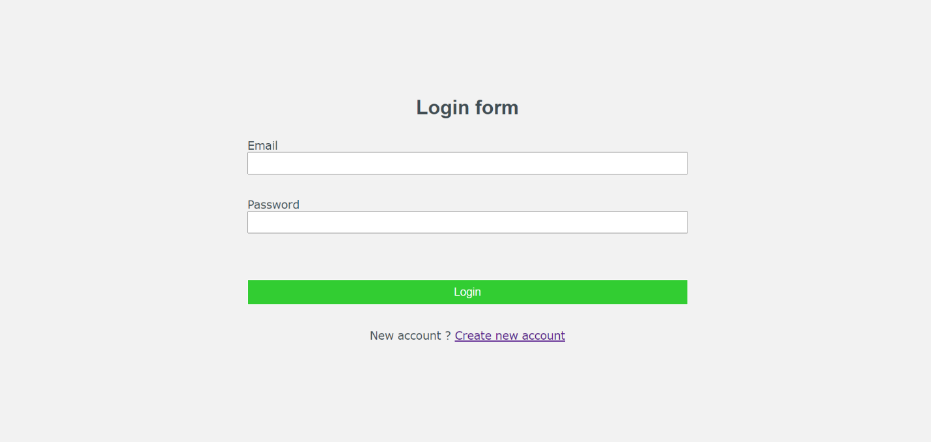

**Register.php**

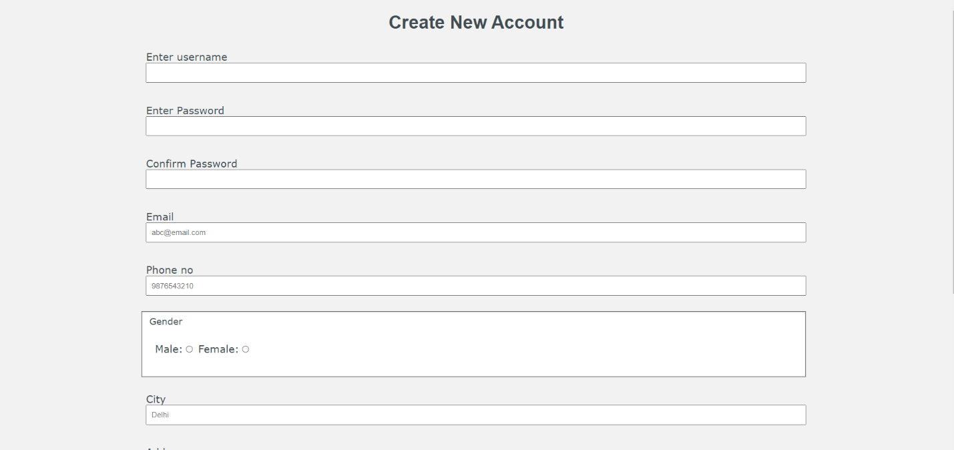

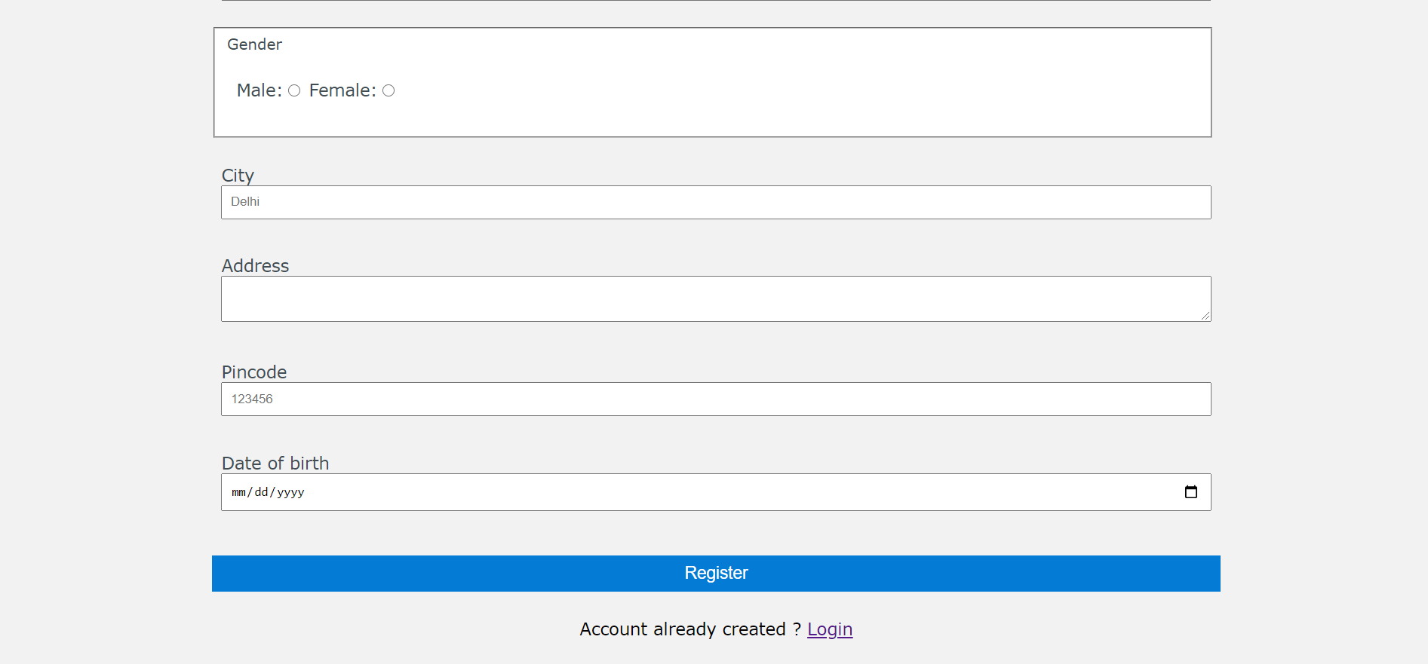

**Main.php**

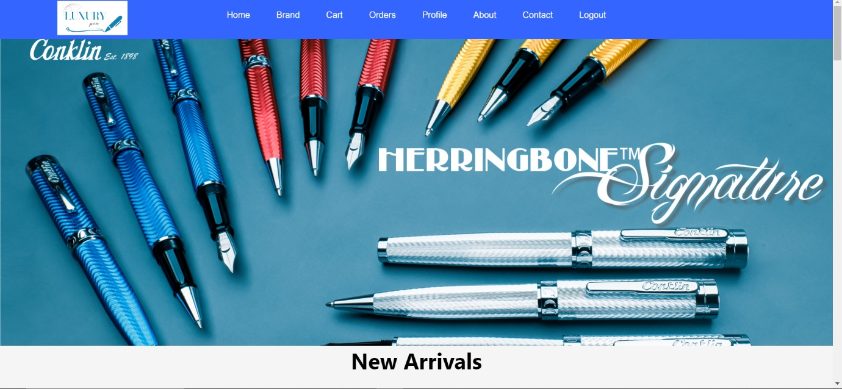

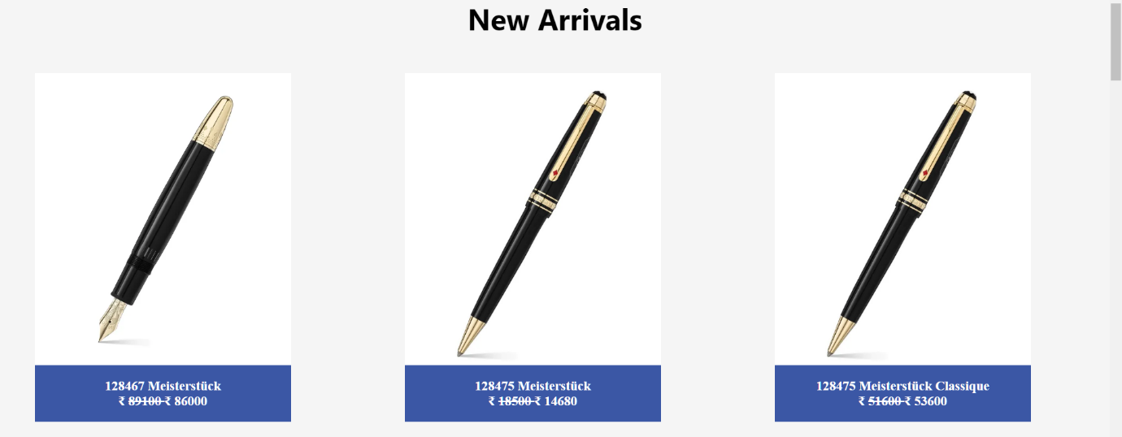

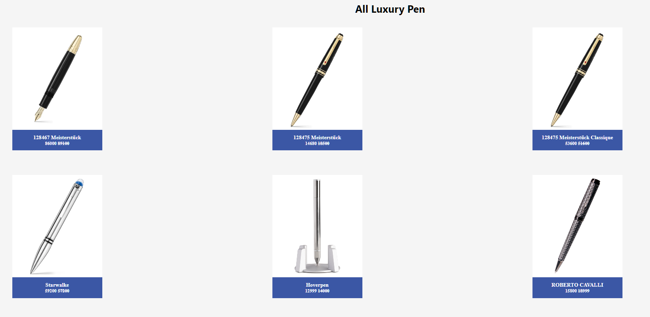

**User product.php**

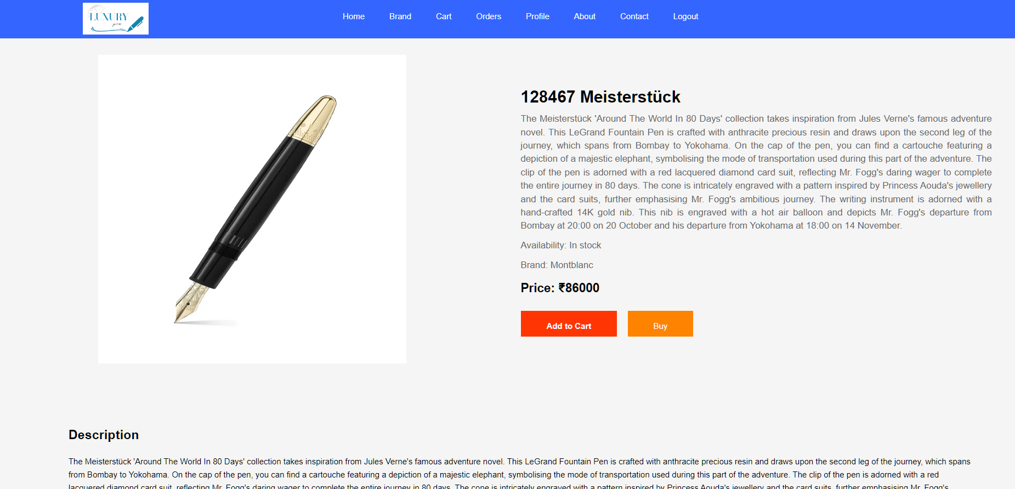

**Cart.php**

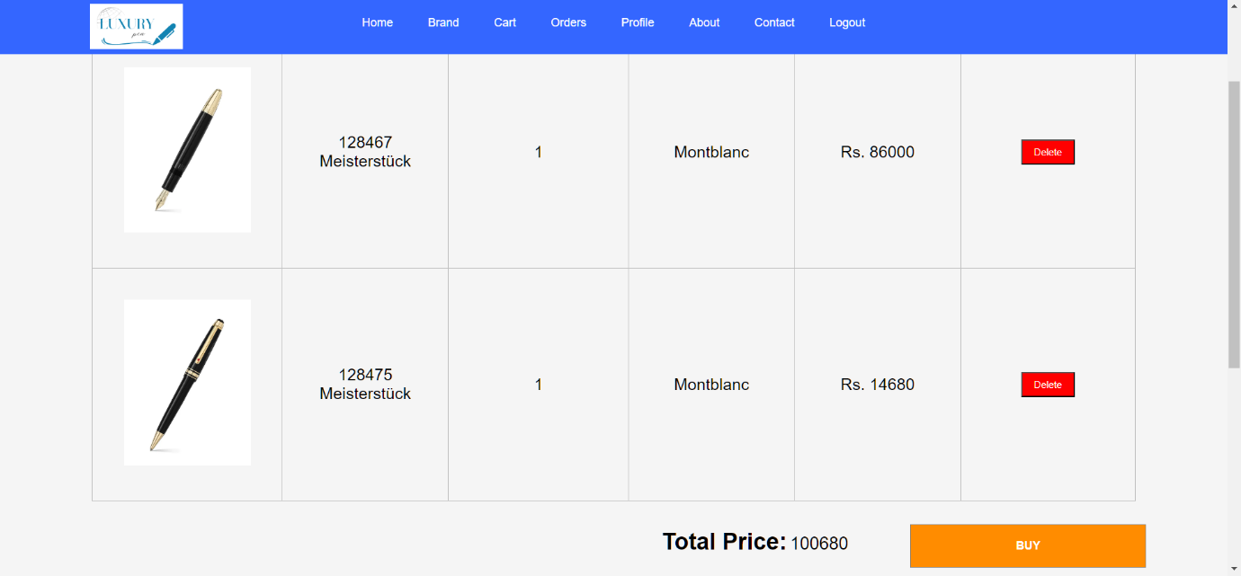

**Checkout.php**

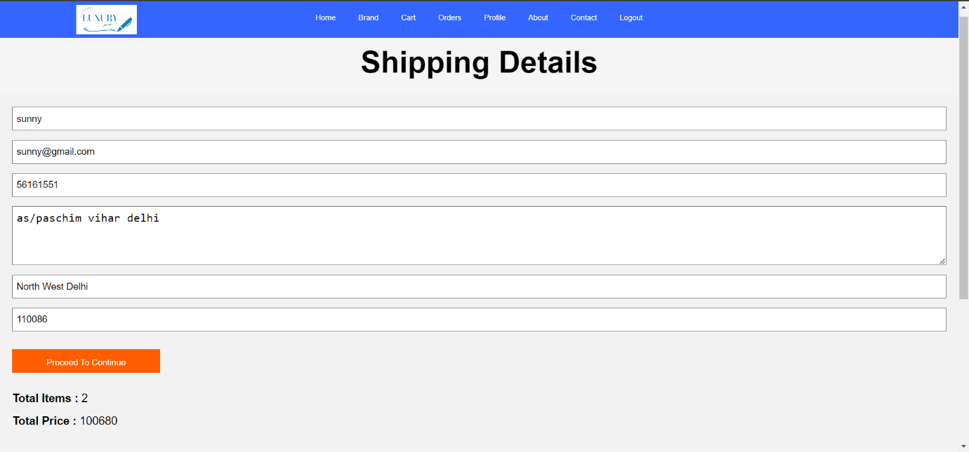

**Userbrand.php**

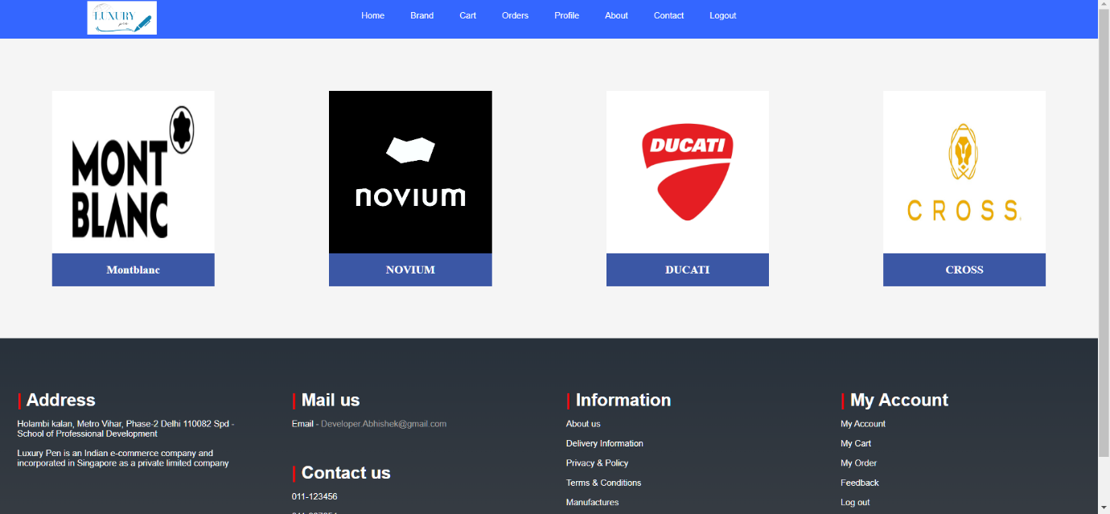

**Show products.php**

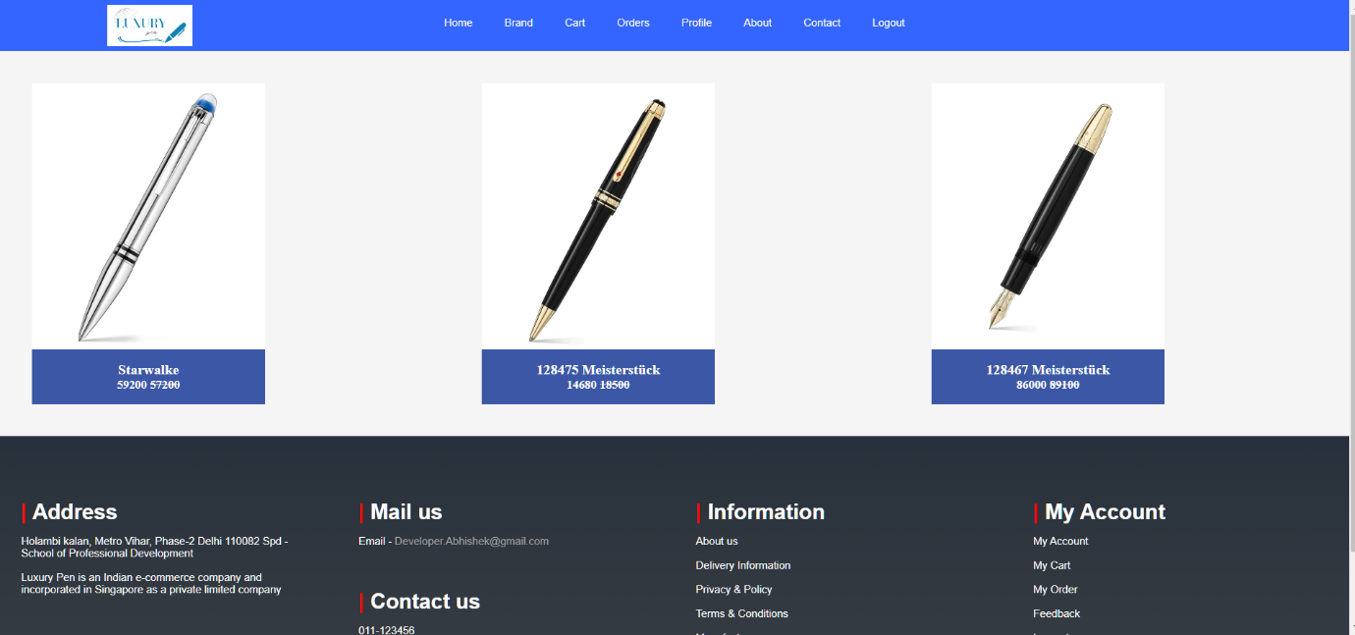

**Profile.php**

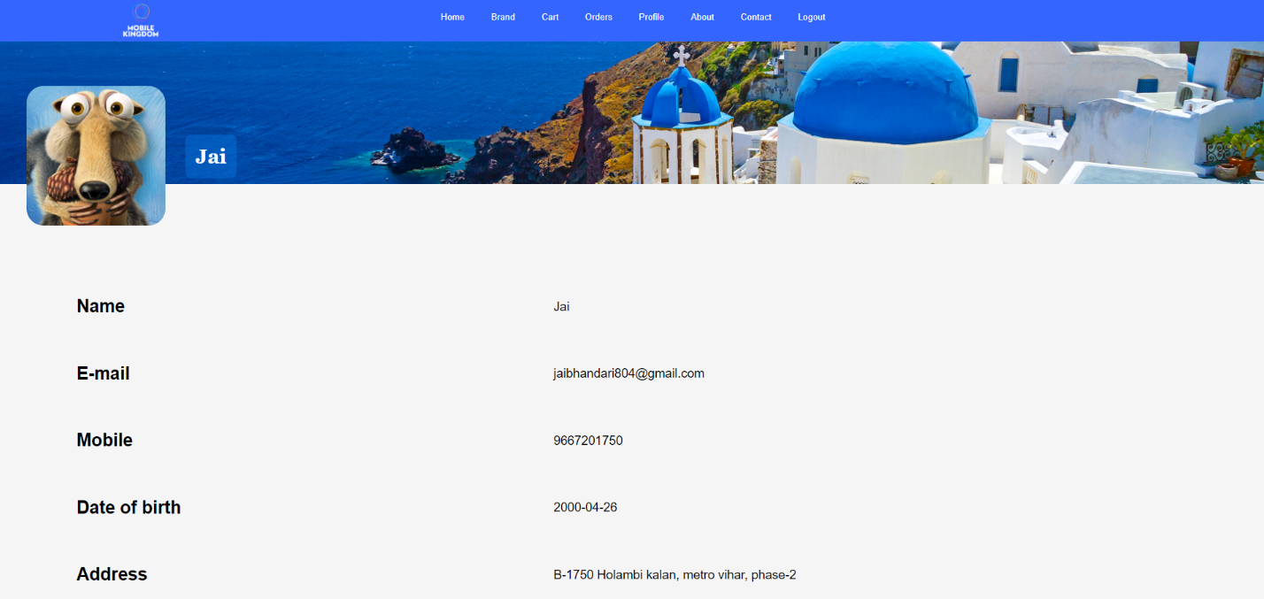

**Contact.php**

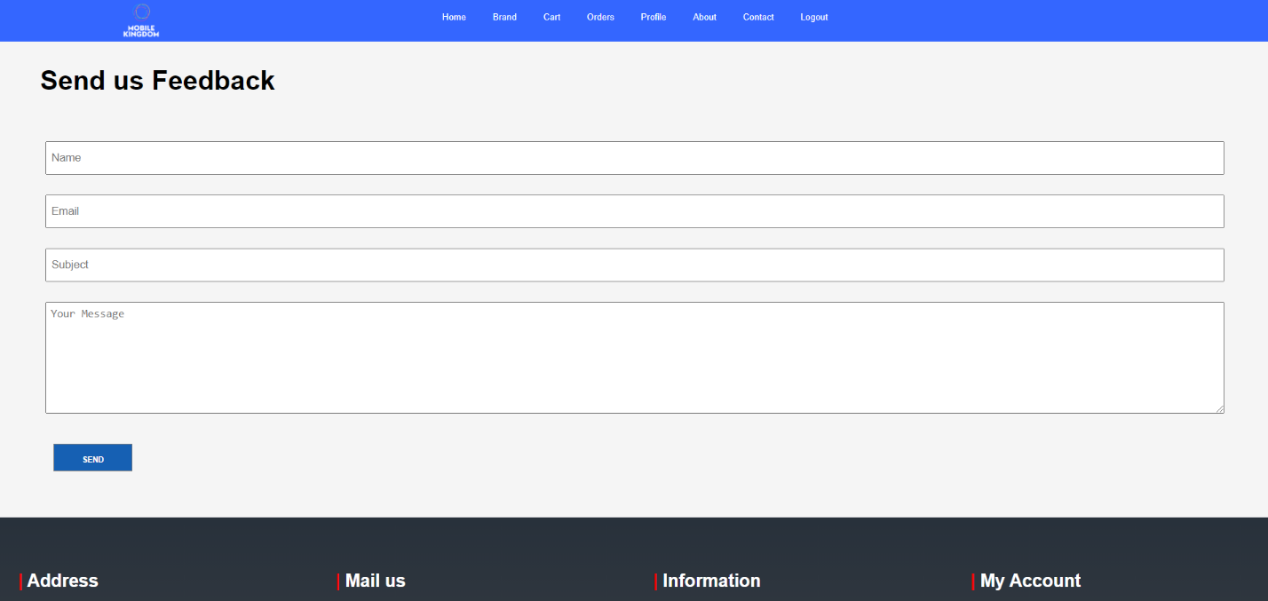

**User order.php**

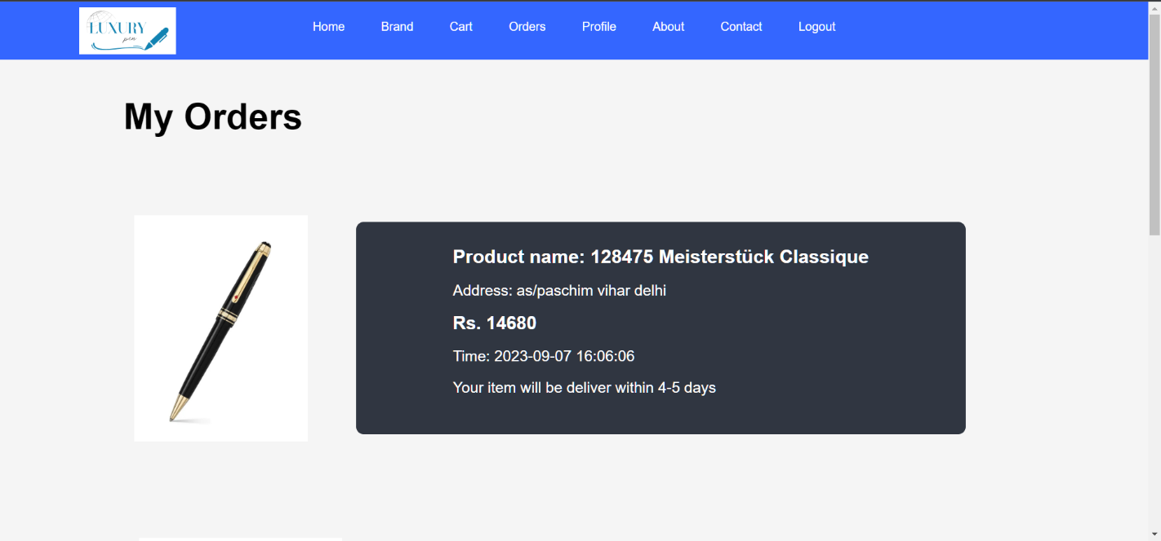

**About.html**

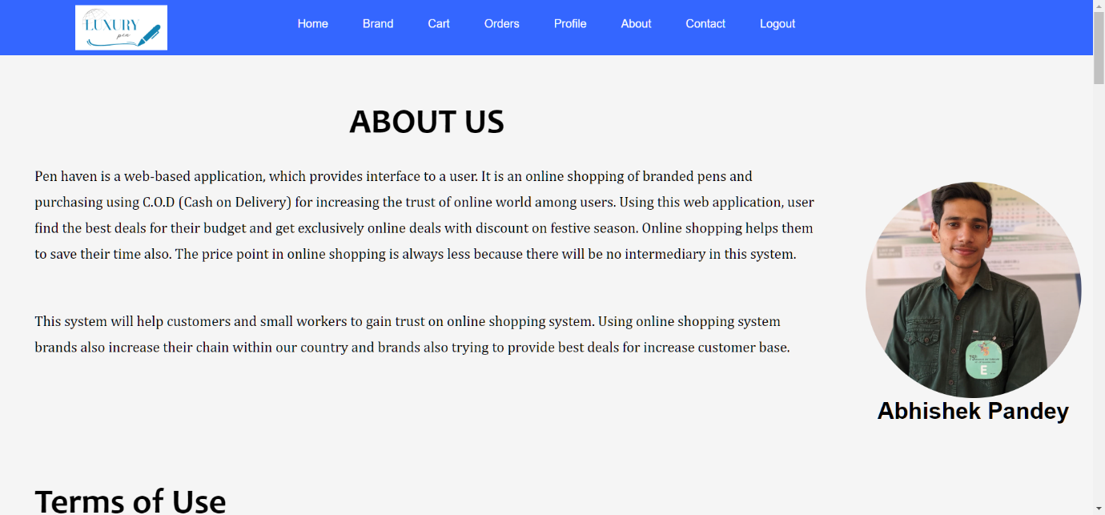

**Coding (User)**

**Register.php**

<!DOCTYPE html>

<html>

<head>

<title>Form</title>

<link rel="stylesheet" href="Main.css">

<style>

.container{

border-radius: 5px;

position: static;

padding: 0vh 30vh;

}

form p{

padding: 10px;

font-size: 18px;

}

select,textarea,input[type="text"],input[type="email"],input[type="password"],input[type="checkbox"],input[type="number"],input[type="date"]

{

width:100%;

padding: 8px;

}

fieldset{

background-color: white;

width: 99%;

}

input[type="submit"]{

background-color: #047bd5;

width: 100%;

padding: 9px;

font-size:18px ;

color: white;

border: 0px solid white;

text-align:center;

}

input[type="submit"]:hover{

cursor: pointer;

background-color:#1689e4;

border: 0px solid white;

}

#create_acc{

text-align:center;

color:black;

}

a{

color: blue;

}

.error-message {

color: red;

}

</style>

</head>

<body>

<?php

include("header.php");

if (isset($_GET['error'])) {

$errorText = $_GET['error'];

} else {

$errorText = ""; // No error initially

}

?>

<div class="container">

<h1 style="text-align: center; font-family:sans-serif;">Create New Account </h1>

<!-- Display the error message here -->

<?php if (!empty($errorText)): ?>

<div class="error-message">

<?php echo $errorText; ?>

</div>

<?php endif; ?>

<form action="database.php" method="post">

<p>Enter username <input type="text" name="uname" required></p>

<p>Enter Password <input type="password" name="upass"></p>

<p>Confirm Password <input type="password" name="ucpass"></p>

<p>Email <input type="email" name="email" placeholder="abc@email.com" required></p>

<p>Phone no<input type="number" name="phone_no" placeholder="9876543210" required></p>

<fieldset>

Gender

<p>

Male:<input type="radio" name="gender" value="male" required>

Female:<input type="radio" name="gender" value="female" required>

</p>

</fieldset>

<p>City <input type="text" name="city" placeholder="Delhi" required></p>

<p>Address<textarea rows="2" cols="10" name="address"></textarea></p>

<p>Pincode <input type="number" name="pincode" placeholder="123456"></p>

<p>Date of birth <input type="date" name="d_o_b" min="1995-01-01" max="2022-01-01" required></p>

<br>

<input type="submit" value="Register" name="register">

<p id="create_acc"> Account already created ? <a href="login.php"> Login</a> </p>

</form>

</div>

</body>

</html>

**Login.php**

<html>

<head>

<title>Home page</title>

<link rel="stylesheet" href="Main.css">

<style>

* {

box-sizing: border-box;

}

body {

font-family: Verdana, Geneva, Tahoma, sans-serif;

background-color: #f2f2f2;

color: #414d53;

}

.container {

border-radius: 5px;

position: relative;

padding: 17vh 25vw 18vh 25vw;

}

form p {

padding: 10px;

font-size: 18px;

}

input[type="text"],

input[type="password"],

input[type="email"] {

width: 100%;

padding: 8px;

}

input[type="submit"] {

background-color: #32cd32;

width: 100%;

padding: 9px;

font-size: 18px;

color: white;

border: 1px solid white;

text-align: center;

}

input[type="submit"]:hover {

cursor: pointer;

background-color: #0ccf0e;

border: 1px solid white;

}

#create_acc {

text-align: center;

}

a {

color: blue;

}

.error-message {

color: red;

}

</style>

</head>

<body>

<?php

include("header.php");

if (isset($_GET['error'])) {

$errorText = $_GET['error'];

} else {

$errorText = ""; // No error initially

}

?>

<div class="container">

<h1 style="text-align: center; font-family:sans-serif;">Login form </h1>

<!-- Display the error message here -->

<?php if (!empty($errorText)): ?>

<div class="error-message">

<?php echo $errorText; ?>

</div>

<?php endif; ?>

<form action="database.php" method="post">

<p>Email <input type="email" name="email" required></p>

<p>Password <input type="password" name="upass"></p>

<br>

<p><input type="submit" name="login" value="Login"></p>

<p id="create_acc"> New account ? <a href="register.php"> Create new account</a> </p>

</form>

</body>

</html>

**Login.php**

<header class="flex-container">

<div class="flex-item" id="flex-item-1">

<img id="logo" src="./cards_images/logo1.png" alt="" width="50%">

</div>

<nav class="flex-item" id="flex-item-2">

<?php

if(isset($_SESSION["loggedin"])){ ?>

<ul>

<li><a href="index.php">Home</a></li>

<li><a href="user_brand.php">Brand</a></li>

<li><a href="cart.php">Cart</a></li>

<li><a href="user_order.php">Orders</a></li>

<li><a href="user_profile.php">Profile</a></li>

<li><a href="about.php">About</a></li>

<li><a href="contact.php">Contact</a></li>

<li><a href="logout.php">Logout</a></li>

</ul>

<?php }else{ ?>

<ul>

<li><a href="index.php">Home</a></li>

<li><a href="user_brand.php">Brand</a></li>

<li><a href="about.php">About</a></li>

<li><a href="contact.php">Contact</a></li>

<li><a href="login.php">Login</a></li>

<li><a href="register.php">Register</a></li>

</ul>

<?php } ?>

</nav>

<div class="flex-item" id="flex-item-3"></div>

</header>

**Database.php**

<?php

$dbHost="localhost";

$dbUser="root";

$dbPass="";

$database="ecom";

$conn= mysqli_connect($dbHost, $dbUser, $dbPass,$database);

if($conn)

{

if(isset($_POST['login']))

{

$email=$_POST['email'];

$password=$_POST['upass'];

#---------------Admin Check first-----------------------------------

if($_POST['email']==="admin@123")

{

$admin_sql="SELECT * FROM `admin_table` WHERE `Name` = '$email'";

$admin_result=mysqli_query($conn,$admin_sql);

$numAdmin=mysqli_num_rows($admin_result);

if($numAdmin==1)

{

$row=mysqli_fetch_assoc($admin_result);

if(password_verify($password,$row['Password']))

{

session_start();

$_SESSION['admin_logged_in']=true;

$_SESSION['username']=$row['Name'];

header("Location:./Admin/Index.php?Admin_login_successfully");

exit;

}

else{

header("Location: login.php?error=Admin row not affect");

}

}

}

#---------------User checking-----------------------------------

$user_sql="SELECT * FROM `users` WHERE `email`='$email'";

$user_result=mysqli_query($conn,$user_sql);

$numUser= mysqli_num_rows($user_result);

if($numUser>0)

{

$row=mysqli_fetch_assoc($user_result);

if(password_verify($password,$row['password']))

{

session_start();

$_SESSION['loggedin']=true;

$_SESSION['username']=$row['username'];

$_SESSION['email']=$email;

$_SESSION['u_id']=$row['u_id'];

header("Location: index.php?Login_successfully");

exit;

}

else{

echo "";

header("Location: login.php?error=Password did not match");

}

}

else{

header("Location: login.php?error=There is no user with this name");

}

}

#...................Account creation...........................

if(isset($_POST['register']))

{

$username= $_POST['uname'];

$password= $_POST['upass'];

$cpassword= $_POST['ucpass'];

$email= $_POST['email'];

$address= $_POST['address'];

$city= $_POST['city'];

$pincode= $_POST['pincode'];

$phone_no= $_POST['phone_no'];

$d_o_b= $_POST['d_o_b'];

$gender= $_POST['gender'];

$sql="SELECT * FROM `users` WHERE `email` = '$email'";

$result=mysqli_query($conn,$sql);

$numExistUser=mysqli_num_rows($result);

if($numExistUser>0)

{

header("Location: register.php?error=Email_already_exist");

exit;

}

else

{

if($password==$cpassword)

{

$hash= password_hash($password,PASSWORD_DEFAULT);

//Insert new user into users table

$sql="INSERT INTO `users` (`username`, `password`, `email`, `address`, `city`, `pincode`, `phone_no`, `d_o_b`, `gender`) VALUES ( '$username', '$hash', '$email', '$address', '$city', '$pincode', '$phone_no', '$d_o_b', '$gender')";

$result=mysqli_query($conn,$sql);

//If result is true

if($result)

{

$user_sql="SELECT * FROM `users` WHERE `email`='$email'";

$user_result=mysqli_query($conn,$user_sql);

$numUser= mysqli_num_rows($user_result);

if($numUser>0)

{

$row=mysqli_fetch_assoc($user_result);

$u_id=$row['u_id'];

$cart_create_sql="CREATE TABLE `cart$u_id` ( `cart_id` INT(40) NOT NULL AUTO_INCREMENT , `p_id` INT(10) NOT NULL , `p_name` VARCHAR(255) NOT NULL , `brand_id` INT(10) NOT NULL , `price` INT(10) NOT NULL , `image` VARCHAR(255) NOT NULL , PRIMARY KEY (`cart_id`))";

$cart_result=mysqli_query($conn,$cart_create_sql);

if($cart_result)

{

$order_table_sql="CREATE TABLE `order_table$u_id` ( `order_id` INT(40) NOT NULL AUTO_INCREMENT , `brand_id` INT(20) NOT NULL , `p_name` VARCHAR(30) NOT NULL , `image` VARCHAR(50) NOT NULL , `price` INT(12) NOT NULL , `u_id` INT(30) NOT NULL , `username` VARCHAR(30) NOT NULL , `email` VARCHAR(50) NOT NULL , `phone_no` BIGINT(10) NOT NULL , `address` VARCHAR(80) NOT NULL , `time` DATETIME NOT NULL DEFAULT CURRENT_TIMESTAMP , PRIMARY KEY (`order_id`))";

$order_result=mysqli_query($conn, $order_table_sql);

if($order_result)

{

header("Location: login.php ?Account_created_Email=$email&&Password=$password");

exit;

}

else{

header("location: register.php?error=Order table query error");

}

}else{

header("location:register.php?error=Something wrong with cart creation");

exit;

}

}else{

header("location: register.php?error=Num user query error");

}

}

else{

header("Location: register.php?error=Rows not affected=$numExistUser");

}

}else

{

header("Location: register.php?error=Password did not match");

}

}

}

}else{

header("Location: register.php?Connection_not_established");

}

?>

**Connection.php**

<?php

session_start();

$dbHost="localhost";

$dbUser="root";

$dbPass="";

$database="ecom";

$conn= mysqli_connect($dbHost, $dbUser, $dbPass,$database);

#-------New arrivals waale

function get_product_limit($conn ,$limit='')

{

$sql="SELECT * FROM `product` where status=1 ";

if($limit!='')

{

$sql.="order by p_id desc limit $limit";

}

$data=array();

$result= mysqli_query($conn,$sql);

while($row=mysqli_fetch_assoc($result))

{

$data[]=$row;

}

return $data;

}

#-----Best sellers

function get_best_product($conn)

{

$sql="SELECT * FROM `product` WHERE count>3 and status=1 order by count desc";

$data=array();

$result= mysqli_query($conn,$sql);

while($row=mysqli_fetch_assoc($result))

{

$data[]=$row;

}

return $data;

}

#------All products

function get_product($conn,$type='')

{

$sql="SELECT * FROM `product` WHERE status = 1 ";

if($type=='latest')

{

$sql.='order by p_id desc';

}

$data=array();

$result= mysqli_query($conn,$sql);

while($row=mysqli_fetch_assoc($result))

{

$data[]=$row;

}

return $data;

}

#------------Find brand in Product description

function find_brand($conn,$id)

{

$sql="SELECT brand from brand where id=$id";

$result=mysqli_query($conn,$sql);

$row=mysqli_fetch_assoc($result);

return $row['brand'];

}

#--------Return data in string

function get_safe_value($conn,$str)

{

return mysqli_real_escape_string($conn,$str);

}

#------Random products

function get_rand_product($conn,$limit='')

{

$sql="SELECT * FROM `product` WHERE status = 1 order by count desc limit $limit";

$data=array();

$result= mysqli_query($conn,$sql);

while($row=mysqli_fetch_assoc($result))

{

$data[]=$row;

}

return $data;

}

function get_brand($conn,$type='')

{

$sql="SELECT * FROM `brand`";

if($type=='latest')

{

$sql.='order by id desc';

}

$sql.="where status='1'";

$data=array();

$result= mysqli_query($conn,$sql);

while($row=mysqli_fetch_assoc($result))

{

$data[]=$row;

}

return $data;

}

function get_all_products($conn,$id)

{

$sql="SELECT * FROM `product` where brand_id=$id and `status`=1";

$data=array();

$result= mysqli_query($conn,$sql);

while($row=mysqli_fetch_assoc($result))

{

$data[]=$row;

}

return $data;

}

?>

**Main.php**

<?php

require("connection.php");

?>

<html>

<head>

<title>Main website</title>

<link rel="stylesheet" href="Main.css">

</head>

<body>

<!-- Header section -->

<?php

require("header.php");

?>

<main>

<div id="header-pic"></div>

</main>

<div class="new-item-heading">

<h1>New Arrivals</h1>

</div>

<div id="main-new-item">

<?php

$check = get_product_limit($conn, 3);

foreach ($check as $list) {

?>

<div class=new-item-container>

<div id="new-item-image">

<a href="user_product.php?id=<?php echo $list['p_id']; ?>">

<img src="./image/<?php echo $list['image']; ?>" alt=""></a>

</div>

<div id="new-item-content">

<a style="color:white;" href="user_product.php?id=<?php echo $list['p_id']; ?>">

<p>

<?php echo $list['p_name'] ?>

</p>

<p>₹ <del>

<?php echo $list['mrp'] ?>

</del> ₹

<?php echo $list['price'] ?>

</p>

</a>

</div>

</div>

<?php } ?>

</div>

<!-- If best product is exist then show Best seller div -->

<?php

$check = get_best_product($conn);

if ($check) { ?>

<div class="new-item-heading">

<h1>Best Seller</h1>

<p>But I must explain to you how all this mistaken idea</p>

</div>

<?php

}

?>

<div id="main-new-item">

<?php

$check = get_best_product($conn);

foreach ($check as $list) {

?>

<div class=new-item-container>

<div id="new-item-image">

<a href="user_product.php?id=<?php echo $list['p_id']; ?>">

<img src="./image/<?php echo $list['image']; ?>" alt=""></a>

</div>

<div id="new-item-content">

<a style="color:white;" href="user_product.php?id=<?php echo $list['p_id']; ?>">

<h3>

<?php echo $list['p_name'] ?>

</h3>

<p>

<?php echo $list['price'] ?> <del>

<?php echo $list['mrp'] ?>

</del>

</p>

</a>

</div>

</div>

<?php } ?>

</div>

<div class="new-item-heading">

<h1>All Luxury Pen</h1>

</div>

<div id="main-new-item">

<?php $check = get_product($conn, 'latest');

foreach ($check as $list) {

?>

<div class=new-item-container>

<div id="new-item-image">

<a href="user_product.php?id=<?php echo $list['p_id']; ?>">

<img src="./image/<?php echo $list['image']; ?>" alt=""></a>

</div>

<div id="new-item-content">

<a style="color:white;" href="user_product.php?id=<?php echo $list['p_id']; ?>">

<h3>

<?php echo $list['p_name'] ?>

</h3>

<p>

<?php echo $list['price'] ?> <del>

<?php echo $list['mrp'] ?>

</del>

</p>

</a>

</div>

</div>

<?php } ?>

</div>

<!-- Footer section -->

<?php

require("footer.php");

?>

</body>

</html>

**User product.php**

<?php

require("connection.php");

$id = $_GET['id'];

$sql = "select * from product where p_id=$id";

$result = mysqli_query($conn, $sql);

$num = mysqli_num_rows($result);

?>

<html>

<head>

<title>Main website</title>

<link rel="stylesheet" href="Main.css">

</head>

<body>

<!-- Header section -->

<?php

require("header.php");

?>

<main>

<div class="supreme-product">

<div class="product-container">

<?php

if ($num) {

while ($row = mysqli_fetch_assoc($result)) {

?>

<div class="product-image">

<img src="./image/<?php echo $row['image']; ?>" alt="">

</div>

<div class="product-desc">

<h1>

<?php echo $row['p_name'] ?>

</h1>

<p>

<?php echo $row['long_desc']; ?>

</p>

<p>Availability:

<?php

$status = $row['status'];

if ($status == '1') {

echo "In stock";

} else {

echo "Out of stock";

}

?>

</p>

<p>Brand:

<?php echo find_brand($conn, $row['brand_id']); ?>

</p><br>

<h2>Price: ₹

<?php echo $row['price']; ?>

</h2><br>

<p>

<?php

if (isset($_SESSION["loggedin"])) { ?>

<a href="cart_query.php?task=add&id=<?php echo $row['p_id']; ?>">

<input type="submit" name="" value="Add to Cart">

</a>

<a href="checkout.php?buy_item=1&id=<?php echo $row['p_id']; ?>">

<input type="submit" name="" value="Buy">

</a>

<?php }else{ ?>

<a href="login.php">

<input type="submit" name="" value="Login For Cart">

</a>

<?php } ?>

</p>

</div>

</div>

</div>

<div class="product-down">

<div class="product-down-inside">

<h1>Description</h1><br>

<p>

<?php echo $row['short_desc']; ?>

</p>

<h1>Specifications</h1><br>

<p>

<?php echo $row['specification']; ?>

</p>

<h1>Delivery</h1><br>

<p>We only provide cash on delivery on every items. Our main motive is to earn customer trust first .Our

project is on first phase so we could include other payment options. </p>

</div>

<?php

}

} else {

header("Location: index.php?");

}

?>

</div>

<div class="new-item-heading">

<h1>New Arrivals</h1>

</div>

<div id="main-new-item">

<?php $check = get_rand_product($conn, 3);

foreach ($check as $list) {

?>

<div class=new-item-container>

<div id="new-item-image">

<a href="user_product.php?id=<?php echo $list['p_id']; ?>">

<img src="./image/<?php echo $list['image']; ?>" alt=""></a>

</div>

<div id="new-item-content">

<a href="user_product.php?id=<?php echo $list['p_id']; ?>">

<h3>

<?php echo $list['p_name'] ?>

</h3>

<p>

<?php echo $list['price'] ?> <del>

<?php echo $list['mrp'] ?>

</del>

</p>

</a>

</div>

</div>

<?php } ?>

</div>

</main>

<!-- Footer section -->

<?php

require("footer.php");

?>

</body>

</html>

**Userbrand.php**

<?php

require("connection.php");

?>

<html>

<head>

<title>Main website</title>

<link rel="stylesheet" href="Main.css">

</head>

<body>

<!-- Header section -->

<?php

require("header.php");

?>

<div id="brand-item">

<?php

$check=get_brand($conn);

foreach($check as $list)

{

?>

<div class=brand-item-container>

<div id="brand-item-image">

<a href="show_products.php?brandid=<?php echo $list['id']; ?>">

<img src="./brand_image/<?php echo $list['image']; ?>" alt="Brand list">

</a>

</div>

<div id="brand-item-content">

<h3><?php echo $list['brand']?> </h3>

</div>

</div>

<?php } ?>

</div>

<!-- Footer section -->

<?php

require("footer.php");

?>

</body>

</html>

**Show products.php**

<?php

require("connection.php");

$id=$_GET['brandid'];

?>

<html>

<head>

<title>Main website</title>

<link rel="stylesheet" href="Main.css">

</head>

<body>

<!-- Header -->

<?php

require("header.php");

?>

<div id="main-new-item">

<?php $check=get_all_products($conn,$id);

foreach($check as $list)

{

?>

<div class=new-item-container>

<div id="new-item-image">

<a href="user_product.php?id=<?php echo $list['p_id']; ?>">

<img src="./image/<?php echo $list['image']; ?>" alt=""></a>

</div>

<div id="new-item-content">

<a style="color:white;" href="user_product.php?id=<?php echo $list['p_id']; ?>">

<h3><?php echo $list['p_name']?></h3>

<p><?php echo $list['price']?> <del><?php echo $list['mrp']?></del></p> </a>

</div>

</div>

<?php } ?>

</div>

<!-- Footer -->

<?php

require("footer.php");

?>

</body>

</html>

**Cart.php**

<?php

require("connection.php");

$u_id=$_SESSION['u_id'];

$sql="select * from cart$u_id";

$result=mysqli_query($conn,$sql);

$num=mysqli_num_rows($result);

$total=0;

$count=0;

?>

<!DOCTYPE html>

<html lang="en">

<head>

<meta charset="UTF-8">

<meta http-equiv="X-UA-Compatible" content="IE=edge">

<meta name="viewport" content="width=device-width, initial-scale=1.0">

<title>Document</title>

<link rel="stylesheet" href="Main.css">

</head>

<body>

<!-- Header section -->

<?php

require("header.php");

?>

<main>

<div id="cart-div">

<table id="cart-table">

<thead id="cart-head">

<tr>

<th class="cart-pic">Products</th>

<th class="cart-name">Name </th>

<th class="cart-quantity">Quantity</th>

<th class="cart-subtotal">Brand</th>

<th class="cart-price">Total</th>

<th class="cart-remove">Remove</th>

</tr>

</thead>

<tbody id="cart-body">

<?php

while($row=mysqli_fetch_assoc($result)){

?>

<tr>

<?php

$count=$count+1;

?>

<td><img src="./image/<?php echo $row['image'];?>" alt=""></td>

<td><?php echo $row['p_name'] ?></td>

<td>1</td>

<td><?php echo find_brand($conn,$row['brand_id']); ?></td>

<td>

Rs. <?php

echo $row['price'];

$total=$total+$row['price'];

?>

</td>

<td>

<button style="background-color:red; padding:.5rem 1rem;">

<a href="cart_query.php?task=delete&cart_id=<?php echo $row['cart_id'];?>">Delete</a>

</button>

</td>

</tr>

<?php }

if($total==0)

{ ?>

<tr>

<td colspan=6><h1>Nothing to show</h1></td>

</tr>

<?php }?>

</tbody>

</table>

<div class="cart-button">

<span style="padding:0em 4em; ">

<h1 style="display:inline-block;">Total Price: </h1>

<h2 style="display:inline-block; font-weight:100;"><?php echo $total;?></h2>

</span>

<?php

if($total!=0)

{?>

<a href="checkout.php?cart=1&total=<?php echo $total;?>&count=<?php echo $count;?>">

<input type="submit" value="Buy">

</a>

<?php

}else{

?>

<a href="index.php">

<input type="submit" value="Buy">

</a>

<?php } ?>

</div>

</div>

</main>

<!-- Footer section -->

<?php

require("footer.php");

?>

</body>

</html>

**Cart query.php**

<?php

require("connection.php");

if(isset($_GET['task']) && $_GET['task']!='')

{

$task= get_safe_value($conn,$_GET['task']);

#product ki id

$id=get_safe_value($conn,$_GET['id']);

$u_id=$_SESSION['u_id'];

# For adding items in cart

if($task=="add")

{

$sql="select * from product where p_id=$id";

$result=mysqli_query($conn,$sql);

$num=mysqli_num_rows($result);

if($num)

{

$row=mysqli_fetch_assoc($result);

$p_name=$row['p_name'];

$brand_id=$row['brand_id'];

$price=$row['price'];

$image=$row['image'];

$new_sql="SELECT * from `cart$u_id` where `p_name`='$p_name'";

$new_result=mysqli_query($conn,$new_sql);

$new_num=mysqli_num_rows($new_result);

if($new_num>0)

{

header("Location: index.php?Already_in_cart");

exit;

}

else{

$cart_sql="INSERT INTO `cart$u_id` (`p_id`, `p_name`, `brand_id`, `price`, `image`) VALUES ('$id', '$p_name', '$brand_id', '$price', '$image')";

$cart_result=mysqli_query($conn,$cart_sql);

if($cart_result)

{

header("Location: cart.php?status_update");

exit;

}

}

}

}

# For delete cart

if($task=="delete")

{

$cart_id=get_safe_value($conn,$_GET['cart_id']);

$cart_delete="DELETE FROM `cart$u_id` WHERE `cart_id` = $cart_id";

$delete_result=mysqli_query($conn,$cart_delete);

if($delete_result)

{

header("Location: cart.php?Cart_deleted");

exit;

}

else{

header("Location: index.php?Delete_cart_query_error");

exit;

}

}

}

?>

**Checkout.php**

<?php

require("connection.php");

$count=1;

$total='';

#-------------directly buy

if(isset($_GET['buy_item']))

{

$p_id=$_GET['id'];

$sql="select * from product where p_id=$p_id";

$result=mysqli_query($conn,$sql);

$num=mysqli_num_rows($result);

$_SESSION['p_id']=get_safe_value($conn,$_GET['id']);

if($num)

{

$row=mysqli_fetch_assoc($result);

$total=$row['price'];

}else{

header("location: index.php?checkout_query_not_working");

exit;

}

}

#-----------------cart se aane waali query ka checkout

if(isset($_GET['cart']))

{

$total=$_GET['total'];

$count=$_GET['count'];

}

$username=$_SESSION['username'];

$u_id=$_SESSION['u_id'];

#-----------users ki details nikalna form me daalne ke liye

$sql="SELECT * FROM users where u_id=$u_id";

$show_result=mysqli_query($conn,$sql);

$row=mysqli_fetch_assoc($show_result);

$address=$row['address'];

$email=$row['email'];

$phone_no=$row['phone_no'];

$city=$row['city'];

$pincode=$row['pincode'];

?>

<html>

<head>

<title>Main website</title>

<link rel="stylesheet" href="Main.css">

</head>

<style>

.checkout-container{

background-color: #f2f2f2;

border: 0px solid black;

padding: 1em;

margin-top:0em;

margin-bottom:4em;

}

.checkout-container form p{

padding: 10px;

font-size: 18px;

}

.checkout-container form h2{

padding: 10px;

}

.checkout-container input[type="text"],input[type="email"],input[type="number"]

{

width:100%;

padding: 8px;

font-size: 20px;

height: 50px;

}

.checkout-container textarea

{

width:100%;

padding: 8px;

font-size: 25px;

}

.checkout-container input[type="submit"]{

background-color: #05c984;

color: white;

border: 0px solid grey;

margin-left: 0;

background: #ff5e00 none repeat scroll 0 0;

font-family: 'Poppins', sans-serif;

font-size: 18px;

font-weight: 400;

text-transform: capitalize;

transition: all 0.3s ease 0s;

padding: 1em 4em;

}

.checkout-container input[type="submit"]:hover{

cursor: pointer;

background-color:rgb(23, 142, 193);

border: 0px solid grey;

}

.checkout-container textarea{

min-height: 5em;

}

</style>

<body>

<?php

require("header.php");

?>

<div style="text-align: center; padding: 1em; font-size: 2em;">

<h1>Shipping Details</h1>

</div>

<div class="checkout-container">

<?php if(isset($_GET['buy_item'])){ ?>

<form method="post" action="user_order.php?buy_item=1">

<?php }else {?>

<form method="post" action="user_order.php">

<?php } ?>

<p><input type="text" name="name" placeholder="Name" value="<?php echo $username ?>" required></p>

<p><input type="email" name="email" placeholder="Email" value="<?php echo $email ?>" required></p>

<p><input type="number" name="phone_no" placeholder="Phone no" value="<?php echo $phone_no ?>" required></p>

<p>

<textarea name="address" placeholder="Address" ><?php echo $address ?></textarea>

</p>

<p><input type="text" name="city" placeholder="City" value="<?php echo $city ?>"></p>

<p><input type="number" name="pincode" placeholder="Pincode" value="<?php echo $pincode ?>"></p><br>

<p>

<?php if(isset($_GET['buy_item'])){ ?>

<input type="submit" name="submit_me" value="Proceed to Continue">

<?php }else {?>

<input type="submit" name="submit" value="Proceed to Continue">

<?php } ?>

</p>

<p>

<h2>Total Items :

<span style="font-weight:200;"><?php echo $count; ?></span>

</h2>

<h2>Total Price : <span style="font-weight:200;"><?php echo $total; ?></span></h2>

</p>

</form>

</div>

<?php

require("footer.php");

?>

</body>

</html>

**User order.php**

<?php

require("connection.php");

$u_id=$_SESSION['u_id'];

#-----Checkout for Cart ----#

if(isset($_POST['submit'])&& $_POST['submit']!='')

{

$sql="SELECT * from `cart$u_id`";

$result=mysqli_query($conn,$sql);

$email=get_safe_value($conn,$_POST['email']);

$phone_no=get_safe_value($conn,$_POST['phone_no']);

$address=get_safe_value($conn,$_POST['address']);

while($row=mysqli_fetch_assoc($result))

{

$brand_id=$row['brand_id'];

$p_name=$row['p_name'];

$image=$row['image'];

$price=$row['price'];

$cart_id=$row['cart_id'];

$p_id=$row['p_id'];

$username=$_SESSION['username'];

$product_sql="SELECT * FROM `product` WHERE p_id=$p_id";

$product_result=mysqli_query($conn,$product_sql);

$row=mysqli_fetch_assoc($product_result);

if($product_result)

{

#increase count of product

$popular=0;

$popular=$row['count'];

$popular=$popular+1;

$popular_sql="UPDATE `product` SET `count` = '$popular' WHERE `product`.`p_id` = $p_id";

$popular_result=mysqli_query($conn,$popular_sql);

if($popular_result)

{

#insert data from cart to order table

$order_sql="INSERT INTO `order_table$u_id` ( `brand_id`, `p_name`, `image`, `price`,`u_id`, `username`, `email`, `phone_no`,`address`) VALUES ( '$brand_id', '$p_name', '$image', '$price','$u_id', '$username', '$email', '$phone_no', '$address')";

$result_order=mysqli_query($conn,$order_sql);

#delete cart items

$delete_cart="DELETE FROM `cart$u_id` WHERE `cart$u_id`.`cart_id`=$cart_id";

$result_delete= mysqli_query($conn,$delete_cart);

}

else{

header("location: index.php?Product_count_error");

}

}else{

header("location: index.php?Product_query_error");

}

}

}

#------------------Directly buy karne ke liye order ki query

if(isset($_GET['buy_item'])&& $_GET['buy_item']!='')

{

$email=get_safe_value($conn,$_POST['email']);

$phone_no=get_safe_value($conn,$_POST['phone_no']);

$address=get_safe_value($conn,$_POST['address']);

$p_id=$_SESSION['p_id'];

$sql="select * from product where p_id=$p_id";

$result=mysqli_query($conn,$sql);

$num=mysqli_num_rows($result);

if($row=mysqli_fetch_assoc($result))

{

$brand_id=$row['brand_id'];

$p_name=$row['p_name'];

$image=$row['image'];

$price=$row['price'];

$popular=$row['count'];

$username=$_SESSION['username'];

$u_id=$_SESSION['u_id'];

#increase count of product

$popular=$popular+1;

$popular_sql="UPDATE `product` SET `count` = '$popular' WHERE `product`.`p_id` = $p_id";

$popular_result=mysqli_query($conn,$popular_sql);

if($popular_result)

{

$order_sql="INSERT INTO `order_table$u_id` ( `brand_id`, `p_name`, `image`, `price`,`u_id`, `username`, `email`, `phone_no`,`address`) VALUES ( '$brand_id', '$p_name', '$image', '$price','$u_id', '$username', '$email', '$phone_no', '$address')";

$result_order=mysqli_query($conn,$order_sql);

}else{

header("location: index.php?Buy_popular_query_result_error");

}

unset($_SESSION['p_id']);

}

else{

header("location: index.php?Do_not_try_to_be_oversmart");

}

}

$show_sql="select * from order_table$u_id order by order_id desc";

$show_result=mysqli_query($conn,$show_sql);

?>

<html>

<head>

<title>Main website</title>

<link rel="stylesheet" href="Main.css">

</head>

<body>

<!-- Header section -->

<?php

require("header.php");

?>

<main>

<div style="margin-top: 3em; margin-bottom: 3em;">

<h1 style=" margin-left:3.4em; font-size: 3em; ">My Orders</h1>

</div>

<div id="order-outer">

<?php

while($row=mysqli_fetch_assoc($show_result))

{?>

<div class="order-container">

<div class="one">

<img src="./image/<?php echo $row['image']?>" alt="">

</div>

<div class="two">

<h1>Product name: <?php echo $row['p_name']?> </h1><br>

<p>Address: <?php echo $row['address']?></p><br>

<h2>Rs. <?php echo $row['price']?></h2><br>

<p>Time: <?php echo $row['time']?></p><br>

<p>Your item will be deliver within 4-5 days</p><br>

</div>

</div>

<br>

<?php } ?>

</div>

<div style="height:10em;">

</div>

</main>

<!-- Footer section -->

<?php

require("footer.php");

?>

</body>

</html>

**Profile.php**

<?php

require("connection.php");

$email=$_SESSION['email'];

$sql="SELECT * FROM `users`where email='$email'";

$show_result=mysqli_query($conn,$sql);

?>

<!DOCTYPE html>

<html lang="en">

<head>

<meta charset="UTF-8">

<meta http-equiv="X-UA-Compatible" content="IE=edge">

<meta name="viewport" content="width=device-width, initial-scale=1.0">

<title>Document</title>

<link rel="stylesheet" href="Main.css">

</head>

<body>

<!-- Header section -->

<?php

require("header.php");

?>

<main>

<?php

$i=1;

while($row=mysqli_fetch_assoc($show_result))

{?>

<div id="top-pic-profile">

<div class="profile">

<div class="profile-pic">

<img src="./cards_images/profile.jpg" alt="">

</div>

<div class="profile-name">

<h1><?php echo $row['username'] ?></h1>

</div>

</div>

</div>

<div class="profile-container" >

<div class="profile-content">

<div class="line">

<h1>Name</h1>

<p id="line1"><?php echo $row['username'] ?> </p>

<p id="line2"></p>

</div>

<div class="line">

<h1>E-mail</h1>

<p id="line1"> <?php echo $row['email'] ?> </p>

<p id="line2"></p>

</div>

<div class="line">

<h1>Mobile</h1>

<p id="line1"> <?php echo $row['phone_no'] ?></p>

<p id="line2"></p>

</div>

<div class="line">

<h1>Date of birth</h1>

<p id="line1"><?php echo $row['d_o_b'] ?> </p>

<p id="line2"></p>

</div>

<div class="line">

<h1>Address</h1>

<p id="line1"> <?php echo $row['address'] ?> </p>

<p id="line2"></p>

</div>

<div class="line">

<h1>Language</h1>

<p id="line1">English</p>

<p id="line2"></p>

</div>

<div class="line">

<h1>Gender</h1>

<p id="line1"><?php echo $row['gender'] ?></p>

<p id="line2"></p>

</div>

<div class="line">

<h1>City</h1>

<p id="line1"><?php echo $row['city'] ?></p>

<p id="line2"></p>

</div>

<div class="line">

<h1>Pincode</h1>

<p id="line1"><?php echo $row['pincode'] ?></p>

<p id="line2"></p>

</div>

<?php } ?>

</div>

</div>

</main>

<!-- Footer section -->

<?php

require("footer.php");

?>

</body>

</html>

**Contact.php**

<?php

require("connection.php");

if(isset($_POST['send']))

{

$username=$_POST['name'];

$email=$_POST['email'];

$subject=$_POST['subject'];

$message=$_POST['message'];

$sql="INSERT INTO `feedback` (`email`, `subject`, `query`, `time`) VALUES ('$email', '$subject', '$message', current_timestamp())";

$result=mysqli_query($conn,$sql);

if($result)

{

$errorText = "Your feedback is succesfully sent";

}

else{

$errorText = "Error Try Again";

}

}

?>

<html>

<head>

<title>Main website</title>

<link rel="stylesheet" href="Main.css">

</head>

<body>

<!-- Header section -->

<?php

require("header.php");

?>

<main>

<div id="top-pic-contact"></div>

<div style="margin-top: 3em;">

<h1 style=" margin-left: 1.5em; font-size: 3em;">Send us Feedback</h1>

</div>

<?php if (!empty($errorText)): ?>

<div class="error-message">

<?php echo $errorText; ?>

</div>

<?php endif; ?>

<div class="form-container">

<form method="post" action="#">

<p><input type="text" name="name" placeholder="Name" required></p>

<p><input type="email" name="email" placeholder="Email" required></p>

<p><input type="text" name="subject" placeholder="Subject"></p>

<p>

<textarea name="message" placeholder="Your Message" maxlength="200"></textarea>

</p><br>

<p>

<input type="submit" name="send" value="Send">

</p>

</form>

</div>

</main>

<!-- Footer section -->

<?php

require("footer.php");

?>

</body>

</html>

**About.html**

<html>

<head>

<title>Main website</title>

<link rel="stylesheet" href="Main.css">

</head>

<body>

<!-- Header section -->

<?php

require("header.php");

?>

<main>

<div class="about-container" >

<div class="about-left">

<h1> ABOUT US</h1>

<p>

Pen haven is a web-based application, which provides interface to a user.

It is an online shopping of branded pens and purchasing using C.O.D

(Cash on Delivery) for increasing the trust of online world among users.

Using this web application, user find the best deals for their budget and

get exclusively online deals with discount on festive season. Online

shopping helps them to save their time also. The price point in online

shopping is always less because there will be no intermediary in this

system.</p>

<br />

<br />

<p>

This system will help customers and small workers to gain trust on

online shopping system. Using online shopping system brands also

increase their chain within our country and brands also trying to provide

best deals for increase customer base.

</p>

</div>

<div class="about-right">

<div id="about-right-content">

<img src="./cards_images/abhi.jpeg" alt="">

<h1>Abhishek Pandey</h1>

</div>

</div>

</div>

<div class="about-down-container" >

<div class="about-down">

<h1 style="text-align: left;">Terms of Use</h1>

<p>

This document is an electronic record in terms of Information Technology Act, 2000 and rules there under as applicable and the amended provisions pertaining to electronic records in various statutes as amended by the Information Technology Act, 2000. This electronic record is generated by a computer system and does not require any physical or digital signatures.

This document is published in accordance with the provisions of Rule 3 (1) of the Information Technology (Intermediaries guidelines) Rules, 2011 that require publishing the rules and regulations, privacy policy and Terms of Use for access or usage of domain name [www.luxury-pen.com]<br><br>

Your use of the Platform and services and tools are governed by the following terms and conditions ("Terms of Use") as applicable to the Platform including the applicable policies which are incorporated herein by way of reference. If You transact on the Platform, You shall be subject to the policies that are applicable to the Platform for such transaction. By mere use of the Platform, You shall be contracting with Flipkart Internet Private Limited and these terms and conditions including the policies constitute Your binding obligations, with Luxury Pen- Ecommerce.<br><br>

For the purpose of these Terms of Use, wherever the context so requires "You" or "User" shall mean any natural or legal person who has agreed to become a buyer on the Platform by providing Registration Data while registering on the Platform as Registered User using the computer systems. Flipkart allows the User to surf the Platform or making purchases without registering on the Platform. The term "We", "Us", "Our" shall mean Luxury Pen- Ecommerce Internet Private Limited.<br><br>

When You use any of the services provided by Us through the Platform, including but not limited to, (e.g. Product Reviews, Seller Reviews), You will be subject to the rules, guidelines, policies, terms, and conditions applicable to such service, and they shall be deemed to be incorporated into this Terms of Use and shall be considered as part and parcel of this Terms of Use. We reserve the right, at Our sole discretion, to change, modify, add or remove portions of these Terms of Use, at any time without any prior written notice to You. It is Your responsibility to review these Terms of Use periodically for updates / changes. Your continued use of the Platform following the posting of changes will mean that You accept and agree to the revisions. As long as You comply with these Terms of Use, We grant You a personal, non-exclusive, non-transferable, limited privilege to enter and use the Platform.<br>

</p>

</div>

</div>

</div>

<div class="about-down-container" >

<div class="about-down">

<h1 style="text-align: left;">Shipping</h1>

<p>

What are the delivery charges?<br><br>

Delivery charge varies with each Seller.

Sellers incur relatively higher shipping costs on low value items. In such cases, charging a nominal delivery charge helps them offset logistics costs. Please check your order summary to understand the delivery charges for individual products.<br>

For Products listed as F-Assured a Rs 40 charge for delivery per item is applied if the order value is less than Rs 500. While, orders of Rs 500 or above are delivered free.<br><br>

Why does the delivery date not correspond to the delivery timeline of X-Y business days?<br><br>

It is possible that the Seller or our courier partners have a holiday between the day your placed your order and the date of delivery, which is based on the timelines shown on the product page. In this case, we add a day to the estimated date. Some courier partners and Sellers do not work on Sundays and this is factored in to the delivery dates.<br><br>

What is the estimated delivery time?<br><br>

Sellers generally procure and ship the items within the time specified on the product page. Business days exclude public holidays and Sundays.<br>

Estimated delivery time depends on the following factors:<br>

</p>

</div>

</div>

</div>

</div>

<div class="about-down-container" >

<div class="about-down">

<h1 style="text-align: left;">Privacy & Policy</h1>

<p>

We value the trust you place in us and recognize the importance of secure transactions and information privacy. This Privacy Policy describes how Flipkart Internet Private Limited and its affiliates collect, use, share or otherwise process your personal information through Luxury Pen- Ecommerce website www.Luxury Pen- Ecommerce.com, its mobile application.. <br><br>

By visiting the Platform, providing your information or availing our product/service, you expressly agree to be bound by the terms and conditions of this Privacy Policy, the Terms of Use and the applicable service/product terms and conditions. If you do not agree, please do not access or use our Platform.<br><br>

<h2>1. Collection of Your Information</h2> <br>

When you use our Platform, we collect and store your information which is provided by you from time to time. In general, you can browse the Platform without telling us who you are or revealing any personal information about yourself. Once you give us your personal information, you are not anonymous to us. Where possible, we indicate which fields are required and which fields are optional. You always have the option to not provide information by choosing not to use a particular service, product or feature on the Platform. <br><br>

We may track your buying behaviour, preferences, and other information that you choose to provide on our Platform. We use this information to do internal research on our users' demographics, interests, and behaviour to better understand, protect and serve our users. This information is compiled and analysed on an aggregated basis. This information may include the URL that you just came from (whether this URL is on our Platform or not), which URL you next go to (whether this URL is on our Platform or not), your computer browser information, and your IP address.

<br><br>

<h2>2. Use of Demographic / Profile Data / Your Information</h2><br>

We use your personal information to provide the product and services you request. To the extent we use your personal information to market to you, we will provide you the ability to opt-out of such uses. We use your personal information to assist sellers and business partners in handling and fulfilling orders; enhancing customer experience; resolve disputes; troubleshoot problems; help promote a safe service; collect money; measure consumer interest in our products and services; inform you about online and offline offers, products, services, and updates; customize and enhance your experience; detect and protect us against error, fraud and other criminal activity; enforce our terms and conditions; and as otherwise described to you at the time of collection of information.<br><br>

With your consent, we will have access to your SMS, contacts in your directory, location and device information. We may also request you to provide your PAN, GST Number, Government issued ID cards/number and Know-Your-Customer (KYC) details to: (i) check your eligibility for certain products and services including but not limited to credit and payment products; (ii) issue GST invoice for the products and services purchased for your business requirements; (iii) enhance your experience on the Platform and provide you access to the products and services being offered by us, sellers, affiliates or lending partners. You understand that your access to these products/services may be affected in the event consent is not provided to us.<br><br>

<h2>3. Cookies</h2><br>

We use data collection devices such as "cookies" on certain pages of the Platform to help analyse our web page flow, measure promotional effectiveness, and promote trust and safety. "Cookies" are small files placed on your hard drive that assist us in providing our services. Cookies do not contain any of your personal information. We offer certain features that are only available through the use of a "cookie". We also use cookies to allow you to enter your password less frequently during a session. Cookies can also help us provide information that is targeted to your interests. Most cookies are "session cookies," meaning that they are automatically deleted from your hard drive at the end of a session.<br><br>

You are always free to decline/delete our cookies if your browser permits, although in that case you may not be able to use certain features on the Platform and you may be required to re-enter your password more frequently during a session. Additionally, you may encounter "cookies" or other similar devices on certain pages of the Platform that are placed by third parties. We do not control the use of cookies by third parties. We use cookies from third-party partners such as Google Analytics for marketing and analytical purposes. Google Analytics help us understand how our customers use the site.

<br><br>

<h2>4. Sharing of personal information</h2><br>

We may share personal information with our other corporate entities and affiliates for purposes of providing products and services offered by them, such as, the deferred payment options Flipkart PayLater offered by Flipkart Advanz Private Limited through its lending partners. These entities and affiliates may share such information with their affiliates, business partners and other third parties for the purpose of providing you their products and services, and may market to you as a result of such sharing unless you explicitly opt-out.<br><br>

We may disclose your personal information to third parties, such as sellers, business partners. This disclosure may be required for us to provide you access to our products and services; for fulfilment of your orders; for enhancing your experience; for providing feedback on products; to collect payments from you; to comply with our legal obligations; to conduct market research or surveys; to enforce our Terms of Use; to facilitate our marketing and advertising activities; to analyse data; for customer service assistance; to prevent, detect, mitigate, and investigate fraudulent or illegal activities related to our product and services. We do not disclose your personal information to third parties for their marketing and advertising purposes without your explicit consent.<br><br>

<h2> 5. Security Precautions</h2><br>

We maintain reasonable physical, electronic and procedural safeguards to protect your information. Whenever you access your account information, we offer the use of a secure server. Once your information is in our possession we adhere to our security guidelines to protect it against unauthorized access. However, by using the Platform, the users accept the inherent security implications of data transmission over the internet and the World Wide Web which cannot always be guaranteed as completely secure, and therefore, there would always remain certain inherent risks regarding use of the Platform. Users are responsible for ensuring the protection of login and password records for their account.<br><br>

<h2>6. Changes to this Privacy Policy</h2><br>

Please check our Privacy Policy periodically for changes. We may update this Privacy Policy to reflect changes to our information practices. We will alert you to significant changes by posting the date our policy got last updated, placing a notice on our Platform, or by sending you an email when we are required to do so by applicable law.

</div>

</div>

</div>

</main>

<!-- Footer section -->

<?php

require("footer.php");

?>

</body>

</html>

**Logout.php**

<?php

session_start();

session_unset();

session_destroy();

header("Location: login.php?Successfully_Logout");

?>

**Mains tyle.css**

*{

margin: 0%;

padding: 0%;

list-style: none;

text-decoration: none;

box-sizing: border-box;

}

body{

font-family: "Helvetica Neue",Helvetica,Arial,sans-serif;

background-color:whitesmoke;

}

/*-----------Navigation Bar -------------------*/

.flex-container{

background-color: rgb(52, 102, 255);

width: 100%;

height: 4.8em;

display:flex;

flex-wrap: nowrap;

position: sticky;

top: 0%;

}

#flex-item-1{

flex: 2;

display: flex;

justify-content: center;

align-items: center;

}

.flex-item #logo{

display: block;

width: 8em;

}

#flex-item-2{

flex: 5;

}

#flex-item-2 ul{

display: flex;

height: 100%;

justify-content: center;

}

#flex-item-2 ul li{

display: flex;

}

#flex-item-2 ul li a{

padding:1.5em;

align-items: center;

vertical-align: middle;

color: white;

}

#flex-item-3{

flex: 2;

display: flex;

justify-content: center;

align-items: center;

}

/*--------Header ---------------*/

#header-pic{

width: 100%;

height: 35rem;

background: url('./cards_images/banner.jpg');

background-size:cover;

background-position: center;

background-repeat: no-repeat;

}

/*---------New Arrivals ----------------*/

#main-new-item{

display: flex;

flex-wrap: wrap;

justify-content: space-between;

}

.new-item-container{

flex-basis: calc(33.33% - 6em);

margin: 3em;

display: flex;

flex-direction: column;

}

#new-item-image{

height: 400px;

width: 350px;

}

#new-item-image img{

width: 100%;

height: 100%;

object-fit: cover; /* This ensures the image fills the container without distortion */

}

#new-item-content{

width: 350px;

background-color: #3b57a5;

text-align: center;

color: white;

font-family: Old Standard TT;

font-size: 18px;

font-weight: 600;

padding: 1em;

}

del{

text-decoration: line-through;

}

.new-item-heading h1{

font-family: system-ui, -apple-system, BlinkMacSystemFont, 'Segoe UI', Roboto, Oxygen, Ubuntu, Cantarell, 'Open Sans', 'Helvetica Neue', sans-serif;

font-size: 40px;

font-weight: 700;

text-align: center;

}

.new-item-heading p{

font-family: 'Old Standard TT', serif;

color: #666666;

font-weight: 400;

text-align: center;

margin-bottom: 1em;

font-size: 18px;

}

/*-------------Footer Design ----------------------------------*/

.footer{

background: linear-gradient(#28313B ,#3a3f45);

color: white;

display: flex;

flex-direction: row;

flex-wrap: nowrap;

width: 100%;

height: 420px;

align-items: stretch;

}

#footer-1{

flex: 2;

display: flex;

flex-direction: column;

padding: 2em;

}

#footer-1 h1{

padding-bottom: 0.5em;

padding-top: 2em;

}

#footer-1 p{

font-size: 16px;

font-weight: 400;

}

#footer-2{

flex: 2;

display: flex;

flex-direction: column;

padding: 2em;

}

#footer-2 h1{

padding-bottom: 0.5em;

padding-top: 2em;

}

#footer-2 p{

font-size: 16px;

font-weight: 400;

}

#footer-3{

flex: 2;

display: flex;

flex-direction: column;

padding: 2em;

}

#footer-3 h1{

padding-bottom: 0.5em;

padding-top: 2em;

}

#footer-3 p a{

font-size: 16px;

font-weight: 400;

color: white;

}

#footer-4{

flex: 2;

display: flex;

flex-direction: column;

padding: 2em;

}

#footer-4 h1{

padding-bottom: 0.5em;

padding-top: 2em;

}

#footer-4 p a{

font-size: 16px;

font-weight: 400;

color: white;

}

/*-------- About section ----------------*/

.about-container{

width: 100%;

display: flex;

}

.about-left{

flex: 2;

padding: 3em;

line-height: 1.8;

}

.about-left h1{

padding-bottom: 15px;

font-size: 3em;

font-family: Candara;

text-align: center;

}

.about-left p{

font-size: 20px;

font-family:Cambria, Cochin, Georgia, Times, 'Times New Roman', serif;

}

.about-right{

flex: 0.6;

display: flex;

justify-content: center;

}

.about-right #about-right-content{

margin-top: 10em;

margin-bottom: auto;

text-align: center;

padding: 1em;

}

.about-right #about-right-content img{

height: 300px;

width: 300px;

border-radius: 200px;

}

/*-----------About -----------*/

.about-down-container{

width: 100%;

display: flex;

}

.about-down{

padding: 3em;

line-height: 1.8;

}

.about-down h1{

padding-bottom: 15px;

font-size: 3em;

font-family: Candara;

}

.about-down p{

font-size: 20px;

font-family:Cambria, Cochin, Georgia, Times, 'Times New Roman', serif;

text-align: justify;

}

/*---------Contact form--------------*/

#top-pic-contact{

width: 100%;

height: 20em;

background: url('./cards_images/hp.jpg ');

background-size:cover;

background-position: center;

background-repeat: no-repeat;

}

.form-container{

padding: 4em;

}

form p{

padding: 1em;

font-size: 18px;

}

textarea,input[type="text"],input[type="email"]

{

width:100%;

padding: 8px;

font-size: 20px;

height: 3em;

}

input[type="submit"]{

background-color: #05c984;

padding:20px 50px;

color: white;

border: 1px solid grey;

margin-left: 1em;

background: #1660b3 none repeat scroll 0 0;

font-family: 'Poppins', sans-serif;

font-size: 14px;

font-weight: 600;

height: 50px;

text-transform: uppercase;

transition: all 0.3s ease 0s;

}

input[type="submit"]:hover{

cursor: pointer;

color: white;

background-color:#2f77c9;

border: 1px solid grey;

}

textarea{

min-height: 200px;

}

/*----------- Profile section -----------*/

#top-pic-profile{

width: 100%;

height: 18em;

background: url('./cards_images/hp.jpg');

background-size:cover;

background-position: center;

background-repeat: no-repeat;

margin-bottom: 4em;

}

.profile-container{

width: 100%;

padding: 2em;

}

.profile-content{

padding: 4em;

}

.profile{

display: flex;

align-items: center;

padding-top: 7em;

padding-left: 3em;

}

.profile-name{

background-color: #066dd58a;

color: white;

margin-left: 2em;

border-radius: 10px;

font-size: 18px;

padding: 1em;

font-family: Georgia, 'Times New Roman', Times, serif;

}

.profile-pic img{

height: 250px;

width: 250px;

border-radius: 30px;

}

.line{

display: flex;

width: 100%;

padding: 2%;

font-family: sans-serif;

}

.line h1{

flex: 3;

font-size: 2em;

}

.line #line1{

flex: 3;

font-size:1.4em;

align-self: center;

}

.line #line2{

flex: 1;

font-size:1.2em;

align-self: center;

}

/*---------Cart section--------------*/

#cart-div{

width: 100%;

padding-top: 6em;

padding-bottom: 6em;

font-family: 'Poppins', sans-serif;

}

#cart-table{

width: 85%;

margin-left: auto;

margin-right: auto;

border:1px solid #c1c1c1;

border-collapse: collapse;

}

#cart-head{

font-size: 2em;

}

#cart-head tr th{

border:1px solid #c1c1c1;

padding: 0.5em;

}

#cart-body{

text-align: center;

font-size: 1.4em;

}

#cart-body tr td{

border:1px solid #c1c1c1;

}

#cart-body td{

width: 150px;

height: 200px;

padding: 3%;

}

#cart-body td img{

width: 100%;

transition: all 0.3s ease-out 0s;

}

#cart-body td input{

background: #e5e5e5 none repeat scroll 0 0;

border: medium none;

border-radius: 3px;

color: #6f6f6f;

font-size: 15px;

font-weight: normal;

height: 40px;

padding: 0 5px 0 10px;

width: 60px;

}

.cart-button{

padding: 2em;

text-align: right;

}

.cart-button input[type="submit"]{

margin-right: 5em;

width: 20%;

color: white;

background: darkorange none repeat scroll 0 0;

font-family: 'Poppins', sans-serif;

font-size: 16px;

font-weight: 600;

height: 60px;

text-transform: uppercase;

transition: all 0.3s ease 0s;

}

/*------- Brand section----------------*/

#brand-item{

height: auto;

width: 100%;

display: flex;

flex-direction: row;

justify-content: space-between;

flex-wrap:wrap ;

padding: 3em;

}

.brand-item-container{

display: flex;

flex-direction:column ;

margin: 3em ;

}

#brand-item-image{

height: 300px;

width: 300px;

}

#brand-item-image img{

width: 100%;

height: 100%;

background-size: contain;

}

a{

color: white;

}

#brand-item-content{

background-color: #3b57a5;

text-align: center;

color: white;

font-family: Old Standard TT;

font-size: 18px;

font-weight: 600;

padding: 1em;

}

.brand-item-heading h1{

font-family: Poppins;

font-size: 40px;

font-weight: 700;

text-align: center;

margin-top: 2em;

}

/*-----------Product description--------------*/

.supreme-product{

display: flex;

width: 100%;

justify-content: center;

}

.product-container{

display: flex;

width: 100%;

padding: 2em;

}

.product-image{

flex: 1;

display: flex;

justify-content: center ;

}

.product-image img{

height: 600px;

width: 600px;

}

.product-desc{

padding: 4em;

flex: 1;

}

.product-desc p{

color: #666666;

font-size: 18px;

margin-top: 12px;

line-height: 26px;

text-align: justify;

}

.product-down{

width: 100%;

font-family: sans-serif;

}

.product-down-inside{

width: 90%;

margin-left: auto ;

margin-right: auto;

padding: 2em;

line-height: 26px;

}

.product-down-inside h1{

margin-top: 2em;

font-size: 25px;

}

/*------------Order section-------------*/

#order-outer{

width: 100%;

}

.order-container{

display: flex;

justify-content: center;

align-items: center;

width:auto;

}

.order-container .one img{

max-height: 300px;

border-radius: 0px;

}

.order-container .two{

padding: 2em 8em;

margin: 4em;

background-color:#303641;

color:white;

border-radius: 10px;

}

.order-container .two h1{

font-size: 25px;

}

.order-container .two p{

font-size: 20px;

}

/*---Buttons in user------*/

.product-desc input[value="Add to Cart"]{

background-color: #ff3604;

padding:20px 50px;

border: 1px;

margin-left: 0;

font-family: 'Poppins', sans-serif;

font-size: 16px;

font-weight: 600;

text-transform: none;

transition: all 0.3s ease 0s;

}

.product-desc input[value="Buy"]{

background-color: #fd8301;

padding:20px 50px;

border: 0px;

margin-left: 1em;

font-family: 'Poppins', sans-serif;

font-size: 16px;

font-weight: 500;

text-transform: none;

transition: all 0.3s ease 0s;

}

**Admin Interface**

**Index.php**

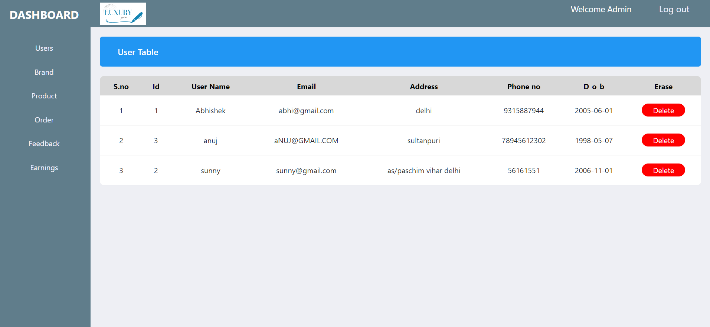

**Brand.php**

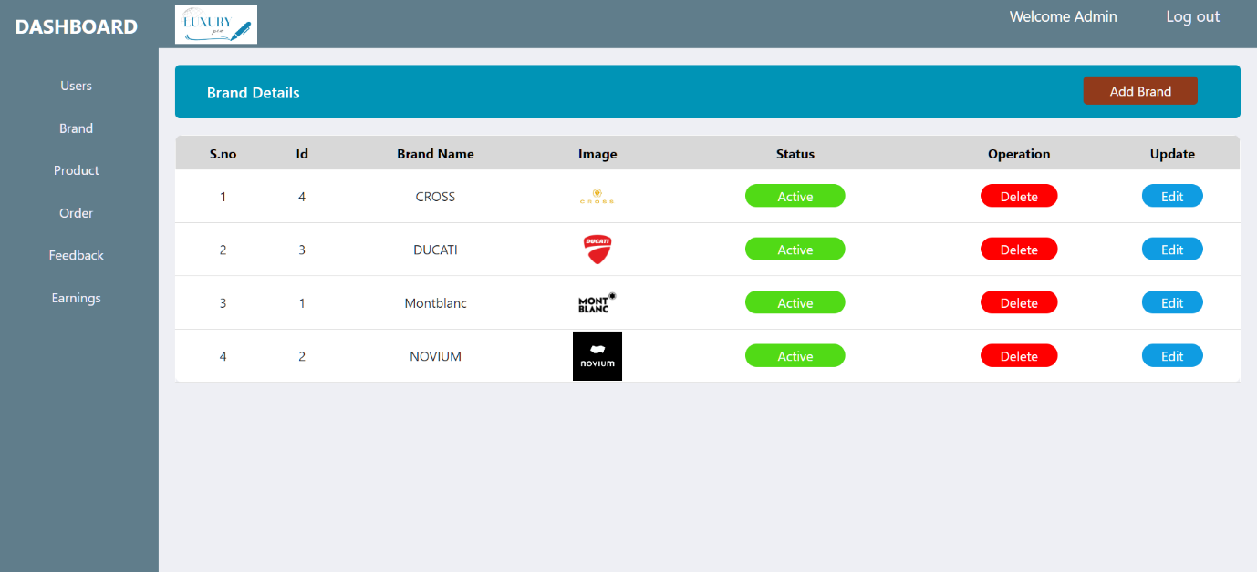

**Manage brand.php**

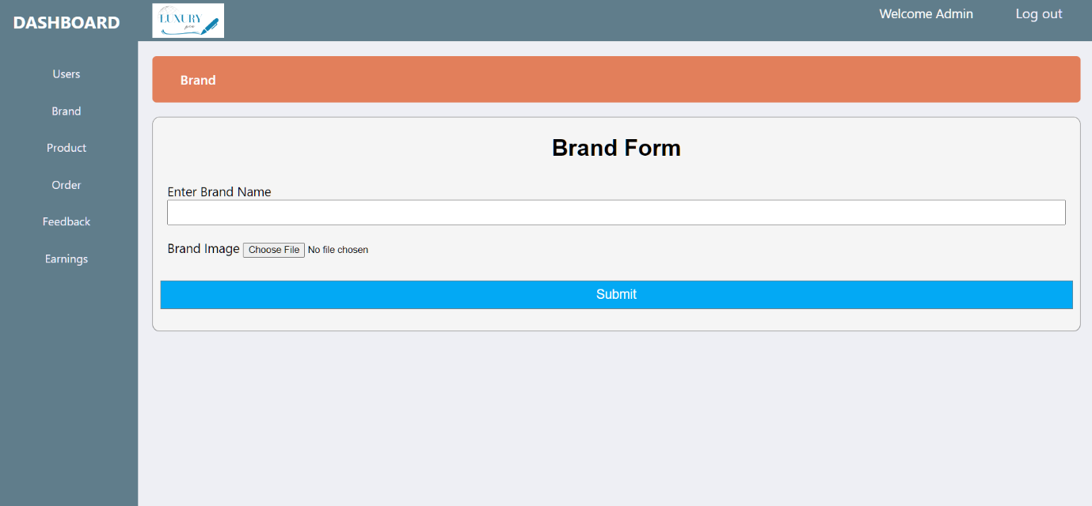

**Product.php**

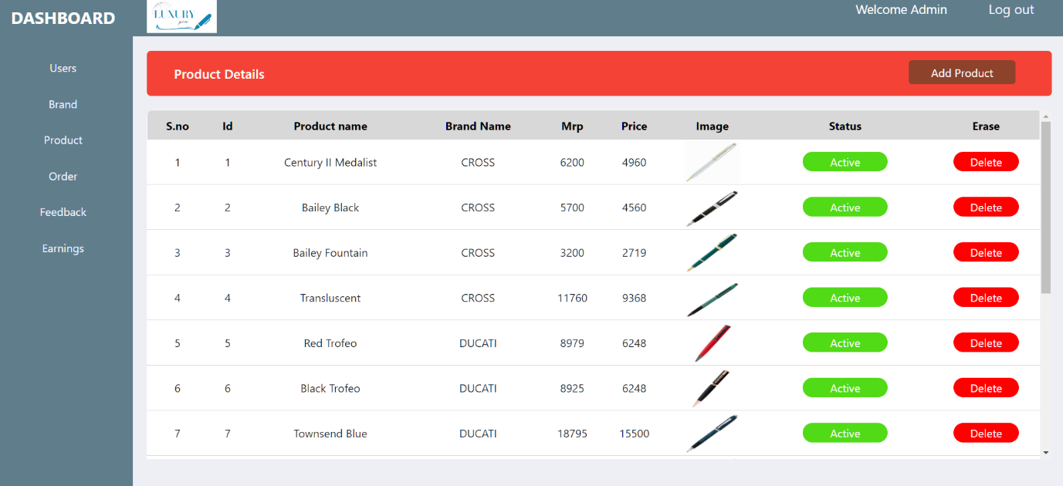

**Add product.php**

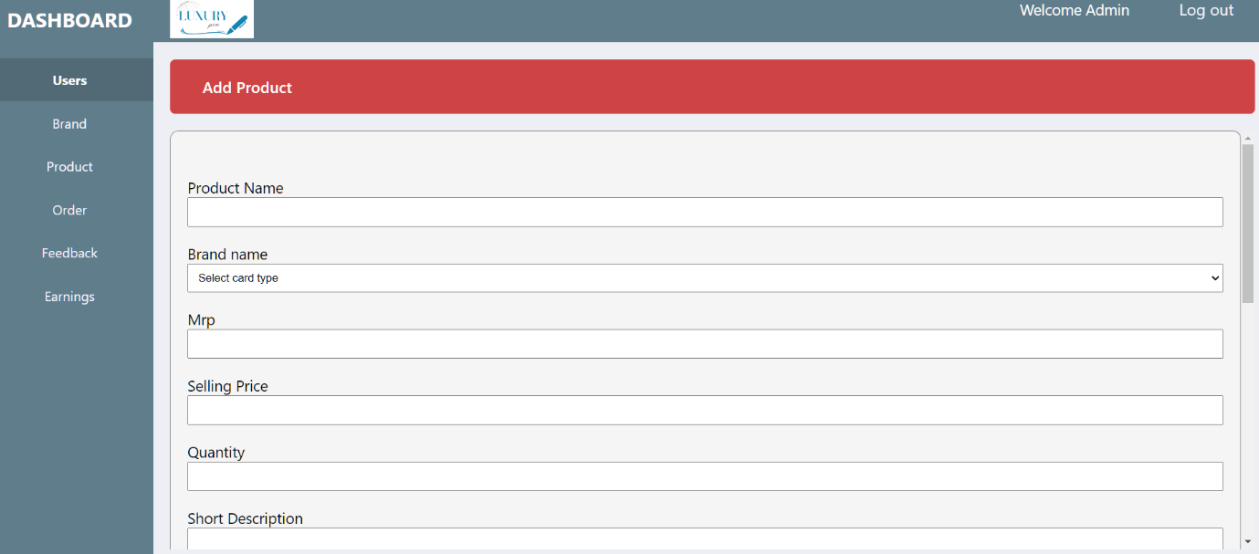

**Order.php**

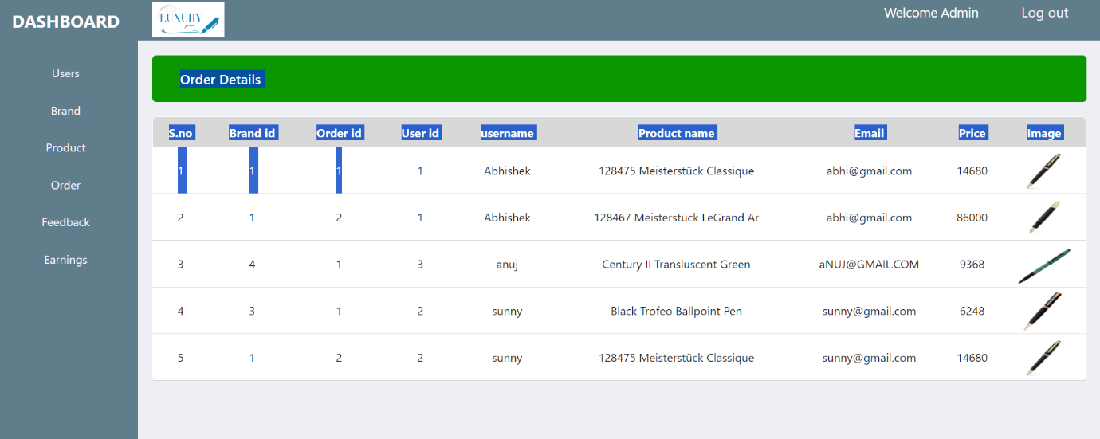

**Feedback.php**

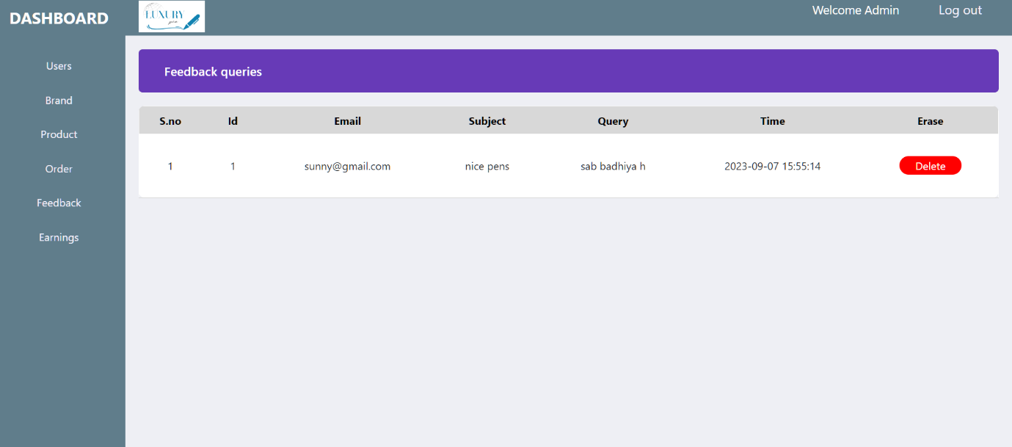

**Earning.php**

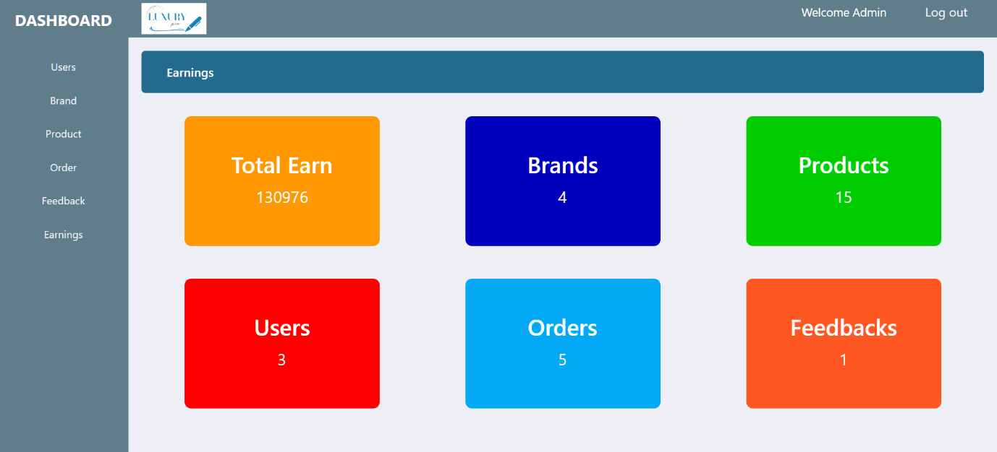

**Coding (Admin)**

**Admin connection.php**

<?php

session_start();

if(!isset($_SESSION['admin_logged_in']) || $_SESSION['admin_logged_in']!=true||isset($_SESSION['loggedin']) ){

session_unset();

session_destroy();

header("Location: login.php?Admin_login_by_proper_ways");

exit;

}

else{

$dbHost="localhost";

$dbUser="root";

$dbPass="";

$database="ecom";

$conn= mysqli_connect($dbHost, $dbUser, $dbPass,$database);

}

function get_safe_value($conn,$str)

{

return mysqli_real_escape_string($conn,$str);

}

#------All products

function get_product($conn,$type='')

{

$sql="SELECT * FROM `product`";

if($type=='latest')

{

$sql.='order by p_id';

}

$data=array();

$result= mysqli_query($conn,$sql);

while($row=mysqli_fetch_assoc($result))

{

$data[]=$row;

}

return $data;

}

#------Random products

function get_rand_product($conn,$limit='')

{

$sql="SELECT * FROM `product` order by count desc limit $limit";

$data=array();

$result= mysqli_query($conn,$sql);

while($row=mysqli_fetch_assoc($result))

{

$data[]=$row;

}

return $data;

}

#-------New arrivals waale

function get_product_limit($conn ,$limit='')

{

$sql="SELECT * FROM `product`";

if($limit!='')

{

$sql.="order by p_id desc limit $limit";

}

$data=array();

$result= mysqli_query($conn,$sql);

while($row=mysqli_fetch_assoc($result))

{

$data[]=$row;

}

return $data;

}

#-----Best sellers

function get_best_product($conn)

{

$sql="SELECT * FROM `product` WHERE count>3 order by count desc";

$data=array();

$result= mysqli_query($conn,$sql);

while($row=mysqli_fetch_assoc($result))

{

$data[]=$row;

}

return $data;

}

function get_brand($conn,$type='')

{

$sql="SELECT * FROM `brand`";

if($type=='latest')

{

$sql.='order by id desc';

}

$data=array();

$result= mysqli_query($conn,$sql);

while($row=mysqli_fetch_assoc($result))

{

$data[]=$row;

}

return $data;

}

function get_all_products($conn,$id)

{

$sql="SELECT * FROM `product` where brand_id=$id";

$data=array();

$result= mysqli_query($conn,$sql);

while($row=mysqli_fetch_assoc($result))

{

$data[]=$row;

}

return $data;

}

function find_brand($conn,$id)

{

$sql="SELECT brand from brand where id=$id";

$result=mysqli_query($conn,$sql);

$row=mysqli_fetch_assoc($result);

return $row['brand'];

}

?>

**Index.php**

<?php

require("admin_connection.php");

$sql="SELECT * FROM `users`order by username asc";

$show_result=mysqli_query($conn,$sql);

?>

<html>

<head>

<title>Index</title>

<link rel="stylesheet" href="Index.css">

</head>

<body>

<div class="wrapper">

<!-- Sidebar -->

<?php

require("./sidebar.php");

?>

<div class="main-content">

<!-- admin header -->

<?php

require("./admin_header.php");

?>

<div class="info">

<div class="info-header" style="display:flex; background-color:#2196f3;">

<h3>User Table</h3>

<div class="info-header-button">

<span></span>

</div>

</div>

<div class="table-wrapper" >

<table class="table-data" style="width: 100%; padding: 15px;">

<thead>

<tr id="sticky-row">

<th>S.no</th>

<th>Id</th>

<th>User Name</th>

<th>Email</th>

<th>Address</th>

<th>Phone no</th>

<th>D_o_b</th>

<th>Erase</th>

</tr>

</thead>

<tbody>

<?php

$i=1;

while($row=mysqli_fetch_assoc($show_result))

{?>

<tr>

<td> <?php echo $i++; ?> </td>

<td> <?php echo $row['u_id']?> </td>

<td> <?php echo $row['username'] ?> </td>

<td> <?php echo $row['email'] ?> </td>

<td> <?php echo $row['address'] ?> </td>

<td> <?php echo $row['phone_no'] ?> </td>

<td> <?php echo $row['d_o_b'] ?> </td>

<td>

<?php echo "<span class='brand-delete'><a href='brand_query.php?utype=delete&id=".$row['u_id']."'>Delete</a></span>"; ?>

</td>

</tr>

<?php } ?>

</tbody>

</table>

</div>

</div>

</div>

</div>

</body>

</html>

**Brand.php**

<?php

require("admin_connection.php");

$sql="SELECT * FROM `brand` order by brand asc";

$show_result=mysqli_query($conn,$sql);

?>

<html>

<head>

<title>Index</title>

<link rel="stylesheet" href="Index.css">

</head>

<body>

<div class="wrapper">

<!-- Sidebar -->

<?php

require("sidebar.php");

?>

<div class="main-content">

<!-- admin header -->

<?php

require("admin_header.php");

?>

<div class="info">

<div class="info-header" style="display:flex; background-color: #0094b6; ">

<h3>Brand Details</h3>

<div class="info-header-button">

<span>

<a href="manage_brand.php?addbrand=1" style="background-color:#913a1b;">Add Brand</a>

</span>

</div>

</div>

<div class="table-wrapper" >

<table class="table-data" style="width: 100%; padding: 15px;">

<thead>

<tr id="sticky-row">

<th>S.no</th>

<th>Id</th>

<th>Brand Name</th>

<th>Image</th>

<th>Status</th>

<th>Operation</th>

<th>Update</th>

</tr>

</thead>

<tbody>

<?php

$i=1;

while($row=mysqli_fetch_assoc($show_result))

{?>

<tr>

<td> <?php echo $i++; ?> </td>

<td> <?php echo $row['id']?> </td>

<td> <?php echo $row['brand'] ?> </td>

<td > <img src="../brand_image/<?php echo $row['image'] ?>" alt="" style="width:60px;"> </td>

<td >

<?php

if($row['status']==1)

{

echo "<span class='brand-active'><a href='brand_query.php?type=status&operation=deactive&id=".$row['id']."'> Active</a></span>";

}

else{

echo "<span class='brand-deactive'><a href='brand_query.php?type=status&operation=active&id=".$row['id']. "'>Deactivate</a></span>";

}

?>

</td>

<td>

<?php echo "<span class='brand-delete'><a href='brand_query.php?type=delete&id=".$row['id']."'>Delete</a></span>"; ?>

</td>

<td>

<?php echo "<span class='brand-edit'><a href='manage_brand.php?type=edit&id=".$row['id']."'>Edit</a></span>"; ?>

</td>

</tr>

<?php } ?>

</tbody>

</table>

</div>

</div>

</div>

</div>

</body>

</html>

**Manage brand.php**

<?php

require("admin_connection.php");

$brand_name='';

if(isset($_GET['id'])&& $_GET['id']!='')

{

#Edit karte time brand ka name nikalne ke liye

$id=get_safe_value($conn,$_GET['id']);

$sql="select * from brand where id = $id";

$result=mysqli_query($conn,$sql);

$num= mysqli_num_rows($result);

if($num>0)

{

$row=mysqli_fetch_assoc($result);

$brand_name=$row['brand'];

}

else{

header("Location: brand.php");

exit;

}

}

if(isset($_POST['submit'])&& $_POST['submit']!='')

{

#Ye edit insert karne ke liye

$brand_name=get_safe_value($conn,$_POST['brand-name']);

if(isset($_GET['id']) && $_GET['id']!='')

{

$update_sql="UPDATE `brand` SET `brand` = '$brand_name' WHERE `id` = $id";

$result=mysqli_query($conn,$update_sql);

header("Location: brand.php?Brand_update_successful");

}

else{

#Ye image insert karne ke liye

$image_name=rand(11111111,99999999).'_'.$_FILES['image']['name'];

$tmp_name=$_FILES['image']['tmp_name'];

move_uploaded_file($tmp_name,'../brand_image/'.$image_name);

$sql="INSERT INTO `brand` (`brand`, `status`, `image`) VALUES ('$brand_name', '1', '$image_name');";

$result=mysqli_query($conn,$sql);

if($result)

{

header("Location: brand.php?Brand_inserted_successfully");

exit;

}

}

}

?>

<html>

<head>

<title>Form</title>

<link rel="stylesheet" href="Index.css">

</head>

<body>

<div class="wrapper">

<!-- Sidebar -->

<?php

require("sidebar.php");

?>

<div class="main-content">

<!-- admin header -->

<?php

require("admin_header.php");

?>

<div class="info">

<div class="info-header" style="background-color:#e27f5b;">

<h3>Brand</h3>

</div>

<div class="table-wrapper">

<div class="container">

<?php if(isset($_GET['addbrand'])) { ?>

<h1 style="text-align: center; font-family:Arial, Helvetica, sans-serif">Brand Form</h1>

<form action="#" method="post" enctype="multipart/form-data">

<p>Enter Brand Name <input type="text" name="brand-name" placeholder="" required value="<?php echo $brand_name ?>"></p>

<p >Brand Image <input type="file" name="image" ></p>

<br>

<input type="Submit" name="submit" value="Submit" style="background-color:#03a9f4;">

</form>

<?php }

elseif(isset($_GET['type']))

{?>

<h1 style="text-align: center; font-family:Arial, Helvetica, sans-serif">Brand Update Form</h1>

<form action="#" method="post">

<p>Enter Brand Name <input type="text" name="brand-name" placeholder="" required value="<?php echo $brand_name ?>"></p>

<br>

<input type="Submit" name="submit" value="Submit" style="background-color:#03a9f4;">

</form>

<?php }?>

</div>

</div>

</div>

</div>

</body>

</html>

**Brand query.php**

<?php

require("admin_connection.php");

if(isset($_GET['type']) && $_GET['type']!='')

{

$type= get_safe_value($conn,$_GET['type']);

$id=get_safe_value($conn,$_GET['id']);

# For activate and deactive of brand status

if($type=="status")

{

$operation=get_safe_value($conn,$_GET['operation']);

$status='';

if($operation=='active')

{

$status='1';

}

else{

$status='0';

}

$brand_status="update brand set status = '$status' where id='$id'";

$status_result=mysqli_query($conn,$brand_status);

if($status_result)

{

$product_status="UPDATE product SET `status` = '$status' WHERE `product`.`brand_id` = '$id'";

$product_status_result=mysqli_query($conn,$product_status);

if( $product_status_result)

{

header("Location: brand.php?status_update");

exit;

}else{

header("Location: brand.php?Product_status_not_changed");

}

}

}

# For delete brand

if($type=="delete")

{

//To delete image from image folder we fetch image name from database

$file_query="SELECT image from brand where id= '$id'";

$file_result=mysqli_query($conn,$file_query);

$brand_delete="delete from brand where id = '$id'";

$delete_result=mysqli_query($conn,$brand_delete);

if($delete_result)

{

//Fetch value of file_result object which is only image name

$row = mysqli_fetch_array($file_result);

$files="../brand_image/$row[0]";

unlink($files); //Delete file

header("Location: brand.php?Brand_deleted");

exit;

}

else{

header("Location: brand.php?Delete_query_error");

exit;

}

}

# For delete feedback

if($type=="feed_delete")

{

$feedback_delete="delete from feedback where f_id = '$id'";

$delete_result=mysqli_query($conn,$feedback_delete);

if($delete_result)

{

header("Location: feedback.php?Feedback_deleted");

exit;

}

else{

header("Location: feedback.php?Delete_query_Error");

exit;

}

}

}

if(isset($_GET['ptype']) && $_GET['ptype']!='')

{

$type= get_safe_value($conn,$_GET['ptype']);

$id=get_safe_value($conn,$_GET['id']);

# For activate and deactive of brand status / product status

if($type=="status")

{

$operation=get_safe_value($conn,$_GET['operation']);

$status='';

if($operation=='active')

{

$status='1';

}

else{

$status='0';

}

$brand_status="UPDATE `product` SET `status` = '$status' WHERE `product`.`p_id` = $id";

$status_result=mysqli_query($conn,$brand_status);

if($status_result)

{

header("Location: product.php?status_update");

exit;

}

}

# For delete brand

if($type=="delete")

{

//To delete image from image folder we fetch image name from database

$file_query="select image from product where p_id= '$id'";

$file_result=mysqli_query($conn,$file_query);

//Select product with product id to delete

$brand_delete="delete from product where p_id = '$id'";

$delete_result=mysqli_query($conn,$brand_delete);

if($delete_result)

{

//Fetch value of file_result object which is only image name

$row = mysqli_fetch_array($file_result);

$files="../image/$row[0]";

unlink($files); //Delete file

header("Location:product.php?Product_deleted");

exit;

}

else{

header("Location: product.php?Delete_query_error");

exit;

}

}

}

if(isset($_GET['utype']) && $_GET['utype']!='')

{

$type= get_safe_value($conn,$_GET['utype']);

$id=get_safe_value($conn,$_GET['id']);

# For delete user

if($type=="delete")

{

$brand_delete="delete from users where u_id = '$id'";

$delete_result=mysqli_query($conn,$brand_delete);

if($delete_result)

{

$cart_delete="DROP TABLE `cart$id`";

$cart_delete_result=mysqli_query($conn,$cart_delete);

if($cart_delete_result)

{

$order_delete_sql="DROP TABLE `order_table$id`";

$order_delete_result=mysqli_query($conn,$order_delete_sql);

if($cart_delete_result)

{header("Location: Index.php?User_deleted");

exit;

}else{

header("location: Index.php?Order_table_delete_error");

exit;

}

}else{

header("location: Index.php?Cart_table_delete_error");

exit;

}

}

else{

header("Location: Index.php?Delete_query_error");

exit;

}

}

}

?>

**Product.php**

<?php

require("admin_connection.php");

$sql="SELECT product.*,brand.brand FROM `product`,`brand`

where product.brand_id=brand.id ";

$result=mysqli_query($conn,$sql);

?>

<html>

<head>

<title>Index</title>

<link rel="stylesheet" href="Index.css">

</head>

<body>

<div class="wrapper">

<!-- Sidebar -->

<?php

require("sidebar.php");

?>

<div class="main-content">

<!-- admin header -->

<?php

require("admin_header.php");

?>

<div class="info">

<div class="info-header" style="display:flex; background-color: #f44336;">

<h3>Product Details</h3>

<div class="info-header-button">

<span>

<a href="add_product.php" >Add Product</a>

</span>

</div>

</div>

<div class="table-wrapper" >

<table class="table-data" style="width: 100%; padding: 15px;">

<thead>

<tr id="sticky-row">

<th>S.no</th>

<th>Id</th>

<th>Product name</th>

<th>Brand Name</th>

<th>Mrp</th>

<th>Price</th>

<th>Image</th>

<th>Status</th>

<th>Erase</th>

</tr>

</thead>

<tbody>

<?php

$i=1;

while($row=mysqli_fetch_assoc($result)){

?>

<tr>

<td> <?php echo $i++; ?> </td>

<td> <?php echo $row['p_id']?> </td>

<td> <?php echo $row['p_name']?> </td>

<td> <?php echo $row['brand'] ?> </td>

<td> <?php echo $row['mrp'] ?> </td>

<td> <?php echo $row['price'] ?> </td>

<td><img style="width: 80px; height: 60px;" src="../image/<?php echo $row['image'] ?>" alt="" > </td>

<td >

<?php

if($row['status']==1)

{

echo "<span class='brand-active'><a href='brand_query.php?ptype=status&operation=deactive&id=".$row['p_id']."'> Active</a></span>";

}

else{

echo "<span class='brand-deactive'><a href='brand_query.php?ptype=status&operation=active&id=".$row['p_id']. "'>Deactivate</a></span>";

}

?></td>

<td>

<?php echo "<span class='brand-delete'><a href='brand_query.php?ptype=delete&id=".$row['p_id']."'>Delete</a></span>"; ?>

</td>

</tr>

<?php } ?>

</tbody>

</table>

</div>

</div>

</div>

</div>

</body>

</html>

**Add product.php**

<?php

require("admin_connection.php");

if(isset($_POST['submit'])&& $_POST['submit']!='')

{

$p_name=get_safe_value($conn,$_POST['p_name']);

$brand=get_safe_value($conn,$_POST['brand']);

$mrp=get_safe_value($conn,$_POST['mrp']);

$price=get_safe_value($conn,$_POST['price']);

$qty=get_safe_value($conn,$_POST['qty']);

$image=get_safe_value($conn,$_POST['image']);

$s_desc=get_safe_value($conn,$_POST['s_desc']);

$l_desc=get_safe_value($conn,$_POST['l_desc']);

$specifation=get_safe_value($conn,$_POST['specification']);

$features=get_safe_value($conn,$_POST['features']);

$image_name=rand(11111111,99999999).'_'.$_FILES['image']['name'];

$tmp_name=$_FILES['image']['tmp_name'];

move_uploaded_file($tmp_name,'../image/'.$image_name);

$sql="INSERT INTO `product` (`brand_id`, `p_name`, `mrp`, `price`, `qty`, `image`, `status`, `short_desc`, `long_desc`, `specification`, `features`) VALUES ( '$brand', '$p_name', '$mrp', '$price', '$qty', '$image_name', '1', '$s_desc', '$l_desc', '$specifation', '$features')";

$result=mysqli_query($conn,$sql);

if($result)

{

header("Location: product.php?Product_inserted_successfully");

exit;

}

else{

header("location: product.php?Product_already_exist");

}

}

?>

<html>

<head>

<title>Form</title>

<link rel="stylesheet" href="Index.css">

</head>

<body>

<div class="wrapper">

<!-- Sidebar -->

<?php

require("sidebar.php");

?>

<div class="main-content">

<!-- admin header -->

<?php

require("admin_header.php");

?>

<div class="info">

<div class="info-header" style="background-color:#ce4444;">

<h3>Add Product</h3>

</div>

<div class="table-wrapper">

<div class="container">

<h1 style="text-align: center; font-family:Arial, Helvetica, sans-serif"></h1>

<form method="post" action="#" enctype="multipart/form-data">

<p>Product Name <input type="text" name="p_name" required></p>

<p>Brand name

<select name="brand">

<option value="5131">Select card type</option>

<?php

$sql="SELECT id,brand FROM `brand`";

$result=mysqli_query($conn,$sql);

while($row=mysqli_fetch_assoc($result))

{

echo "<option value=".$row['id'].">".$row['brand']."</option>";

}

?>

</select>

</p>

<p>Mrp<input type="text" name="mrp" placeholder="" required></p>

<p>Selling Price <input type="text" name="price" ></p>

<p>Quantity <input type="text" name="qty" ></p>

<p>Short Description <textarea name="s_desc" cols="30" rows="6">

</textarea>

</p>

<p>Long Description <textarea name="l_desc" cols="30" rows="6"></textarea>

</p>

<p>Specifications <textarea name="specification" cols="30" rows="6"> </textarea></p>

<p>Features<textarea name="features" cols="30" rows="6"></textarea></p>

<p>Product Image <br><br> <input type="file" name="image" ></p><br>

<input type="submit" name="submit" value="Submit">

</form>

</div>

</div>

</div>

</div>

</div>

</body>

</html>

**Order.php**

<?php

require("admin_connection.php");

$userId_sql="SELECT u_id FROM `users`";

$user_result=mysqli_query($conn,$userId_sql);

?>

<html>

<head>

<title>Index</title>

<link rel="stylesheet" href="Index.css">

</head>

<body>

<div class="wrapper">

<!-- Sidebar -->

<?php

require("sidebar.php");

?>

<div class="main-content">

<!-- admin header -->

<?php

require("admin_header.php");

?>

<div class="info">

<div class="info-header" style="display:flex; background-color: #099600;">

<h3>Order Details</h3>

<div class="info-header-button">

<span>

</span>

</div>

</div>

<div class="table-wrapper" >

<table class="table-data" style="width: 100%; padding: 15px;">

<thead>

<tr id="sticky-row">

<th>S.no</th>

<th>Brand id</th>

<th>Order id</th>

<th>User id</th>

<th>username</th>

<th>Product name</th>

<th>Email</th>

<th>Price</th>

<th>Image</th>

</tr>

</thead>

<tbody>

<?php

$i=1;

while($user_row=mysqli_fetch_assoc($user_result))

{

$u_id=$user_row['u_id'];

$sql="SELECT * from `order_table$u_id`";

$result=mysqli_query($conn,$sql);

while($row=mysqli_fetch_assoc($result)){

?>

<tr>

<td> <?php echo $i++; ?> </td>

<td> <?php echo $row['brand_id'] ?> </td>

<td> <?php echo $row['order_id']?> </td>

<td> <?php echo $row['u_id'] ?> </td>

<td> <?php echo $row['username'] ?> </td>

<td> <?php echo $row['p_name']?> </td>

<td> <?php echo $row['email'] ?> </td>

<td> <?php echo $row['price'] ?> </td>

<td>

<img style="width: 80px; height: 60px;" src="../image/<?php echo $row['image'] ?>" alt="" >

</td>

</tr>

<?php }

}

?>

</tbody>

</table>

</div>

</div>

</div>

</div>

</body>

</html>

**Feedback.php**

<?php

require("admin_connection.php");

$sql="SELECT * FROM `feedback` order by f_id desc";

$show_result=mysqli_query($conn,$sql);

?>

<html>

<head>

<title>Feedback</title>

<link rel="stylesheet" href="style.css">

</head>

<body>

<div class="wrapper">

<div class="sidebar">

<h2>Dashboard</h2>

<ul>

<li><a href="Index.php">Users</a></li>

<li><a href="brand.php">Brand</a></li>

<li><a href="product.php">Product</a></li>

<li><a href="order.php">Order</a></li>

<li><a href="feedback.php">Feedback</a></li>

<li><a href="earning.php">Earnings</a></li>

</ul>

</div>

<div class="main-content">

<div class="header">

<div class="left-header">

<a class="logo" href="#"><img src="logo2.png" alt="Logo"></a>

</div>

<div class="right-header">

<span ><a href="#" id="welcome" >Welcome Admin </a></span>

<span ><a href="logout.php" id="logout" >Log out</a></span>

</div>

</div>

<div class="info">

<div class="info-header" style="display:flex; background-color: rgb(109 122 174);">

<h3>Feedback queries</h3>

<div class="info-header-button">

<span></span>

</div>

</div>

<div class="table-wrapper" >

<table class="table-data" style="width: 100%; padding: 15px;">

<thead>

<tr id="sticky-row">

<th>S.no</th>

<th>Id</th>

<th>Email</th>

<th>Subject</th>

<th>Query</th>

<th>Time</th>

<th>Erase</th>

</tr>

</thead>

<tbody id="f-data">

<?php

$i=1;

while($row=mysqli_fetch_assoc($show_result))

{?>

<tr>

<td> <?php echo $i++; ?> </td>

<td> <?php echo $row['f_id']?> </td>

<td> <?php echo $row['email'] ?> </td>

<td> <?php echo $row['subject'] ?> </td>

<td> <?php echo $row['query'] ?> </td>

<td> <?php echo $row['time'] ?> </td>

<td>

<?php echo "<span class='feedback-delete'><a href='brand_query.php?type=feed_delete&id=".$row['f_id']."'>Delete</a></span>"; ?>

</td>

</tr>

<?php } ?>

</tbody>

</table>

</div>

</div>

</div>

</div>

</body>

</html>

**Earning.php**

<?php

require("admin_connection.php");

?>

<html>

<head>

<title>Form</title>

<link rel="stylesheet" href="style.css">

</head>

<body>

<div class="wrapper">

<div class="sidebar">

<h2>Dashboard</h2>

<ul>

<li><a href="Index.php">Users</a></li>

<li><a href="brand.php">Brand</a></li>

<li><a href="product.php">Product</a></li>

<li><a href="order.php">Order</a></li>

<li><a href="feedback.php">Feedback</a></li>

<li><a href="earning.php">Earnings</a></li>

</ul>

</div>

<div class="main-content">

<div class="header">

<div class="left-header">

<a class="logo" href="#"><img src="logo2.png" alt="Logo"></a>

</div>

<div class="right-header">

<span ><a href="#" id="welcome" >Welcome Admin</a></span>

<span ><a href="logout.php" id="welcome" >Log out</a></span>

</div>

</div>

<div class="info">

<div class="info-header" style="background-color:#236b8e;">

<h3>Earnings</h3>

</div>

<div class="table-wrapper" style="display:flex; justify-content:space-around; flex-wrap:wrap;">

<div class="earn-container" style="background: #ff9800;">

<div class="earn-inner">

<h1>Total Earn</h1>

<?php

$userId_sql="SELECT u_id FROM `users`";

$user_result=mysqli_query($conn,$userId_sql);

$earn=0;

while($user_row=mysqli_fetch_assoc($user_result))

{

$u_id=$user_row['u_id'];

$sql="SELECT * from `order_table$u_id`";

$result=mysqli_query($conn,$sql);

while($row=mysqli_fetch_assoc($result)){

$earn=$earn+$row['price'];

}

}''?>

<p><?php echo $earn?></p>

<?php ?>

</div>

</div>

<div class="earn-container" style="background:#0000be; ">

<div class="earn-inner">

<h1>Brands</h1>

<?php

$brand_sql="SELECT * FROM `brand`";

$brand_result=mysqli_query($conn,$brand_sql);

$brand_num=mysqli_num_rows($brand_result);

?>

<p><?php echo $brand_num?></p>

<?php ?>

</div>

</div>

<div class="earn-container" style="background: #00cd00;">

<div class="earn-inner">

<h1>Products</h1>

<?php

$product_sql="SELECT * FROM `product`";

$product_result=mysqli_query($conn,$product_sql);

$product_num=mysqli_num_rows($product_result);

?>

<p><?php echo $product_num?></p>

<?php ?>

</div>

</div>

<div class="earn-container" style="background:red;">

<div class="earn-inner">

<h1>Users</h1>

<?php

$users_sql="SELECT * FROM `users`";

$users_result=mysqli_query($conn,$users_sql);

$users_num=mysqli_num_rows($users_result);

?>

<p><?php echo $users_num?></p>

<?php ?>

</div>

</div>

<div class="earn-container" style="background:#03a9f4;">

<div class="earn-inner">

<h1>Orders</h1>

<?php

$userId_sql="SELECT u_id FROM `users`";

$user_result=mysqli_query($conn,$userId_sql);

$orders=0;

while($user_row=mysqli_fetch_assoc($user_result))

{

$u_id=$user_row['u_id'];

$sql="SELECT * from `order_table$u_id`";

$result=mysqli_query($conn,$sql);

while($row=mysqli_fetch_assoc($result)){

$orders=$orders+1;

}

}

?>

<p><?php echo $orders?></p>

<?php ?>

</div>

</div>

<div class="earn-container" style="background: #ff5722;">

<div class="earn-inner">

<h1>Feedbacks</h1>

<?php

$feedback_sql="SELECT * FROM `feedback`";

$feedback_result=mysqli_query($conn,$feedback_sql);

$feed_num=mysqli_num_rows($feedback_result);

?>

<p><?php echo $feed_num?></p>

<?php ?>

</div>

</div>

</div>

</div>

</div>

</body>

</html>

**Style.css**

*{

margin: 0%;

padding: 0%;

box-sizing: border-box;

list-style: none;

text-decoration: none;

}

body{

background-color:#eeeff4;

font-family: -apple-system,BlinkMacSystemFont,"Segoe UI",Roboto,"Helvetica Neue",Arial,sans-serif,"Apple Color Emoji","Segoe UI Emoji","Segoe UI Symbol","Noto Color Emoji";

}

.wrapper{

display: flex;

position: relative;

}

/* Sidebar ki styling */

.wrapper .sidebar{

position: fixed;

width: 200px;

height: 100%;

background: #607d8b;

}

.wrapper .sidebar h2{

color:#fff;

text-transform: uppercase;

text-align: center;

margin-bottom: 30px;

padding-top: 20px;

}

.wrapper .sidebar ul li{

text-align: center;

}

.wrapper .sidebar ul li a{

color: #f5f3ff;

display: block;

font-size: 3Spx;

padding: 15px;

}

.wrapper .sidebar ul li:hover{

background: #516a76;

font-weight:bolder ;

}

.wrapper .sidebar ul li a:hover{

color: #fff;

}

/* Main content */

.wrapper .main-content{

width: 100%;

margin-left: 200px;

}

.wrapper .main-content .header{

padding: 10px;

padding-bottom:5px ;

background:#607d8b;

color:#717171;

border-bottom: 1px solid #e0e4e8;

display: flex;

position: sticky;

top: 0px;

z-index: 999;

}

.logo img{

width: 100px;

}

.wrapper .main-content .header .left-header{

margin-left: 10px;

}

.wrapper .main-content .header .right-header{

width: 100%;

text-align: right;

}

.wrapper .main-content .header .right-header span{

margin: 20px;

border-radius: 2px;

}

.wrapper .main-content .header .right-header span a{

color: #f5f3ff;

padding: 15px;

font-size: 1.2rem;

}

.wrapper .main-content .header .right-header a:hover{

color:#b9dbff;

}

/* Form */

.container{

background-color: whitesmoke;

border: 1px solid gray;

border-radius: 10px;

position: relative;

padding: 5px 10px 30px 10px;

}

.container h1{

padding: 20px;

}

form p{

padding: 10px;

font-size: 18px;

}

select,textarea,input[type="text"],input[type="email"],input[type="password"],input[type="checkbox"],input[type="number"],input[type="date"]

{

width:100%;

padding: 8px;

}

fieldset{

background-color: white;

width: 99%;

}

input[type="submit"]{

background-color: #18dd60;;

width: 100%;

padding: 9px;

font-size:18px ;

color: white;

border: 1px solid grey;

}

input[type="submit"]:hover{

cursor: pointer;

background-color:#0bfa63;

border: 1px solid grey;

}

/* Main content ka info */

.wrapper .main-content .info{

margin: 20px;

box-sizing: border-box;

}

.info-header{

width: 100%;

padding:20px;

position: sticky;

top: 80px;

margin-bottom: 20px ;

z-index: 998;

border-radius: 6px;

}

.info-header h3{

margin-left: 1em;

color:rgb(255, 255, 255);

font-weight: 500;

}

/*--------------Info ki table------------------------*/

.table-wrapper{

overflow-y:auto;

height: 70vh;

border-top-left-radius: 10px;

border-top-right-radius: 10px;

box-sizing: border-box;

}

.table-data{

width: 100%;

text-align: center;

border-collapse: collapse;

background: #ffffff;

border-radius: 10px;

border: 1px solid rgb(255, 255, 255);

}

.table-data th{

padding: 10px;

position: sticky;

top: 0px;

background-color: #d8d8d8;

}

.table-data td{

border-bottom: 1px solid #dadada;

vertical-align: middle;

color: #212529;

box-sizing: border-box;

}

/* Edit in brand table */

.brand-active a{

padding: 0.2em 2.45em;

color:#fff;

border-radius: 15px;

background-color:rgb(81, 218, 22);

margin: 1em;

}

.brand-deactive a{

padding: 0.2em 2.45em;

color:#fff;

border-radius: 15px;

background-color:darkorange;

}

.brand-delete a{

padding: 0.2em 1.5em;

color:#fff;

border-radius: 15px;

background-color:red;

}

.brand-edit a{

padding: 0.2em 1.5em;

color:#fff;

border-radius: 15px;

background-color:rgb(15, 156, 226);

}

/* info header button */

.info-header-button{

margin-left: auto;

}

.info-header-button a{

padding: 0.4em 2em;

color:#fff;

border-radius: 5px;

background-color:rgb(20 20 21);

margin-right: 2em;

}

/*----------Feedback section------------*/

.table-wrapper{

overflow-y:auto;

height: 70vh;

border-top-left-radius: 10px;

border-top-right-radius: 10px;

box-sizing: border-box;

}

.table-data{

width: 100%;

text-align: center;

border-collapse: collapse;

background: #ffffff;

border-radius: 10px;

border: 1px solid rgb(255, 255, 255);

overflow-x: auto;

}

.table-data th{

padding: 10px;

position: sticky;

top: 0px;

background-color: #d8d8d8;

}

.table-data td{

border-bottom: 1px solid #dadada;

vertical-align: middle;

line-height: 4;

color: #212529;

box-sizing: border-box;

}

/* Edit in brand table */

.brand-active a{

padding: 0.2em 2.45em;

color:#fff;

border-radius: 15px;

background-color:rgb(81, 218, 22);

margin: 1em;

}

.brand-deactive a{

padding: 0.2em 2.45em;

color:#fff;

border-radius: 15px;

background-color:darkorange;

}

.brand-delete a{

padding: 0.2em 1.5em;

color:#fff;

border-radius: 15px;

background-color:red;

}

.brand-edit a{

padding: 0.2em 1.5em;

color:#fff;

border-radius: 15px;

background-color:rgb(15, 156, 226);

}

/* info header button */

.info-header-button{

margin-left: auto;

}

.info-header-button a{

padding: 0.4em 2em;

color:#fff;

border-radius: 5px;

background-color:rgb(20 20 21);

margin-right: 2em;

}

/*---------Feedback section-------*/

#f-data tr td{

line-height: 2;

padding: 2em;

}

.feedback-delete a{

padding: 0.2em 1.5em;

color:#fff;

border-radius: 15px;

background-color:red;

}

/*----------Earning section---*/

.earn-container{

background-color: whitesmoke;

border: 0px solid gray;

border-radius: 10px;

position: relative;

padding: 10px;

width: 300px; height: 200px;

margin:1em;

text-align: center;

display: flex;

align-items: center;

}

.earn-inner{

width: 100%;

color: white;

}

.earn-inner h1{

font-weight: 500;

padding-bottom: 10px;

font-size: 35px;

}

.earn-inner p{

font-weight: 400;

padding-bottom: 10px;

font-size: 25px;

}

**Testing**

Testing is the process of running a system with the intention of finding errors. Testing enhances the integrity of a system by detecting deviations in design and errors in the system. Testing aims at detecting error-prone areas. This helps in the prevention of errors in a system. Testing also adds value to the product by conforming to the user requirements.

Software testing can be state as the process of validating and verifying that a computer program/application/product:

• Meets the requirements that guided its design and development

• Works as expected

• Can be implement with the same characteristics

• Satisfies the needs of stakeholders

Software testing, depending on the testing method employed, can be implement at any time in the software development process.

**TESTING METHODS**

System testing is the stage of implementation. This is to check whether the system works accurately and efficiently before live operation commences. Testing is vital to the success of the system. The candidate system is subject to a variety of tests: on line response, volume, stress, recovery, security and usability tests. A series of tests are perform for the proposed system is ready for user acceptance testing. The Testing Steps are:

**Black- Box Testing**

The technique of testing without having any knowledge of the interior workings of the application is called black box testing. The tester is oblivious to the system architecture and does not have access to the source code. Typically, while performing a black-box test, a tester will interact with the system's user interface by providing inputs and examining outputs without knowing how and where the inputs are worked upon.

**White-Box Testing**

White-box testing is the detailed investigation of internal logic and structure of the code. White-box testing is also called glass testing or open-box testing. In order to perform white-box testing on an application, a tester needs to know the internal workings of the code. The tester needs to have a look inside the source code and find out which unit/chunk of the code is behaving inappropriately.

**Unit Testing**

Unit testing focuses efforts on the smallest unit of software design. This is known as module testing. The modules are tested separately. The test is carried out during programming stage itself. In this step, each module is found to be working satisfactory as regards to the expected output from the module

**Integration Testing**

Data can be lost across an interface. One module can have an adverse effect on another, sub functions, when combined, may not be linked in desired manner in major functions. Integration testing is a systematic approach for constructing the program structure, while at the same time conducting test to uncover errors associated within the interface. The objective is to take unit tested modules and builds program structure. All the modules are combined and tested as a whole.

**Output Testing**

After performing the validation testing, the next step is output testing of the proposed system, since no system could be useful if it does not produce the required output in a specific format. The output format on the screen is found to be correct. The format was designed in the system design time according to the user needs. For the hard copy also; the output comes as per the specified requirements by the user. Hence, output testing did not result in any correction for the system.

**User Acceptance Testing**

User acceptance of a system is the key factor for the success of any system. The system under consideration is tested for the user acceptance by constantly keeping in touch with the prospective system users at the time of developing and making changes whenever required.

This is done in regard to the following point:

a) Input Screen Design

b) Output Screen Design

c) Format of reports and other outputs.

**Validation**

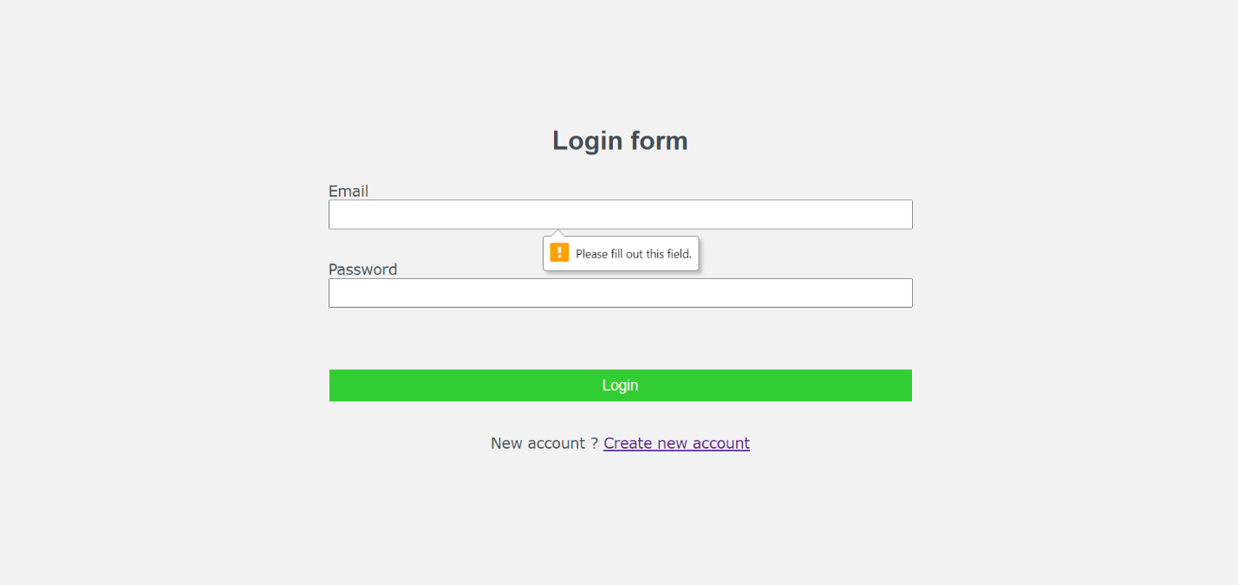**Login**

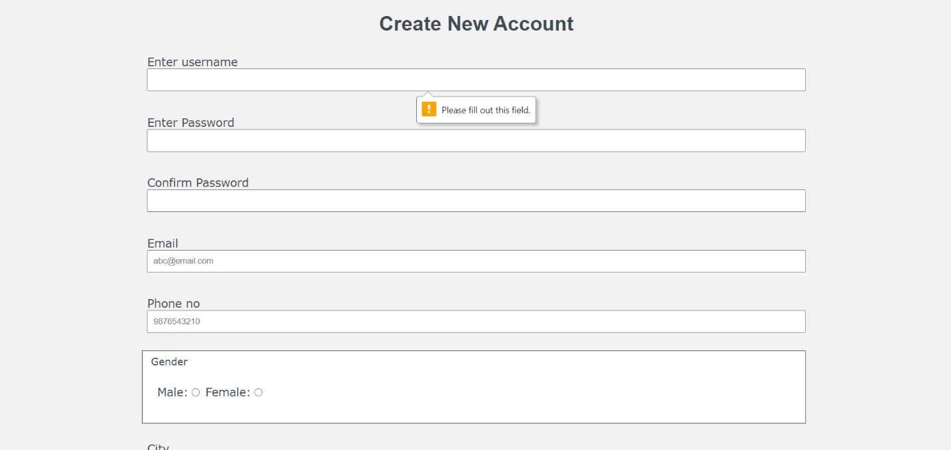**Registration**

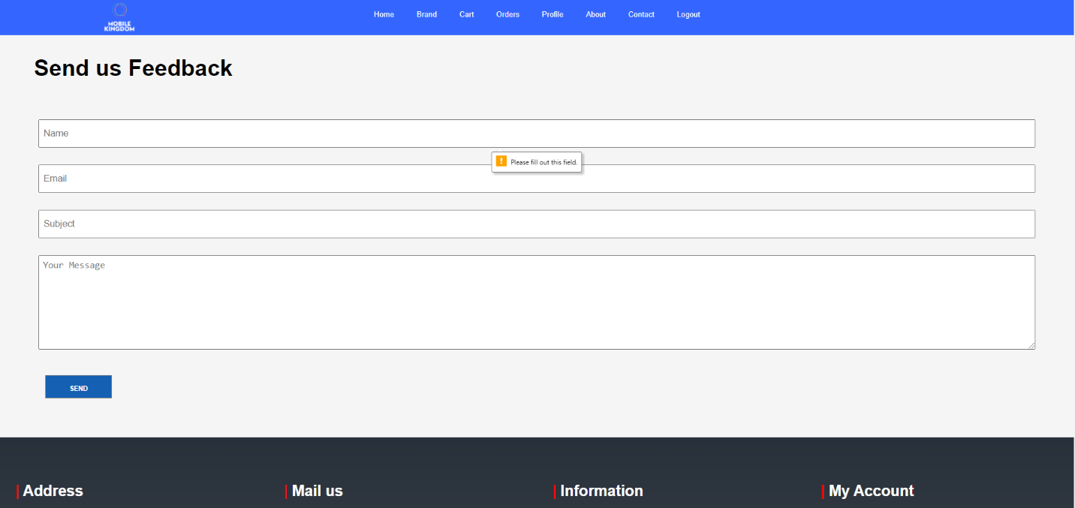**Feedback**

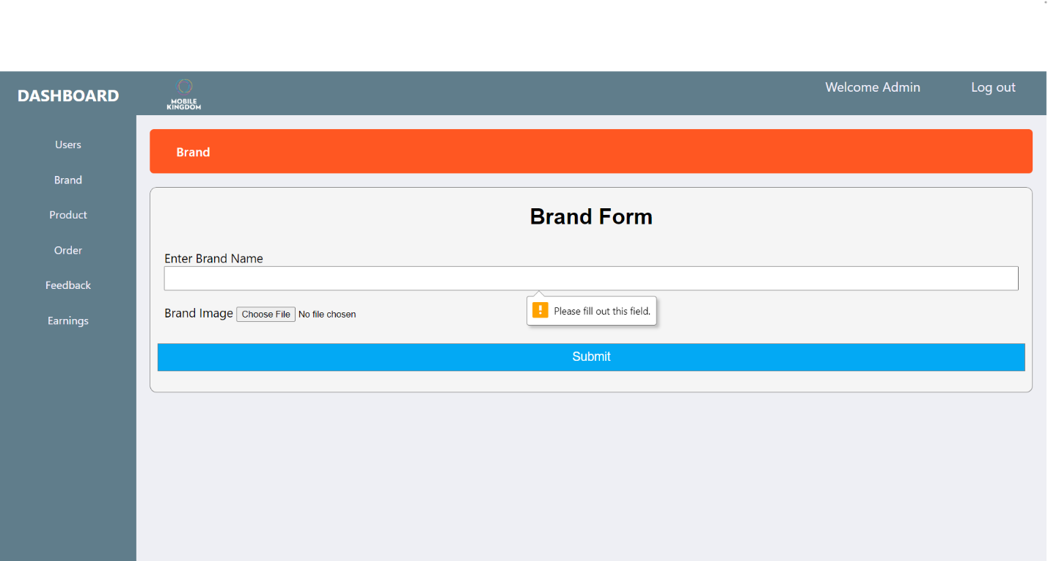**Add brand**

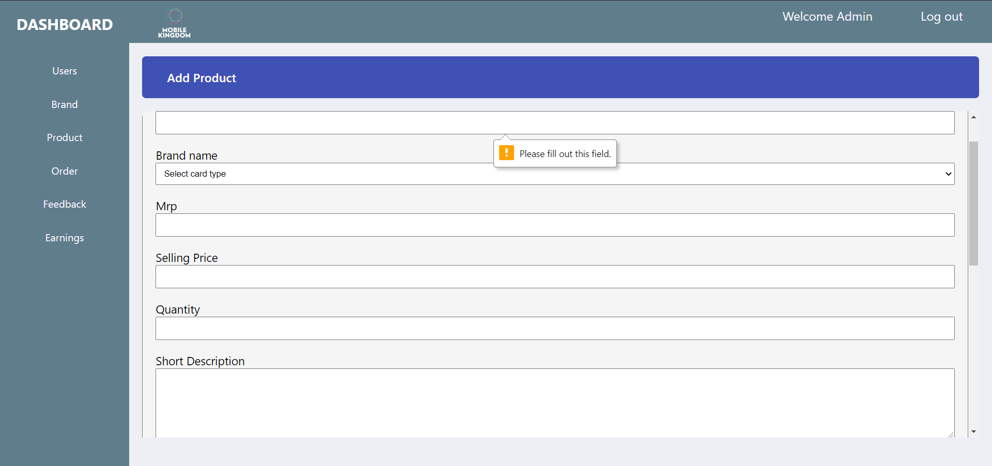**Add product**

**System security measures**

Security is the major concern for any organization so that any unauthorized user cannot access the organization data and any other secure things, same thing applicable in our project there should be a proper authentication for each user so that nobody can access user account accept the authorized user. Some security measures are:

1. By providing each member of this system with unique password , so

that no one can access their account and information without their

permission.

2. While entering the data into the form it will check for users that

field is properly filled & it should not be null.

3. In this system only authorized member can add or modify the loan

detail , personal information, EMI details and Interest rate details.

4. In this , all transaction are done in secure and safe environment.

5. In this all data show in encrypted manner so we can say that

‘information is totally in safe hand, no need to worry ‘.

The Basic System Security Measures apply to all systems at NYU, regardless of the level of their System Classification. It is a baseline, which all systems must meet. Note that for most personal workstations, these are the only Measures that apply. The requirements are:

**Password Protection:**

All accounts and resources must be protected by passwords which meet

the following requirements, which must be automatically enforced by the

system:

1. Must be at least eight characters long
2. Must NOT be dictionary or common slang words in any language, or be readily guessable
3. Must include at least three of the following four characteristics in any order:upper case letters, lower case letters, numbers, and special characters, such as*!@#$%^&*.

d. Must be changed at least once per year

**Software Updates:**

Systems must be configured to automatically update operating system

software, server applications (webserver, mailserver, database server,

etc), client software (web-browsers, mail-clients, office suites, etc), and

malware protection software (anti-virus, anti-spyware, etc). For Medium or High Availability systems, a plan to manually apply new updates within a documented time period is an acceptable alternative.

**Firewall:**

Systems must be protected by a firewall which allows only those incoming

connections necessary to fulfill the business need of that system. Client

systems which have no business need to provide network services must

deny all incoming connections. Systems that provide network services

must limit access those services to the smallest reasonably manageable

group of hosts that need to reach them.

**Malware Protection:**

Systems running Microsoft or Apple operating systems must have antivirus software installed and it must be configured to automatically scan and update.

**Database Security:**

Database security concerns the use of a broad range of information

security controls to protect databases (potentially including the data,

the database applications or stored functions, the database systems, the database servers and the associated network links) against compromises of their confidentiality, integrity and availability. It involves various types or categories of controls, such as technical, procedural/administrative and

physical. Database security is a specialist topic within the broader realms

of computer security, information security and risk management.

Security risks to database systems include, for example:

1. Unauthorized or unintended activity or misuse by authorized

database users, database administrators, or network/systems

managers, or by unauthorized users or hackers (e.g. inappropriate

access to sensitive data, metadata or functions within databases, or

inappropriate changes to the database programs, structures or

security configurations)

2. Malware infections causing incidents such as unauthorized access,

leakage or disclosure of personal or proprietary data, deletion of or

damage to the data or programs, interruption or denial of authorized

access to the database, attacks on other systems and the

unanticipated failure of database services

3. Overloads, performance constraints and capacity issues resulting

in the inability of authorized users to use databases as intended

4. Physical damage to database servers caused by computer room

fires or floods, overheating, lightning, accidental liquid spills,

static discharge, electronic breakdowns/equipment failures and

obsolescence

5. Design flaws and programming bugs in databases and the

associated programs and systems, creating various security

vulnerabilities (e.g. unauthorized privilege escalation), data

loss/corruption, performance degradation etc.

6. Data corruption and/or loss caused by the entry of invalid data

or commands, mistakes in database or system administration

processes, sabotage/criminal damage

**Debugging**

It is a systematic process of spotting and fixing the number of bugs, or

defects, in a piece of software so that the software is behaving as

expected. Debugging is harder for complex systems in particular when

various subsystems are tightly coupled as changes in one system or

interface may cause bugs to emerge in another.

In software development, debugging involves locating and correcting code

errors in a computer program. Debugging is part of the software testing

process and is an integral part of the entire softwaredevelopment lifecycle.

Once an error has been identified, it is necessary to actually find the error in the code.

Debugging is a developer activity and effective debugging is very

important before testing begins to increase the quality of the system.

Debugging will not give confidence that the system meets its

requirements completely but testing gives confidence.

Debugging, in computer programming and engineering, is a multistep

process that involves identifying a problem, isolating the source of the

problem, and then either correcting the problem or determining a way to

work around it. The final step of debugging is to test the correction or

workaround and make sure it works.

**The debugging process**

In software development, debugging involves locating and correcting code

errors in a computer program. Debugging is part of the software

testingprocess and is an integral part of the entire software development

lifecycle. The debugging process starts as soon as code is written and

continues in successive stages as code is combined with other units of

programming to form a software product. In a large program that has

thousands and thousands of lines of code, the debugging process can be

made easier by using strategies such as unit tests, code

reviews and pair programming.

Once an error has been identified, it is necessary to actually find the error

in the code. At this point, it can be useful to look at the code's logging and

use a stand- alone debugger tool or the debugging component of an

integrated development environment (IDE). Invariably, the bugs in the

functions that get most use are found and fixed first. In some cases, the

module that presents the problem is obvious, while the line of code itself is

not. In that case, unit tests -- such as JUnit and xUnit, which allow the

programmer to run a specific function with specific inputs -- can be helpful

in debugging.

**Common debugging tools**

Source code analyzers, which include security, common code errors and

complexity analyzers, can also be helpful in debugging. A complexity

analyzer can find modules that are so intricate as to be hard to understand

and test. Some tools can actually analyze a test run to see what lines of

code were not executed, which can aid in debugging. Other debugging

tools include advanced logging and simulators that allow the programmer

to model how an app on a mobile device will display and behave.

Some tools, especially open source tools and scripting languages, do not

run in an IDE and require a more manual approach to debugging. Such

techniques include dropping values to a log, extensive "print" statements

added during code execution or hard-coded "wait" commands that simulate

a breakpoint by waiting for keyboard input at specific times.

The use of the word bug as a synonym for error originated in

engineering. The term's application to computing and the inspiration for

using the word debugging as a synonym for troubleshooting has been attributed to Admiral Grace Hopper, a pioneer in computer programming, who was also known for her dry sense of humor. When an actual bug (a moth) got caught between electrical relays and caused a problem in the U.S. Navy's first computer, Admiral Hopper and her team "debugged" the computer and saved the moth. It now resides in the Smithsonian Museum

**FUTURE SCOPE**

We always try to make it simple and more user friendly. As by increasing some coding, we can improve its functionality. Online payment system is not available for users, which should be improve in near future. Until now, it does not have the facility of back of database. We also try to add some discount on payment via some specific bank credit card and add feature of EMI for convenience of customer.

For security issue we also try to make it more secure than before at every aspects and also try to give some additional for our premium members. For make it more beneficial, we also try to add compare feature for comparing two or more similar product for grab the best deal among them. We also give platform to give feedback on every product of our website as review.

For affiliate marketing, we also add feature for customer to gain some profits by selling our products. There will be endless possibilities for making our website more comfortable among users.

**References**

**Books**

* The Complete Reference PHP
* Head First SQL: Your Brain on SQL by Lynn Beighley
* IGNOU: Introduction to Software Engineering
* Giraffe Academy : You tube

**Websites**

* [www.google.com](http://www.google.com)
* [www.php.net](http://www.php.net)
* [www.yahoobaba.net](http://www.yahoobaba.net)
* [www.geekyshows.com](http://www.geekyshows.com)